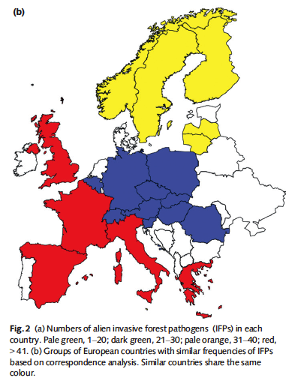
- In the picture from the paper by Santini et al three different colors are highlighted: what do they mean? And why those countries are coded with different colors

- Can you explain how Ascomycetes, Oomycetes and Basidiomycetes have been represented as invasive forest pathogens in Europe. Include the historical component in your answer

- Which one is the most efficient mean of introduction of pathogens in Europe according to the analysis of Santini et al

- White pine blister rust: can you describe which hosts it affects? Are there differences in resistance among hosts

- Can you describe what causes differences in the white pine blister rust outbreaks in western and eastern North America? What factors are determinant in the spread of this disease and how do the two regions differ

- Why do we care about the impacts of WPBR? Who and what are going to be affected

