Software Practicum – Population Genetics using GENEPOP

GENEPOP - descriptive statistics, estimates of genetic differentiation (traditional & microsat specific estimates of genetic differentiation), Hardy-Weinberg equilibrium (pairwise comparisons of single locus and global tests), geographic vs. genetic distance.

Raymond M & Rousset F 1995. GENEPOP (version 1.2): population genetics software for exact tests and ecumenicism. Journal of Heredity 86:248-249.
GENEPOP performs three major tasks:
1) It computes exact tests: for Hardy-Weinberg equilibrium, for population differentiation and for genotypic disequilibrium among pairs of loci.
2) It computes estimates of classical population parameters, such as Fst and other correlations, allele frequencies, etc.
3) It converts the input GENEPOP file to formats used by other programs, like Biosys (Swofford and Selander, 1981), Fstat (Goudet, 1995) and Linkdos (Garnier-Gere and Dillmann, 1992). Linkdos is also provided with GENEPOP, with the authorization of their authors. Slatkin’s isolation-by-distance program, DIST, available in previous versions of Genepop, has been replaced by the program ISOLDE (included in this version).

B) INPUT FILE FORMATS
1. Input file MUST NOT HAVE ANY EXTENSIONS -- IE. (If the file is produced in WORD, NOTEPAD, SIMPLE TEXT or other word processing document, it must not be saved as a rich text file (FILENAME.RTF) document file (FILENAME.DOC) or TEXT FILE (FILENAME.TXT). The input file name is limited to 6 characters.

Input file format

- Use Genepop to compute allelic richness, estimate genetic structure (FST) and Hardy-Weinberg equilibrium.
- Select Internet Explorer – Under favorites, find Genepop on the web or use HTML address: http://wbiomed.curtin.edu.au/genepop/ The following options and information appear:
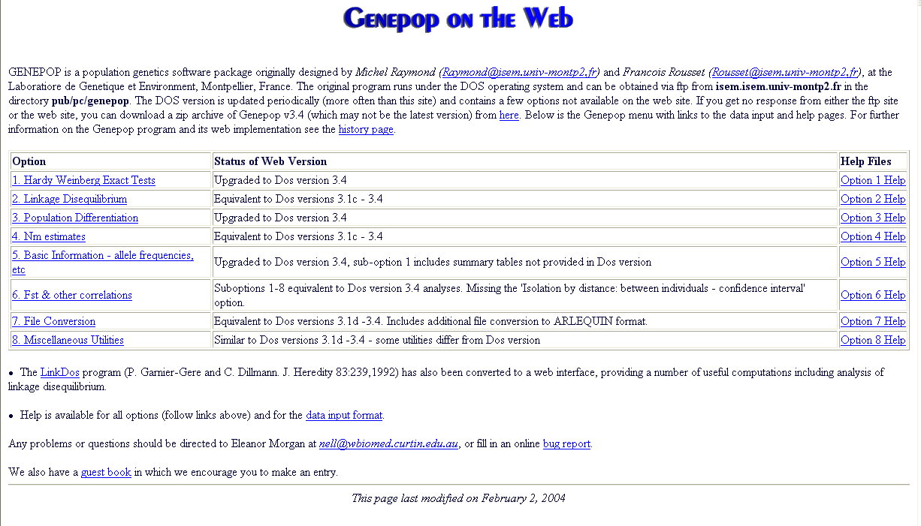

- Input file – open the file Rbrev. Double click on file and select Notepad to view the file. This dataset contains 3 populations. In population 1, there are 33 individuals, pop2 = 20 individuals, pop3 = 15 individuals.
1. First, select option 5 for basic information.
2. Under Input Data Format, select 3 digit alleles.
3. Under Browse, select Rbrev (Under Desktop in Folder Called Software Practicum)
4. Select HTML format for Output Results.
5. Select option number 1 to compute Ho, He and summary stats.
6. Select Submit Data.
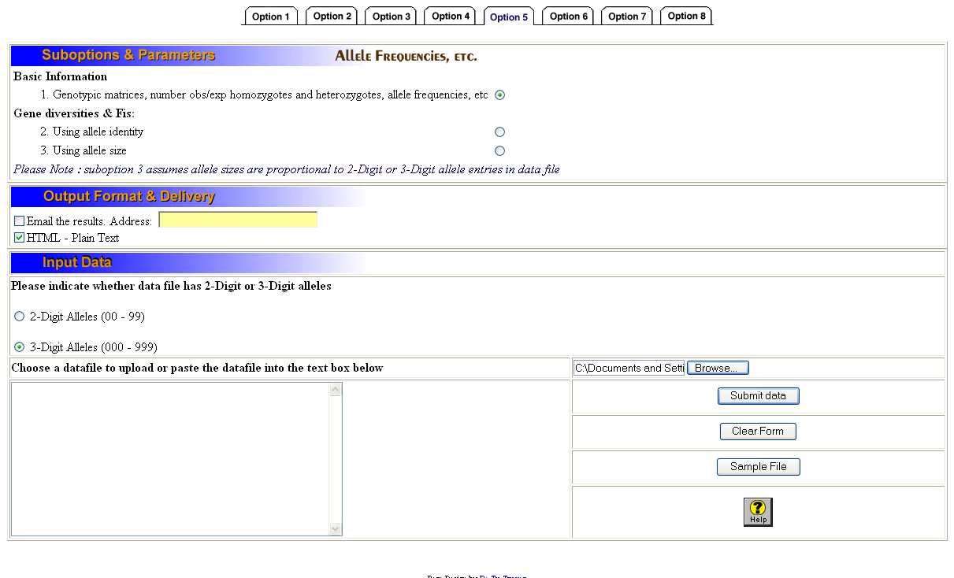

- Select Option number 6 to compute genetic differentiation.
    - Browse and select R brev file.
2. Under Input Data Format, select 3 digit alleles.
3. Under Browse, select Rbrev (Under Desktop in Folder Called Software Practicum).
4. Select HTML format for Output Results.
5. To compute FST for all populations, select option 1 under Allele identity (F-statistics).
6. To compute pairwise distance between populations, select option 5, Create semi-matrix of Fst estimates.

- Select Option number 1 to calculate Hardy-Weinberg.
    - Browse and select R brev file.
2. Under Input Data Format, select 3 digit alleles.
3. Under Browse, select Rbrev (Under Desktop in Folder Called Software Practicum).
4. Select HTML format for Output Results.
5. Select Probability test under subtitle ‘For each locus in the population’

- What is the estimate of F_{ST} for the all populations? For the pairwise populations? Which 2 populations are more genetically dissimilar (ie: which have the highest FST values?) Which are more similar?
- Are populations in Hardy-Weinberg equilibrium? Remember, if the value of observed heterozygotes is greater than expected (p>0.05), we can reject the null hypothesis of H-W equilibrium. What are some of the factors that could contribute to rejecting null hypothesis of H-W?

- If there is time, I would try testing whether genetic structure is related to simple isolation by distance under option 6.
    - Browse and select R brev file.
2. Under Input Data Format, select 3 digit alleles.
3. Under Browse, select Rbrev (Under Desktop in Folder Called Software Practicum).
4. Select HTML format for Output Results.
5. Select Probability test under subtitle Create Semi-matrix of F_{ST} estimates.
6. Select the output results (all test) and copy (CTL C).
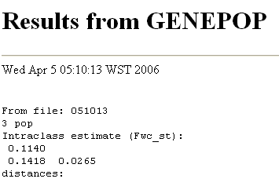
- Select all text and copy and past into text box under option six.
- This time, do not select the file Rbrev. Choose only HTML output results. Open the file called geographic distances in the software practicum folder. Select all, copy (CTL-C) and paste into open text window (CTL-V)
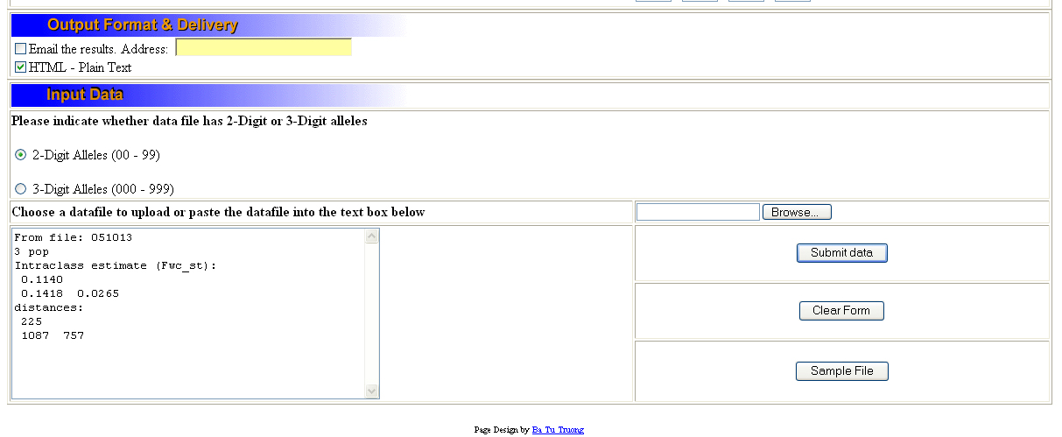
- Select Option number 7. Isolation by distance (using Isolde) to test whether geographic distance and genetic distance (FST) are correlated.
- Make sure you select the parameters below – make sure that you add a minimum distance (10 m), number of permutations (100-1000) and the four random number seeds.
Isolation by distance parameters:
 | Fit to Ln(distance) | 
 | Fit to distance | 
 | Convert F-statistics to F/(1-F)-statistics? | Yes  No
 | Minimum distance between samples to be taken in account for regression? | 
 | Number of permutations for Mantel test : | 
 | Please enter 4 random number generator seeds (0-168) : | 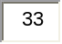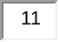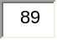
- The probability values are given in the output file based on Spearman rank correlation coefficients. Are geographic distance and genetic distance correlated with F_{ST}?

