GeneScan Instructions (Fragment Analysis)
To estimate the allele frequency for one individual (sample #107b), you will need
to estimate the fragment lengths using the ABI Software. There are a few
software programs that will analyze ABI files including GeneScan, the software
you will use today. To analyze the sample, first open GeneScan 3.7 in the
program menu.

- Create a new project file by selecting new under the file name.
- Select Project under Create New Menu.
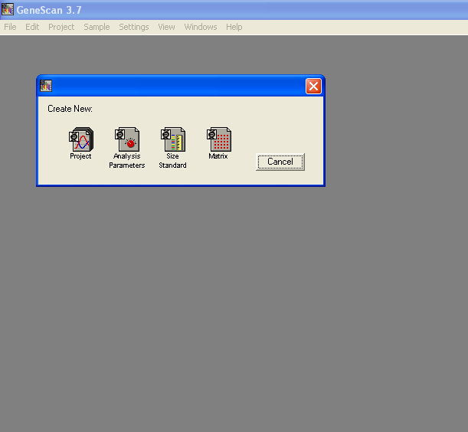

- Under the Menu Project, select Add Project Sample Files.
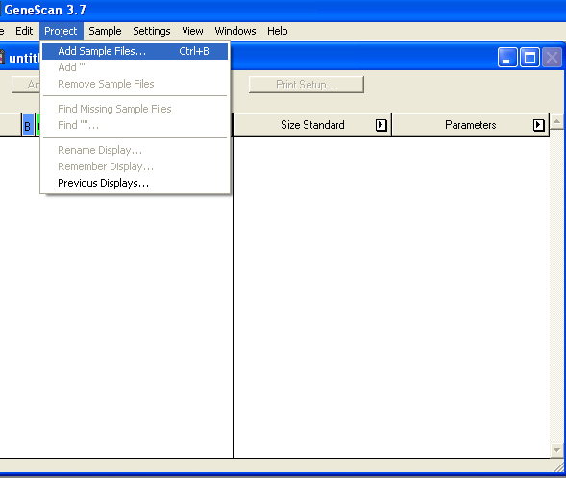

- Select GeneScan Files on Desktop SoftwarePracticum by clicking Add All followed by Finish.
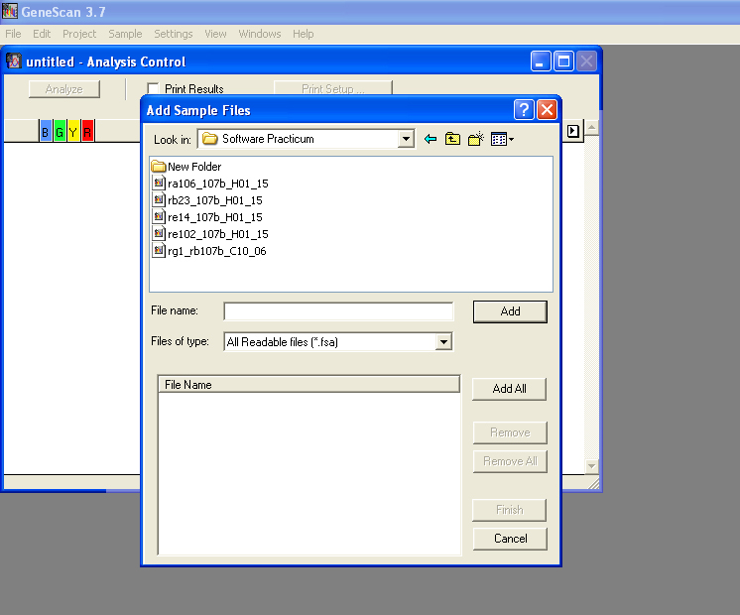

- Analyze Files by Selecting Blue (click on blue box). Click Analyze.
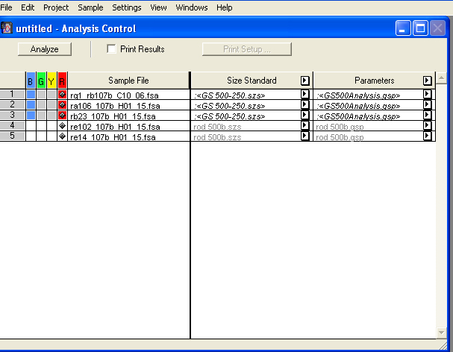
- After files are analyzed, go the Windows menu and select Results Control.
- Select Blue (this is the dye set used to create genescans) and then Display under the right side panel.

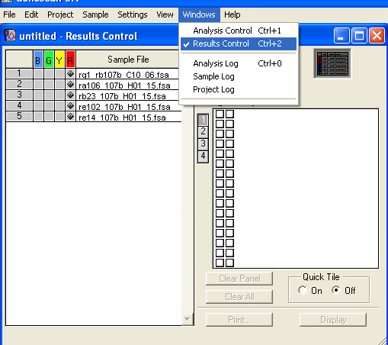
- Select Align by Size. This function will align all the fragments by the size with the lowest fragment to the highest fragment.
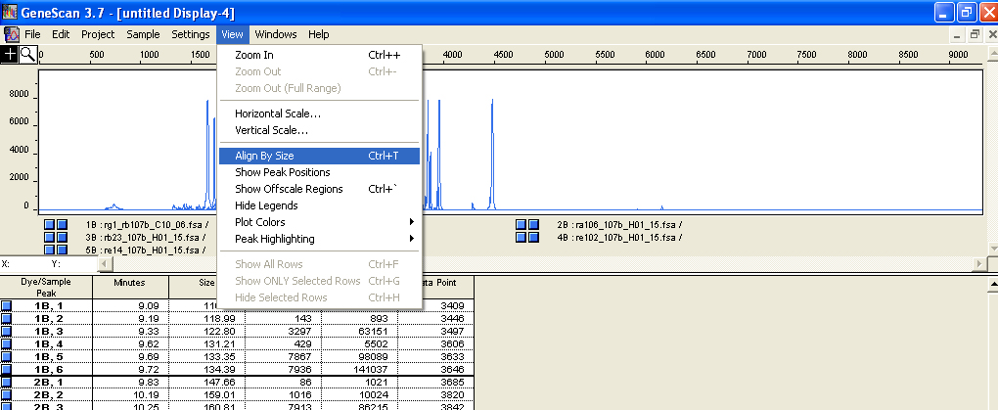
- In the left hand corner, you will find the zoom function. Zoom in by selecting the middle of the screen until you see all the fragments aligned.
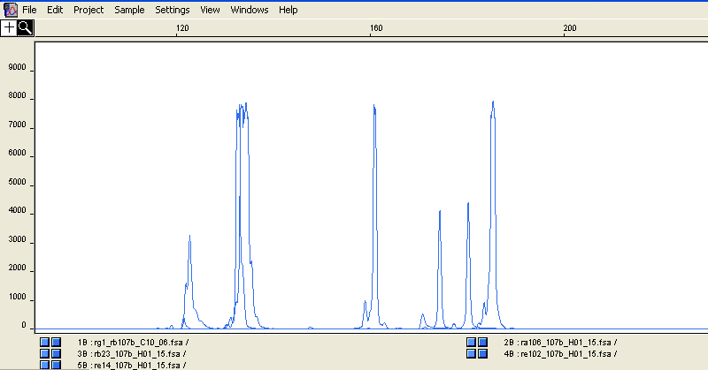
For each sample, there are two blue boxes. In the right box, you can change the color for each locus (loci are rg1, rb23, re14, ra106, re102). You can view each locus in a different color by double clicking on right had box and changing color to green, orange, red etc. Double-click on 4 of the 5 alleles and change color so that each allele is coded a different color.

Ignore all fragments less than 50 bp – this is the noise created in the dataset.
Once alleles of each locus are color coded, you can use the + function (left hand panel) to select a fragment (allele) and determine the size. For example, I’ve selected the locus coded in gray (RA5) and discovered the allele size is 185 bp. In this case, this individual is a homozygote. Determine all fragment sizes and enter into spreadsheet for each locus. Remember, there are two alleles for locus rb23 and rg1.
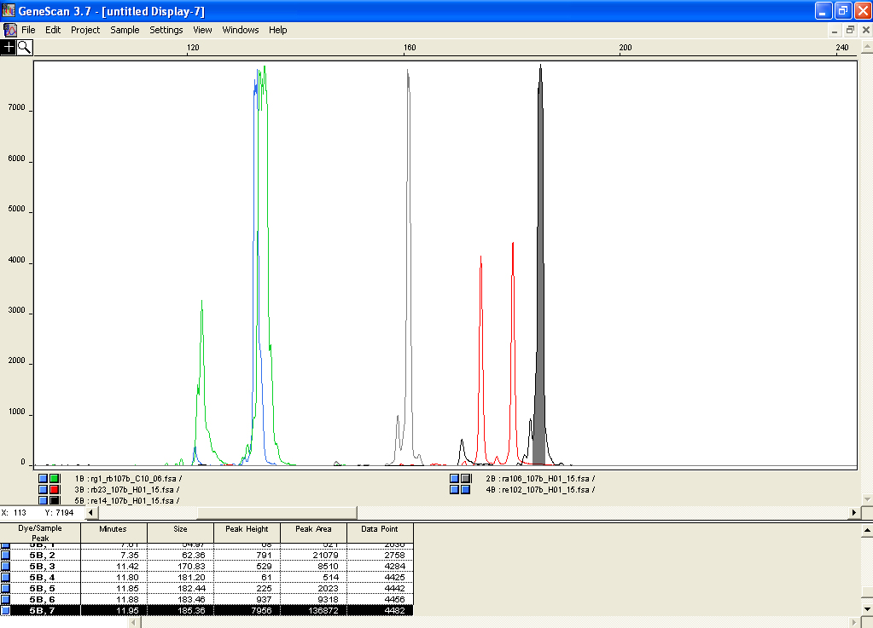
 | Rb23 | Re102 | Ra106 | Rg1 | Re14
Allele 1
Allele 2

Add the results of this exercise to the spreadsheet labeled Rbrev under the Software Practicum following the same format. The file is setup with three populations and loci are ordered as in the Table above.

Population data for Russula brevipes
RB23
RE102
RA106
RG1
RE14
Pop
1 107b ,
1 5 , 187205 138138 154156 164170 190188
1 30 , 187205 138138 154156 148148 190188
1 3 , 187208 138138 154156 145148 188190
1 42 , 187211 138138 154156 148148 190188
1 23 , 196199 138138 154156 145164 188188
1 19 , 196199 138138 154154 148164 190190
1 100 , 196199 138138 154154 148152 190190
1 13 , 196205 138138 154156 148164 190188
1 2 , 196208 138138 154156 148152 190188
1 31.2 , 196208 138138 154156 152170 188188
1 43 , 196208 138138 154156 000000 190190
1 15 , 196211 138138 154154 139152 000000
1 36 , 196211 138138 156156 139145 190188
1 120 , 196211 138138 156156 145145 190188
1 9 , 196233 138138 154156 155158 190190
1 24 , 199205 136138 154156 158158 000000
1 25 , 199205 138136 154156 158161 188188
1 32 , 199205 136136 156156 148152 188188
1 44a , 199214 136136 154154 155158 190190
1 35 , 199233 136136 154156 148155 188190
1 27 , 202202 136136 152154 145148 188190
1 16 , 202202 138138 154156 139148 190190
1 28 , 202208 138138 154156 145148 188188
1 8 , 202211 138138 154156 155164 190190
1 33 , 202211 138138 154154 148167 188188
1 7 , 202211 136138 156156 158164 190190
1 17 , 202214 138138 156156 148148 188188
1 22a , 205205 138138 154156 145164 188188
1 34b , 205205 138136 154154 136158 190190
1 37 , 205208 138138 154156 145158 190190
1 115 , 205233 138138 154154 155170 190188
1 34 , 208208 136138 154156 155170 188188
1 29 , 208211 138138 154156 158164 190190
Pop
2 147 , 178214 138140 154154 148148 188188
2 55 , 187205 140140 156156 164167 188188
2 56 , 187205 138138 156156 161164 188188
2 65 , 193208 138138 154156 158164 188188
2 47 , 196196 138138 154156 158161 188188
2 48 , 196196 138140 154156 158158 000000
2 51 , 196208 140138 154156 133152 188188
2 142 , 196208 140138 154156 148148 188188
2 155 , 196211 140138 154154 152161 188188
2 158 , 199205 140140 154154 148152 188188
2 151 , 199208 138138 156156 148152 188188
2 63 , 202202 138138 156156 164167 188188
2 144 , 202205 138138 154154 139148 188188
2 154 , 205208 140140 154156 148161 188188
2 60 , 205208 138138 156156 148148 188188
2 156 , 205211 138138 154156 161164 188188
2 152 , 205211 138140 156156 161161 188188
2 49 , 205214 140140 154156 148161 188188
2 143 , 205214 140138 154156 152164 188188
2 161 , 208208 138138 154156 148155 188188
Pop
3 171 , 187196 138138 154156 155167 188188
3 182b , 196205 140140 154154 152161 188188
3 79 , 196205 140140 154156 158164 000000
3 179 , 196205 140140 154154 158164 188188
3 81 , 196205 138138 154156 136155 188188
3 80 , 196208 138138 154156 142167 188188
3 72 , 196211 138138 154156 152164 188188
3 175 , 196211 140140 154154 164164 188188
3 76b , 196211 140140 154156 145148 188188
3 172 , 196233 140140 154156 155158 188188
3 76 , 202205 140140 154154 155164 188188
3 74 , 205211 140138 154154 152161 188188
3 182c , 205211 138138 154156 139148 188188
3 82 , 208214 138138 154156 145148 188188
3 77 , 211220 138138 154154 164164 188188

