ES10 February 14, 2003 Inez Fung

Topic: Atmospheric Circulation

- Annual mean climates: incident solar radiation versus outgoing terrestrial radiation: net heat gain at equator, heat loss at poles → atmospheric circulation cells.
- Forces acting to accelerate air parcels: pressure gradient force, gravity, and the Coriolis effect. The Coriolis effect is an “apparent” force, resulting from the transformation of the Earth’s rotating coordinate to the viewer’s stationary coordinate. The Coriolis effect deflects motion to the right in the Northern Hemisphere and to the left in the Southern Hemisphere.
- FACT1: Hot air rises; cold air sinks. In low pressures regions, rising air cools; water vapor condenses; rains. In high pressure regions, sinking air warms and dries.
- FACT2: Specific heat of X: the amount of heat required to raise the temperature of 1 gram of X by 1 degree RELATIVE to the heat required to raise the temperature of 1 gram of water by 1 degree. Specific heat of water = 1; of rocks = 0.2 → Continents heat up faster and cool down faster than oceans.

- Rising motion → low pressure over surface; Sinking motion → high pressure. Continuity → cells. The general circulation of the atmosphere comprises three circulation “cells”: the Hadley, Ferrel and polar cells.
- Coriolis “force” deflects surface flow of the three circulation cells → surface easterlies in the tropics, westerlies at mid-latitudes, and easterlies at high latitudes.
- FACT3 → regional climates, e.g. warm and wet in tropics, warm desert belt in subtropics.
- FACT4 → continental versus maritime climates
- FACT3 and FACT4 → monsoons or seasonal shifts in circulation; day-night sea-land breezes.
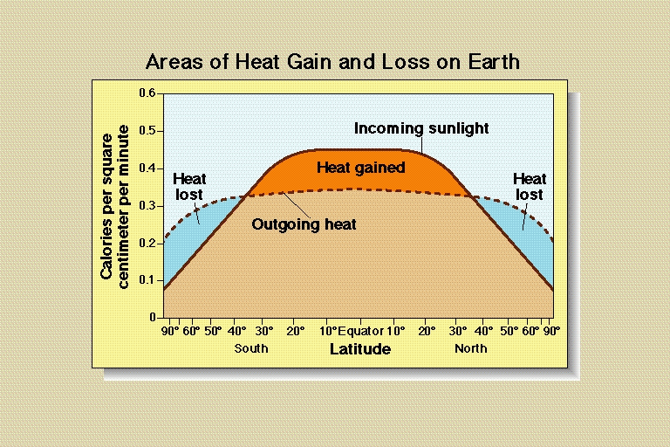

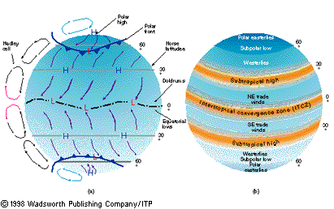

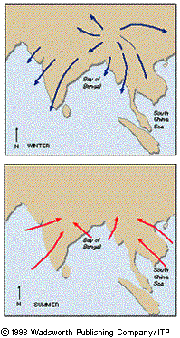
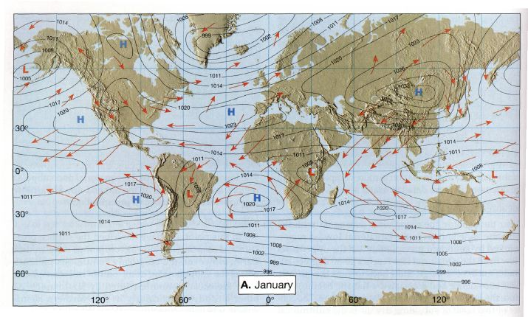
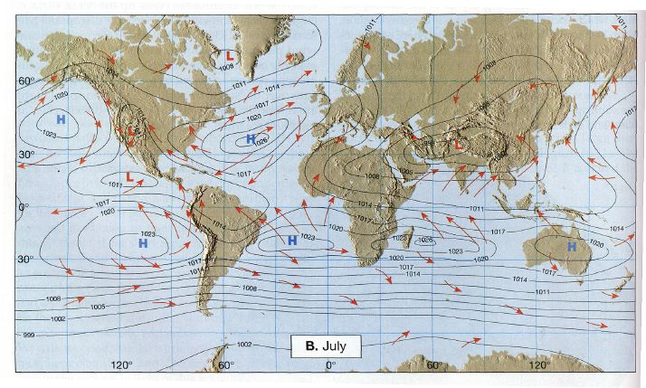
2

