Activity 1.1.7 Inventory fungi
- BIOCODE FINAL REPORT
  - Abstract - 250 words describing main achievements and findings
  - Narrative Description - Detailed summary of methods and results (1-2 pages)
  - Publications - Preferably as Endnote file too
  - Presentations - List of other communications at conferences
  - Public Outreach - List of newspaper articles, TV interviews, school programs, etc.
  - Participants - List of people, preferably with their level (e.g., graduate student) role (what they did), institution, and contact (email) - indicate those who should be a co-author on the MBP data paper (all those that contributed to the dataset).
  - Grants - List any supplementary or continuing funding obtained thanks to the MBP
  - Future directions - What work is continuing and briefly outline the next steps (<1 page)

----

Previous Report:
Biocode Investigator Matteo Garbelotto (UCB) led the activities of the fungal specialist group. Field surveys conducted during the years 2008 and 2009 resulted in obtaining 4,086 samples collected in 560 collecting events. Project efforts during the 2010 project year were focused on the extensive laboratory portion of the project, conducted by postdoctoral researcher Todd Osmundson (UCB). Focal efforts consisted of (1) generation and analysis of DNA barcode sequences for macrofungi (“mushrooms”); (2) generation and analysis of DNA barcode sequences for cultures of endophytic fungi; (3) characterization of the mycobiota of the invasive plant Miconia calvescens across an elevational gradient.

Database comparison of macrofungal sequences to GenBank for the first subset of sequences analyzed shows that 62 percent of the Moorea sequences exhibit less than 97 percent identity to sequences currently in GenBank (see Figure), indicating high endemicity in Moorea, a paucity of Pacific fungi in GenBank, or both. Work conducted on the Moorea Biocode Project will, regardless of the underlying reason(s) for this low level of sequence identity, make an important contribution to GenBank taxon coverage. In a separate analysis of the same macrofungal sequences, 23 percent exhibited a best GenBank match to an environmental sequence (i.e., a macrofungus either obtained in culture without a corresponding herbarium voucher collection, or obtained only as an environmental DNA sequence). Our addition of voucher-supported sequences will enhance ecological and biodiversity discovery by providing a taxonomic anchor for fungi observed in the environment.

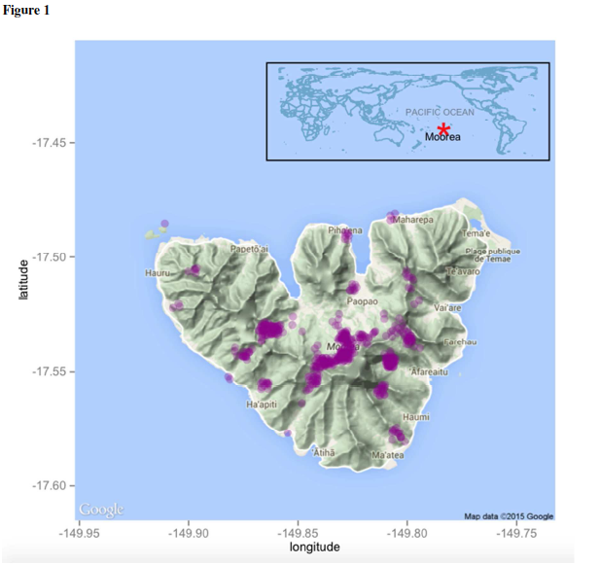

Sampling areas for macrfungi in Moorea

Distribution of sequence identity percentages for Moorea macrofungi compared to sequences in GenBank. Red horizontal line reflects 97% sequence identity, often used as a cutoff value for definition of molecular operational taxonomic units (MOTUs).

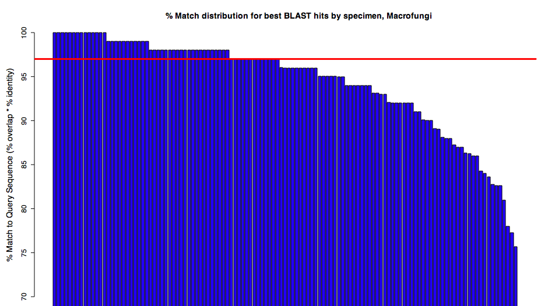
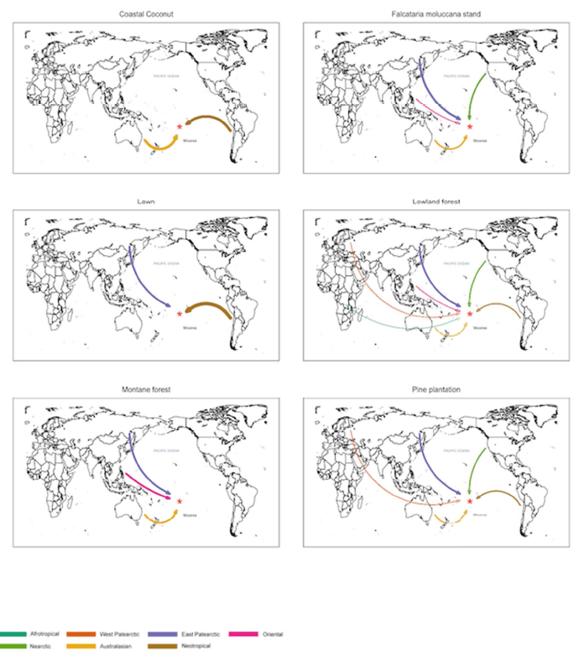

Biogeographical origin of macrofungal communities in different ecosystems

Preliminary analyses of endophyte cultures sequenced at UCB exhibited a rate of 52 percent successful partially-bidirectional (i.e., overlapping) contiguous sequences; a number of additional sequences are of sufficient quality for analysis but lack overlap between sequencing directions. Sequencing completion and further analysis are currently in progress. Preliminary analyses of approximately 25% of the cultures yielded 273 molecular operational taxonomic units. As most endophytic fungi do not produce prominent reproductive structures (sporocarps), cultures serve as important voucher specimens for these fungi. Therefore, we have given high priority to the maintenance of voucher cultures, and have begun preliminary discussions with the CBS-KNAW Fungal Biodiversity Centre, Netherlands (http://www.cbs.knaw.nl), with the goal of finding a permanent repository for the Moorea collections. The American Type Culture Collection (www.atcc.org) is another possible repository for these cultures.

Previous studies have demonstrated high diversity in soil and endophytic (plant tissue-inhabiting) fungi; therefore, we hypothesize that most of the fungal diversity on Moorea is found in the microfungi collected from these habitats. We collected 1,353 environmental samples for DNA-sequence based detection of fungi as well as 1,912 cultures of fungi from plant material and 141 cultures of fungi from insects (predominantly beetles). Though we have not completed overall diversity analyses on these samples, we have made several point analyses that suggest high microfungal diversity:
- Studies of endophytic fungi in the invasive plant Miconia calvescens using a DNA clone library approach revealed 53 distinct fungal taxa within the leaves of this single plant species. Our sampling curve did not reach an asymptote, suggesting that additional fungal taxa are present. We have attempted to reanalyze diversity using a high-throughput sequencing approach (which has become more widely-used in the time since our original survey); this study is likely to detect additional fungal species from M. calvescens.
- A clone library survey of Tahitian chestnut (Inocarpus fagifer) trees resulted in estimates of 35 fungi from wood and 125 fungi from leaf tissues, with no overlap between the species present in the two tissue types. It should be noted that these estimates are preliminary and were extrapolated from a limited amount of data; follow-up studies using high-throughput sequencing are currently in progress.
- Sequences from roots of the introduced pine tree Pinus caribaea indicated 5-10 species of ectomycorrhizal fungi. Although unusual among Moorea plants in being ectomycorrhizal and introduced, these results cannot be easily extrapolated to other plants; however, previous studies of tropical plants suggest that the endomycorrhizal and endophytic fungi found in root tissues are likely to show little overlap with fungi from leaf tissues; future studies of roots would therefore add additional fungal taxa to an overall diversity count for the island.

The invasive plant Miconia calvescens has been identified as a significant threat to the native plant biota of Moorea. A fungal biocontrol agent, Colletotrichum gloeosporioides f. sp. miconiae, was released in Tahiti in 2000 and subsequently spread naturally to Moorea. Field observations show increasing foliar damage to M. calvescens plants with elevation, suggesting that either the biocontrol fungus does not establish, or establishes but is less effective, at lower elevations. We conducted molecular surveys of the fungal microbiota of M. calvescens, with the objectives of (i) determining whether C. gloeosporioides f. sp. miconiae was differentially present over an elevation gradient and (ii) determining whether fungal community composition differs over the elevation gradient. Results generated in 2010 showed the presence of C. gloeosporioides f. sp. miconiae at all elevations, suggesting that the efficiacy, rather than the establishment, of the biocontrol fungus is the cause of low levels of foliar damage at low elevations; in addition, we successfully isolated C. gloeosporioides f. sp. miconiae as a component of the endophytic biota of low-elevation M. calvescens plants. Molecular characterization of fungal community composition across the elevational gradient is currently in progress. Irene Chen, an undergraduate student at UCB supervised by Dr. Garbelotto and Dr. Osmundson, conducted a study in which endophytic fungi isolated from plants along the elevational gradient were placed into competition with C. gloeosporioides f. sp. miconiae in vitro. Endophytes from low-elevation plants exhibited a significantly higher level of competition success than high-elevation endophytes, suggesting a possible role of the endophytic fungal community in mediating success of the biocontrol fungus.

Analyses and manuscript preparation are currently being planned for the above projects, with the goal of manuscript submission during the early summer of 2011. Additionally, sequence analysis for a pilot project conducted with members of the terrestrial invertebrate specialist group involving the sampling of beetle-associated yeasts and filamentous fungi from several sites on Moorea is currently in progress.

2010

Activity 1.1.7 Inventory fungi
Biocode Investigator Matteo Garbelotto (UCB) led the sampling of fungi on Moorea. Sampling during 2009 was conducted in Moorea between early July and early October by Garbelotto, collaborator Sarah Bergemann (Middle Tennessee State University) postdoctoral researcher Todd Osmundson (UCB), and field assistants Lydia Baker and Lydia Smith, with 2-3 persons on location at all times during this period. Primary goals for field sampling were to (1) obtain a more comprehensive sampling of macrofungi through intensive plot surveys; (2) produce culture isolates of fungi associated with foliar disease symptoms of native and introduced plants; (3) increase sampling of plant-associated fungi in high-elevation habitats; (4) sample airborne spore diversity as a means of capturing a portion of the fungal diversity not associated with substrates that were directly sampled; (5) conduct surveys of leaf-associated fungi across entire plant communities within sampling plots; (6) increase the number of sites sampled for ectomycorrhizal roots of introduced Caribbean pine (Pinus caribaea) trees; (7) increase cooperation between taxon research groups (terrestrial fungi, terrestrial plants, and terrestrial invertebrates). During the 2009 sampling period, 2,529 samples (including macrofungi vouchers, plant tissues for fungal DNA libraries, air samples, root tips, cultures, and soil samples) were collected in 291 collecting events, for a total of 4,106 samples collected in 560 collecting events thus far during the study.
An estimated total of 200-250 morphospecies of macrofungi were collected during 2008- 2009. Plot sampling of macrofungi in 2009 yielded a number of growth forms (for example, resupinate or “crust” fungi adhering to the undersides of decaying logs) that would most likely not have been obtained through more general collecting methods. High quality bidirectional sequences have been obtained for approximately 300 of the 557 macrofungal collections. As was observed in the 2008 sampling, the majority of macrofungi found on Moorea in 2009 were wood saprotrophic species, with Polyporales s.l., Xylariales, Auriculariales and Agaricales (e.g., Galerina, Gymnopilus, Pleurotus, Coprinus s.l., Marasmius s.l.) particularly well represented in numbers of collections. Significant observations from 2009 include an increase in the number of entolomatoid agaric species (these fungi are currently being identified by Dr. David Largent, professor emeritus at Humboldt State University), several collections of widely distributed tropical fungi that expand the known geographic range for these species (e.g., the netted stinkhorn Phallus cf. indusiatus, earthstar Geastrum sp., and agaric Cyptotrama asprata), and the first observation of an ectomycorrhizal sporocarp (Rhizopogon sp.).
Culturing of endophytic fungi from leaves, wood and diseased leaves over the 2008 and 2009 collecting expeditions yielded 1,874 isolates. All isolates have been subcultured and are maintained at UC-Berkeley. DNA extractions have been completed for all isolates, and first-pass sequencing has been completed for all isolates collected in 2008; DNA extracts from isolates collected in 2009 are currently at the Smithsonian Institution for DNA sequencing. First-pass sequencing of 2008 cultures at UCB has been highly successful, with high quality bidirectional sequences obtained for approximately 90% of isolates in batches examined to date. Comparison of DNA sequences to the GenBank database is currently in progress. DNA extraction has been completed for most other samples collected in 2009 (i.e., airborne spore samples, plant tissues, and mycorrhizal root tips).
Because most of the fungal diversity in an ecosystem consists of microfungi (fungi invisible to the unaided eye), and even macrofungi spend a majority of their life cycle in a cryptic state, accurate sampling of fungal diversity requires constructing environmental DNA libraries in which total organismal DNA is extracted from a substrate (e.g., a plant leaf), fungal DNA is preferentially amplified using fungal-specific PCR primers, individual fungal amplicons are separated by molecular cloning, and resulting clones are sequenced. For the majority of endophytic fungi that are not amenable to isolation in culture, the DNA sequence information is the sole means of determining their presence. Although the construction and analysis of DNA clone libraries presents some difficult logistical and computational challenges, preliminary analyses of Moorea samples have generated some interesting results. Analysis of a DNA clone library containing leaf samples from 3 host plant species (the trees Falcataria moluccana, Inocarpus fagifer, and Hibiscus tiliaceus) resulted in a species richness estimate (using a rarefaction estimator (Chao1) and assuming a species definition of 97% sequence similarity under a furthest neighbor algorithm) of 132 species with a mean percentage of 69.3% of species unique to each host. Analysis of an Inocarpus fagifer wood library generated an estimate of 36 fungal species, with no overlapping species recorded with leaf libraries.
Extrapolation of these results to the estimated nearly 1000 plant species on Moorea would result in an estimate of over 60,000 fungal species on Moorea, over six times the estimate (7,000 to 10,000) made at the beginning of the project. However, such estimates are highly sensitive to (a) the number of clone sequences sampled (for example, analysis of an Inocarpus fagifer leaf library with a higher number of clones sequenced yielded a species estimate of 128 for that host alone); (b) the amount of true fungal species overlap between plant host species; and (c) the alignment of DNA sequences provided as input to the computer algorithm. A substantial increase in the number of DNA sequences analyzed is currently underway in order to address (a). In order to address (b), whole-community plots were constructed in which every plant species in the plot was sampled, allowing more accurate estimates of overlapping fungal species between host plants. In order to address (c), the effect of alternative sequence partitioning on estimates will be examined. Compared to the fungal component of the Moorea Biocode Project, other fungal biodiversity studies have concentrated on sampling a more limited subset of fungi in terms of substrate, host, ecological guild, morphotype (e.g., only macrofungi or only DNA clone-based sampling), or all of the above. Therefore, even though it is unlikely that an exhaustive inventory of all fungi on Moorea will result from our current study, given the significantly increased estimate of overall diversity, the Biocode Project is likely to generate the most comprehensive estimate of fungal diversity to date for a tropical ecosystem.
Two collaborative projects were undertaken with other Biocode taxon specialist groups during the 2009 field expedition. Selection and sampling of whole-community vegetation plots was conducted in collaboration with members of the terrestrial plant specialist group. A pilot project was conducted with members of the terrestrial invertebrate specialist group involving the sampling of beetle-associated yeasts and filamentous fungi from several sites on Moorea. As insect-associated fungi represent quite likely the largest reservoir of fungal diversity not sampled in the other components of the Biocode fungal study, this collaboration represents an important opportunity to add to the fungal inventory.
The fungal specialist group engaged in a number of outreach activities during the reporting period. Research presentations included a Department of Environmental Science and Management – Ecosystem Sciences seminar and a contributed presentation for the Third International Barcode of Life Conference. For the second consecutive year, the specialist group provided support to the course “Biology and Geomorphology of Tropical Islands,” conducted by UC-Berkeley at the Gump Station, presenting two course lectures and supervising a student research project by Ms. Irene Chen, who conducted a study of antagonistic interactions between foliar endophytic fungi and a fungal pathogen introduced for biological control of the invasive plant Miconia calvescens. In addition, research experience gained in both the field and laboratory by Lydia Smith during her work on the project was likely a major factor in her successful admission to several highly ranked doctoral programs.
Current and planned activities are focused on the extensive laboratory portion of the study, with highest priorities accorded to (1) completing sequencing of macrofungi and cultures; (2) comprehensive assessment of fungal diversity (leaf, wood, soil, air) using Inocarpus fagifer forests as a model system; (3) construction and sequencing of whole-community clone libraries; (4) comprehensive comparisons of leaf-associated fungal communities across dominant tree species; (5) characterization of the mycobiota of the invasive plant Miconia calvescens across an elevational gradient. Approximately 37% of DNA sequencing has been completed for these priority items (Table 1).
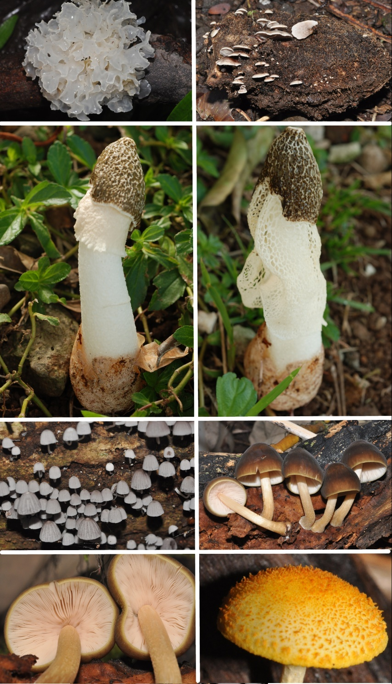

ROW1: (Left) Tremella cf. fuciformis, a “jelly fungus”; (Right) Seeds of Tahitian Chestnut (Inocarpus fagifer) as an ecosystem – fungi, invertebrates, and a plant seedling have established on this decaying seed.
ROW2: (Left) A netted stinkhorn, Phallus cf. indusiatus, immature; net has not completely formed; (Right) Same fungus a few hours later, when net has formed.
ROW3: Two wood saprotrophic fungi. (Left) Mycena sp. (Right) Pluteus sp.
ROW4: (Left) View of the gills of Pluteus sp. (Right) Cyptotrama asprata.

