OakSTeP: Oak SOD Testing Kit Request Form
(Please fill in all fields)
Full Name: Date:
Email:
Shipping Address:

OakSTeP User Number:
Number of testing kits requested (4 maximum):
Total Amount of Donation ($150 per kit):
Submit Payment at oakstep.org
Payment Confirmation Number:
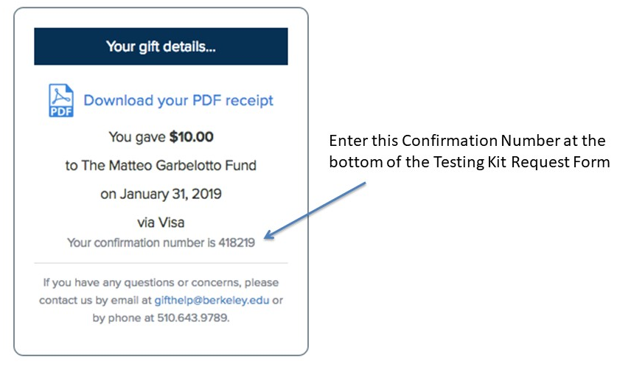
Email scanned form to:
registration@oakstep.org
or mail completed form to:
Doug Schmidt, c/o OakSTeP, 54 Mulford Hall, Berkeley, CA 94720

