Sudden Oak Death Blitzes 2020
New Format Due to Covid-19

1)- Training (30 minutes) and sign-up (5 minutes) have to be done online at www.sodblitz.org before collecting the sampling materials at the SOD Blitz Stations in the locations specified below. Please sign up before you start the survey, and preferably when you take the online training.

2)- Once at your local SOD Blitz Station you can pick up one or two collection packets following the social distancing rules of the State of California clearly specified in the online training. Stay at least 6 feet from other collectors. Bring your own pencil. Each packet allows you to sample 10 trees. Do not pick more unless you talked to the organizer.

3)- Make sure you have downloaded the free App “SODmap mobile” to determine the exact location of the trees you sample, before you start the survey.

4)- Each Blitz has a start and an end date, including the hour. You can pick up materials at the start time and you have to return your samples and any unused collection materials by the end date and cutoff time.

5)- You can sample private properties with the owner’s permission, alongside public roads and in parks or open spaces that are open to the public.

6)- Any questions? Email your local organizer, please. Thank you so much for your participation.

The Napa Blitz
Saturday April 11th 10 am until Tuesday April 14th 10 am
Please do not return packets with samples to Blitz Station but mail them to U.C. Berkeley using the preprinted mail labels and postage included in each packet.
SOD Blitz Station located in the front porch of the Napa County Agriculture Commissioners Office Building, 1710 Soscol Avenue, Napa.
Contact: Bill Pramuk info@billpramuk.com

The Santa Lucia Preserve Blitz
(For local residents only)
Saturday, April 18th
Contact: Christy Wyckoff cwyckoff@slconservancy.org

The Saratoga & Skyline Blitzes
Saturday April 25th 10 am until Monday May 4th 10 am.
(If Shelter in Place ordinance is enforced, please keep samples cool and dry, and preferably return them on May 4th)
1)- SARATOGA SOD Blitz Station located on the left of the entrance of the Montalvo Arts Center, 15400 Montalvo Road, Saratoga CA (See map below)

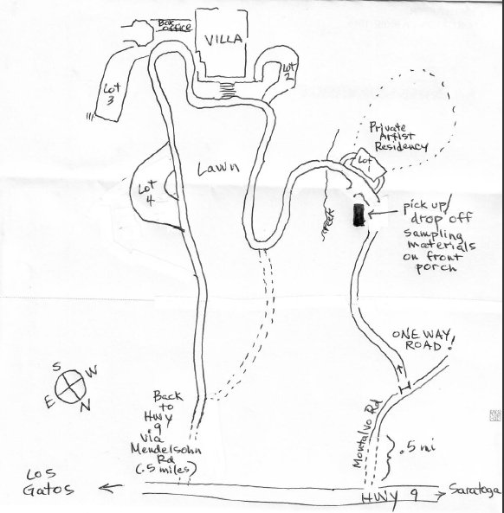

Contact: Ann Northrup annnorthrup@sbcglobal.net
CNPS: Toni Gregorio-Bunch tidytip.lp@gmail.com
MidPen Open Space Contact: Coty Sifuentes csifuentes@openspace.org
City of Saratoga: Kate Bear kbear@saratoga.ca.us

2)- SOUTH SKYLINE SOD Blitz Station located on the rear Side of the Saratoga Summit Forestry and Fire Protection (CalFire) CDF fire station. 12900 Skyline Blvd, Los Gatos, CA.
Contact: Jane Manning skyline_sod@yahoo.com
MidPen Open Space Contact: Coty Sifuentes csifuentes@openspace.org

The East Bay Blitzes
Saturday, May 9th 10 am until Tuesday May 12th 10 am
1)- ORINDA, Pick up and drop off at Orinda Library 26 Orinda Way, Orinda, Ca. 94563
Click here for detail directions
Contact: Bill Hudson wllhh@ymail.com

2)- UC BERKELEY, SOD Blitz Station, West Side of U.C. Berkeley Parking Booth, West Crescent, Berkeley, CA 94720 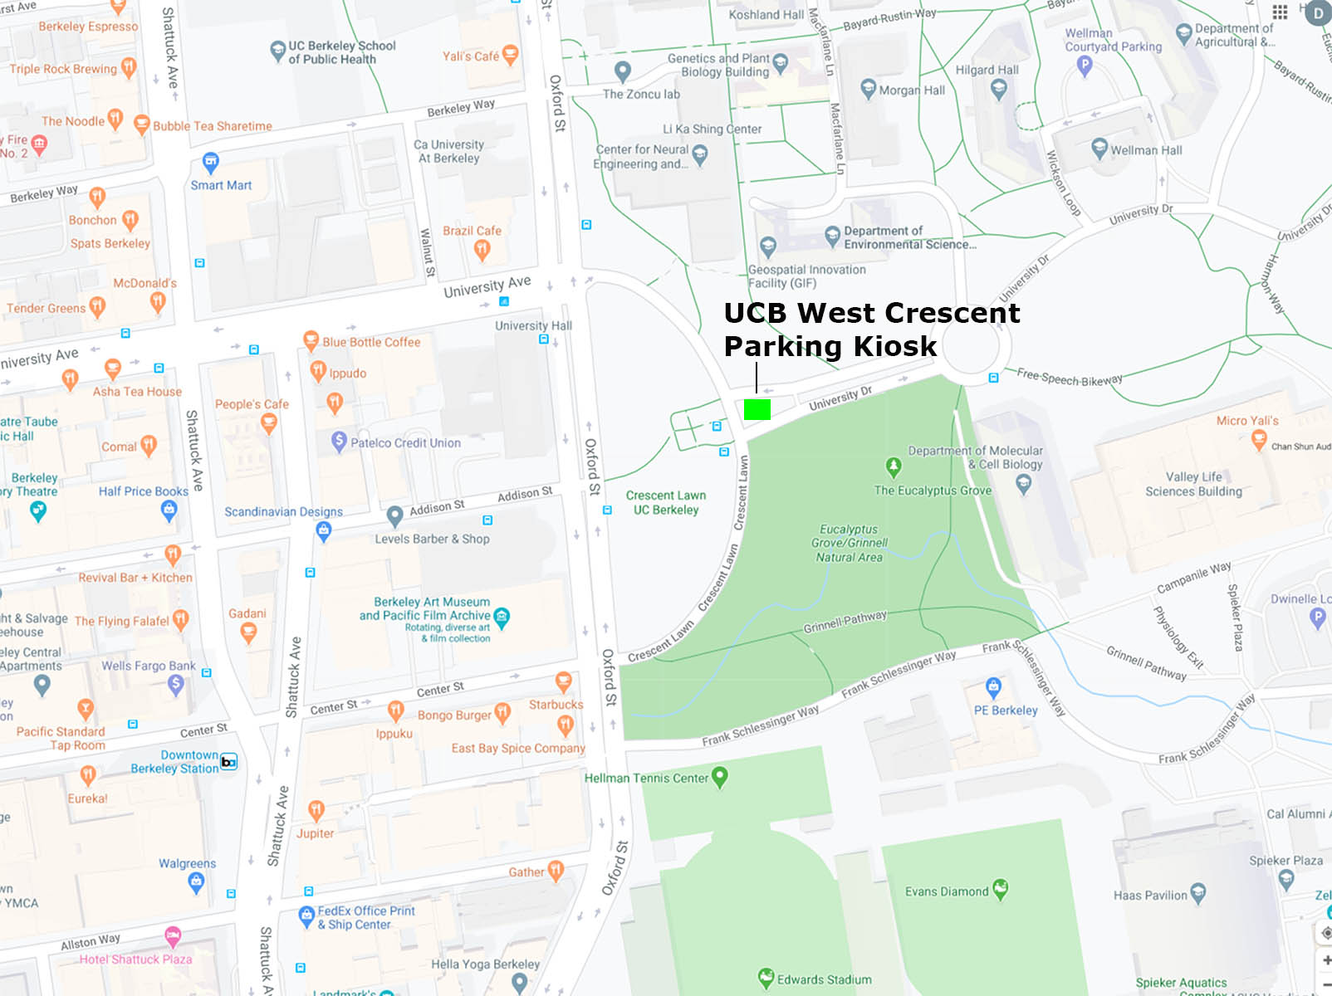
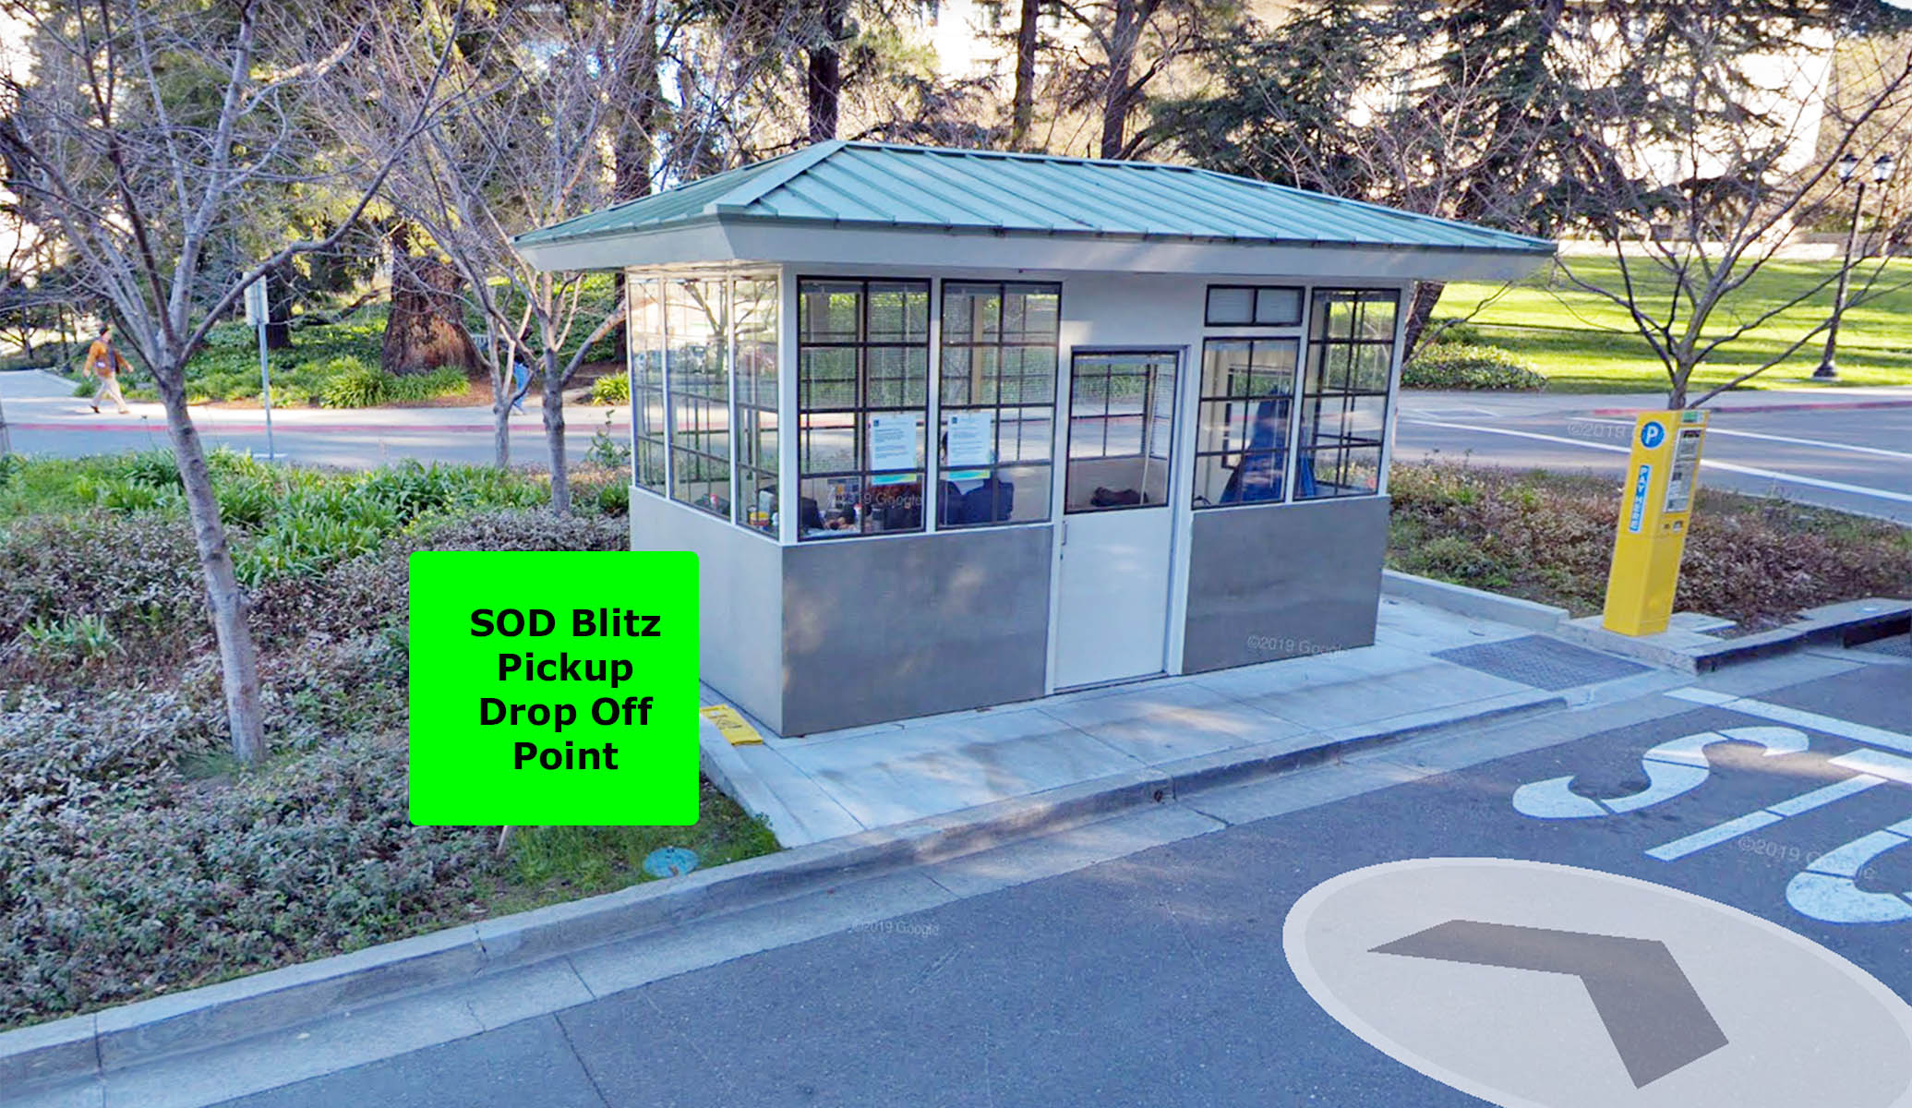

Doug Schmidt info@matteolab.org

The San Francisco Blitz
Tuesday, May 5th 9 am until Thursday May 7th 10 am
SOD Blitz Station located at the middle entry gate to Golden Gate Park Nursery, See map below

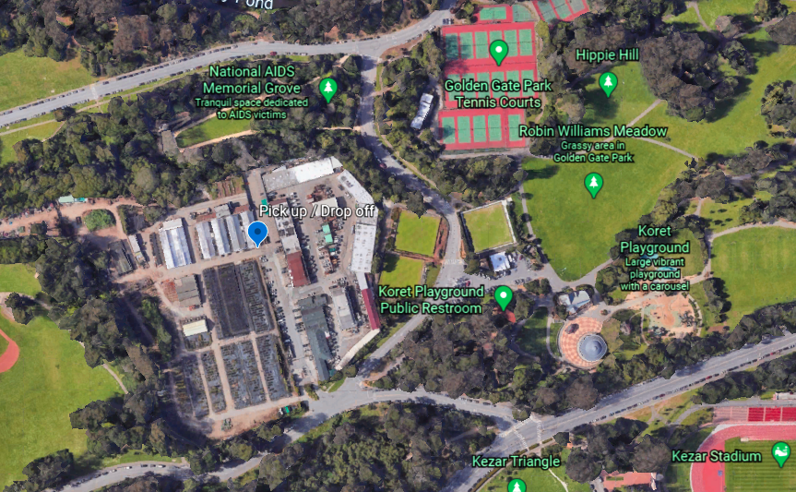

Contacts : Iribarne, David david.iribarne@sfgov.org
Conforti Christa: CConforti@presidiotrust.gov
Mia Ingolia, MIngolia@sfwater.org

The Sonoma and Kashia Blitzes
Saturday, May 2nd 10 am until Tuesday, May 5th, 10 am
Please do not return packets with samples to Blitz Station, but instead mail them to U.C. Berkeley using the preprinted mail labels and postage included in each packet.
Contact: Kerry Wininger kwininger@ucanr.edu
Registration Required: http://ucanr.edu/2020sodblitz

1) Sonoma State University's Galbreath Preserve (southeast Mendocino county)
SOD Blitz station location TBD
Saturday 5/2, 9-10am: Join our Zoom Q&A session; details sent upon registration
More information: cei.sonoma.edu/sod-blitz-galbreath-2020

2) Sonoma State University's Fairfield Osborn Preserve
*This is a bilingual event / Este es un evento bilingue*
SOD Blitz station location TBD / ubicación de la estación de eventos TBD
Sunday 5/3, 9-10am: Join our Zoom Q&A session; details sent upon registration / Únase a nuestra sesión de preguntas y respuestas de Zoom; detalles enviados al registrarse
More information / más información: cei.sonoma.edu/sod-blitz-osborn-2020

3) Petaluma
SOD Blitz station location TBD
Thursday 4/30, 6-7pm: Join our Zoom Q&A session; details sent upon registration

4) Cloverdale
SOD Blitz station location TBD
Saturday 5/2, 9-10am: Join our Zoom Q&A session; details sent upon registration

5) Tentative: Kashia Pomo tribal lands (private group)
Contact Kerry Wininger (email above) for more information

Week of May 2-9: the North Peninsula Blitz
Contact: Steve Epstein steve@burlingamehills.org

The Marin Blitz
Saturday, May 9th 10 am until Tuesday, May 12th, 10 am
SOD Blitz Station located outside the main entrance to the Science Building, 155 Palm Avenue, San Rafael. (Please approach via Acacia Avenue: walk through a little park and cross over a wooden bridge)
Contacts: Wolfgang Schweigkofler wolfgang.schweigkofler@dominican.edu
CNPS Marin Kristin Jacob kristinjakob@att.net

The San Luis Obispo Blitzes
Saturday, May 16th 10 am until Tuesday, May 19th 10 am
1)- SOD Blitz Station in front of the SLO County Department of Agriculture, 350 N Main St, Templeton, CA 93465.

2)- SOD Blitz Station in front of the SLO County Department of Agriculture, 2156 Sierra Way, San Luis Obispo, CA.
Contacts: Kim Corella Kim.Corella@fire.ca.gov
Cindy Roessler skaaantics@yahoo.com

May 19-22: The North Coast Blitzes, Humboldt & Del Norte
Date and location TBA
Contacts: Chris Lee christopher.lee@fire.ca.gov
Yana Valachovic yvala@ucanr.edu

The Peninsula SOD Blitz
Saturday, May 30th 10 am until Tuesday, June 2nd 10 am
SOD Blitz Station will be located in front of the Portola Valley Town Center, 765 Portola Rd.
Contacts: Debbie Mendelson sodblitz@gmail.com
LAH: Sue Welch sodblitz09@earthlink.net
MidPen Open Space: Coty Sifuentes csifuentes@openspace.org
Emerald Hills: Rochelle Kopp rnkopp@aol.com

The Santa Cruz Blitz
Saturday May 30th 10 am until Tuesday May 2nd^{th} 10 am
SOD Blitz Station at the front gate of the UCSC Arboretum. 1156 High St, Santa Cruz, CA 95064. Location: Google Map LINK and coordinates. 36°58'55.1"N 122°03'40.8"W
Contacts: Jon Detka jdetka@ucsc.edu & Brett Hall brett@ucsc.edu

The Carmel Valley, Big Sur and City of Monterey (new!) Blitzes
Saturday May 30th 10 am until Tuesday May 2nd^{th} 10 am
SOD Blitz Station located in front of Palo Corona Discovery Center (part of the Monterey Pe ninsula Regional Park District) 4860 Carmel Valley Rd, Carmel-By-The-Sea, CA 93923
Contacts: Kerri Frangioso kfrangioso@ucdavis.edu
Justin Prouty prouty@monterey.org

The Mendocino County Blitz
Saturday, June 6th 10 am until Tuesday, June 9th 10 am
Please do not return packets with samples to Blitz Station but mail them to U.C. Berkeley using the preprinted mail labels and postage included in each packet.
SOD Blitz Station will be in front of the Garden Store of the Mendocino Coast Botanical Gardens, 18220 North Highway 1, Fort Bragg, CA 95437
Contacts: Mario Abreu abreu@mcn.org
Michael Jones mjones@ucdavis.edu

