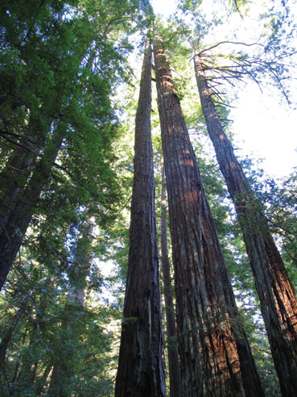
Climate Change Action Internship
Save the Redwoods League & Berkeley High School - March 2015

Make a difference in the environment by mentoring Berkeley High School (BHS) students on Climate Change and the Redwood Forest. Climate Change Action Interns will educate and support BHS students through a hands-on experience at Redwood Regional Park and lead them in creating their own Climate Change Action Projects focused on educating the community.

Requirements for interns:
- Feel comfortable in nature
- Interest in climate change education programs
- Attend all meetings and classes and complete project with Berkeley High School students
- Able to work independently to guide high school students to complete projects
Applications are due by 5PM on Wednesday, February 18 and can be found here: http://tinyurl.com/kjls7rs

Please reach out to jenny@berkeleyschoolsreport.com if you have any questions

- Interest and patience working with high school students
- Helpful but not required: A background in natural science

Interns will guide BHS students with the following:
- Create a vision and plan for their project
- Time management: Help the students determine what they can realistically achieve given the time and resources they have
- Complete their project
- Present their project to their class (potentially with outside guests invited)

Compensation: A $200 stipend will be given to interns upon successful completion of the internship

Schedule (approximately 25 hours during March 2015)
Interns must be able to participate in all required sessions.

Training for Interns by Save the Redwoods League
- Wed March 4, 5-7 PM, location TBD on UCB campus, Food provided; Initial training: An introduction of the Redwood Forest and internship responsibilities
- Saturday, March 7, 11am-1pm; meet at Chabot Space and Science Center, 11am-1pm (we will provide bus info; interns can also carpool after meeting on the prior Wed); We will walk to Redwood Regional Park where we’ll prepare for the field trip with the BHS students

Individual Research Conducted By Interns (approximately 3-5 hours)
In addition to the schedule below, interns will be responsible for conducting individual research in order to assist the BHS students with their Climate Change Action Projects. This may include (but not be limited to) researching the following:
  - Climate change curriculum
  - Organizations in the area that are working on climate change projects.
  - Possible projects they could lead with the students

Working with Berkeley High School students:
Interns must choose one BHS class period to work with and be present for that same class period for:
- Monday, March 9 and Tuesday, March 10: Two pre-field trip lessons (note the different times on Monday and Tuesday), led by Save the Redwoods League and assisted by interns
- The field trip (either Wednesday, March 11 or Thursday, March 12, depending on which group they select), led by Save the Redwoods League and assisted by interns
- Friday, March 13: One post-field trip lesson, led by Save the Redwoods League and assisted by interns
- Week of March 16-20: Five post-field trip lessons led by interns. Interns will work with small groups of BHS students to create their own Climate Change Action Projects focused on educating the community. Save the Redwoods League will not be participating on these days.

Specific dates/times for each BHS class period:
Interns join one class period for all sessions

Period 1 (Plan to arrive 15 minutes prior to start times)
- Monday, March 9, 9:57 AM-10:40 AM at BHS
- Tuesday, March 10, 8:27 AM-9:25 AM at BHS
- Wednesday, March 11, 8:00 AM-3:30 PM Field trip to Redwood Regional Park, meet at BHS
- Friday, March 13, 8:27 AM-9:25 AM at BHS
- Monday, March 16, 9:57 AM-10:40 AM at BHS
- Tuesday, March 17 – Friday, March 20, 8:27 AM-9:25 AM at BHS

Period 3 (Plan to arrive 15 minutes prior to start times)
- Monday, March 9, 11:40 AM-12:23 PM at BHS
- Tuesday, March 10, 10:40 AM-11:38 AM at BHS
- Wednesday, March 11, 8:00 AM-3:30 PM Field trip to Redwood Regional Park, meet at BHS
- Friday, March 13, 10:40 AM-11:38 AM at BHS
- Monday, March 16, 11:40 AM-12:23 PM at BHS
- Tuesday, March 17 – Friday, March 20, 10:40 AM-11:38 AM at BHS

Period 4 (Plan to arrive 15 minutes prior to start times)
- Monday, March 9, 1:09 PM-1:52 PM at BHS
- Tuesday, March 10, 12:24 PM-1:22 PM at BHS
- Wednesday, March 11, 8:00 AM-3:30 PM Field trip to Redwood Regional Park, meet at BHS
- Friday, March 13, 12:24 PM-1:22 PM at BHS
- Monday, March 16, 1:09 PM-1:52 PM at BHS
- Tuesday, March 17 – Friday, March 20, 12:24 PM-1:22 PM at BHS

Period 5 (Plan to arrive 15 minutes prior to start times)
- Monday, March 9, 1:58 PM -2:41 PM at BHS
- Tuesday, March 10, 1:28 PM-2:26 PM at BHS
- Thursday, March 12, 8:00 AM-3:30 PM Field trip to Redwood Regional Park, meet at BHS
- Friday, March 13, 1:28 PM-2:26 PM at BHS
- Monday, March 16, 1:58 PM -2:41 PM at BHS
- Tuesday, March 17 – Friday, March 20, 1:28 PM-2:26 PM at BHS

Period 6 (Plan to arrive 15 minutes prior to start times)
- Monday, March 9, 2:47 PM-3:30 PM at BHS
- Tuesday, March 10, 2:32 PM-3:30 PM at BHS
- Thursday, March 12, 8:00 AM-3:30 PM Field trip to Redwood Regional Park, meet at BHS
- Friday, March 13, 2:32 PM-3:30 PM at BHS
- Monday, March 16, 2:47 PM-3:30 PM at BHS
- Tuesday, March 17 – Friday, March 20, 2:32 PM-3:30 PM at BHS

