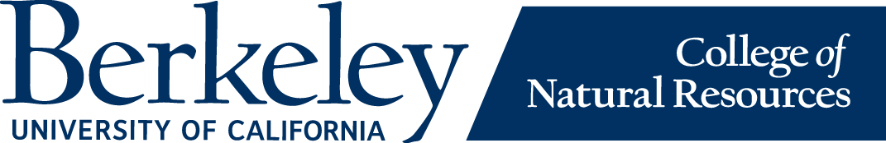

Wellness Wednesday

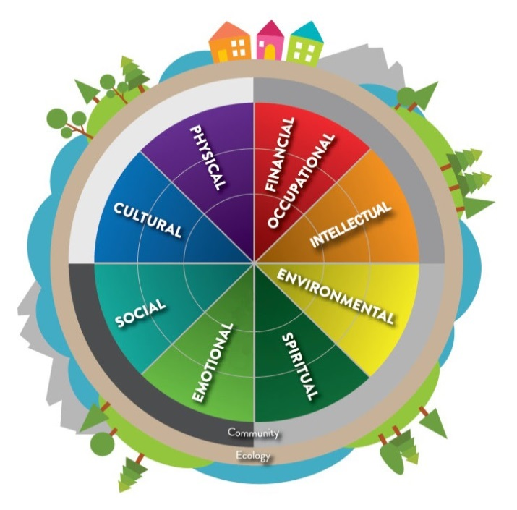
Emotional
Career Psychology, Career Library,
The Career Counseling Library is a unique collection of books, files, directories, and electronic resources staffed by a professional staff who will help you explore majors, careers, and graduate programs.
Counseling and Psychological Services,
CAPS offers short term counseling for personal, academic, and career issues. There is no charge to get started, and all registered students can access services regardless of insurance.
Harm Reduction, Substance Abuse
University Health Services offers specialized, confidential counseling services aimed at helping students strengthen coping skills, problem solve, and identify resources. Social Services counseling is open to all registered UC Berkeley students.
Sexual Assault/Confidential Advocates Office
The UC Berkeley PATH to Care Center leads the efforts to transform our campus into a community that is free of sexual violence, sexual harassment, intimate partner violence, and stalking through prevention, advocacy, training, and healing.
Personal and Academic Counseling through Educational Opportunity Program (EOP)
All EOP students are eligible to benefit from EOP’s Personal and Academic counseling, which helps students balance their personal responsibilities with the academic demands of UC Berkeley.
Student Health Workers (Dorms, Coops, UHS)
The Health Worker Program promotes healthy personal and residential community practices, including self-care, risk management, and use of health care services. Health Workers are student peer educators who live in the residence halls, fraternities, sororities, and the International House.
Student Advocates Office
The Student Advocate’s Office (SAO) is an executive, non-partisan office of the student government at UC Berkeley. They offer representation, help, and advice to any student or student group involved in a dispute with the University. All assistance is free and confidential.

Environmental and Social Eco-Systems
SERC,
The Student Environmental Resource Center at UC Berkeley cultivates a collaborative space to strengthen the collective effectiveness of the sustainability community, and provides resources for students to actualize their visions of a more equitable, socially just, and resilient future.
ASUC,
The ASUC Sustainability Team (STEAM) is an ASUC-sponsored organization at UC Berkeley aimed at making the campus more sustainable through the creation of and participation in project groups and their events.
ECO
UC Berkeley’s Environmental Council is a democratic and representative body consisting of appointed representatives and alternates from UC Berkeley’s Environmental and Sustainability Student Organizations.
Student Organic Garden, DECAL
The Student Organic Garden Association (SOGA) is a democratic student association of garden stewards and educators committed to sustainable organic gardening grounded in direct experience. Their mission is to establish continuity of maintenance and support for the Student Organic Garden year-round, in order to provide a creative thriving space for democratic hands-on education and food justice for students and the greater community.
UC Botanical Garden
The UC Berkeley Botanical Garden is a 34-acre garden and one of the most diverse landscapes in the world, with over 10,000 types of plants including many rare and endangered species. The UC Botanical Garden is free for UC Berkeley students with a Cal ID.
Rose Garden and Cordornices Park
UC Berkeley’s Historic Rose Garden is a regional destination with its 1,500 rose bushes and 250 varieties of roses, along with breathtaking views of the San Francisco Bay and the Golden Gate Bridge. Across from the garden is Codornices Park, complete with picnic areas, baseball/softball fields, multi-purpose turf, hiking trails, and more.
Tilden Park, Hiking and Swimming @ Lake Anza
Tilden Park is an expansive, 2,079 acre natural park that features hiking trails, a Botanic Garden, petting zoo, steam train, swimming at Lake Anza, and more.
Intellectual
Student Learning Center-Cesar Chavez Student Center
The Student Learning Center supports a global community of learners as they navigate the cultural expectations and academic rigor of UC Berkeley. Through honoring students’ diverse starting points and meeting them where they are, the SLC aims to empower all students to realize their full academic potential and aspirations.
Forestry and ESPM Seminars and Lecture Series
Expand your knowledge by attending a variety of the fantastic and interesting seminars offered by the ESPM Department throughout the semester!
Pre-Health Advisor Office hours held at Mulford
Meet with the Career Center Pre-Health Advisor Jo Scullion and Irma Moreno to better plan for the preparation process of applying to a health professional school and gain insight on what health professional schools would consider as a competitive applicant.
Strategies For Success Workshops Held at the Beginning of Every Semester
Each semester, the College of Natural Resources holds various Strategies for Success workshops aimed at helping all students achieve the most out of their UC Berkeley experience.
Pre-health Decal
The Pre-Health Decal is designed to help students at Cal gain a well-rounded insight into the possible pre-health professions that undergraduates can pursue through a survey of the health professions through lecture presentations and speakers.
Biology Scholars Program
The Biology Scholars Program at UC Berkeley is a program that challenges the “by the numbers” popular view about who can and should do science. The BSP allows members to successfully bridge their passion for science with their unique identities and perspectives to give back to their communities.
Greater Good Science Center
The Greater Good Science Center studies the psychology, sociology, and neuroscience of well-being and teaches skills that foster a thriving, resilient, and compassionate society.
Disabilities Student Program,
UC Berkeley’s DSP provides additional support and resources to over 1,600 undergraduate and graduate students with both visible and invisible disabilities. DSP helps students with disabilities navigate UC Berkeley by establishing a set of academic accommodations based on the needs of each individual student.

Physical
Recreational Sports Facilities (RSF) 6AM-11PM M-F, 8AM-11PM Sat-Sun
The RSF is the University’s largest, most complete fitness center with over 100,000 square feet of activity space, including an Olympic-sized swimming pool, 3 weight rooms, 7 basketball courts, 7 racquetball/handball courts, six squash courts, treadmills, elliptical trainers, stairmasters, rowing machines, and stationary bikes.
Backyard UCB Fire trails: Panoramic and Claremont Hills
Take a hike along the UC Berkeley fire trails and enjoy stunning views of the Bay Area, rock labyrinths, and a beautiful array of native California wildlife.
Cal Adventures
Cal Adventures offers instructional sailing, paddleboarding, windsurfing, sea kayaking, rock climbing, and rappelling classes, custom trips and day programs for UC Berkeley and the local community.
Oakland 5K/Half/Full Marathon March 22, 2020
Love to run? Register for the annual Oakland Running Festival and experience Oakland’s diversity and beauty with a race that touches all aspects of Oaktown, and finishes with a much deserved party!
Lake Merritt 3mi Loop
Enjoy the scenery of Oakland’s Lake Merritt with a stroll along its 3-mile bank. While you’re at it, check out some of the wonderful attractions along the loop, such as the Oakland Museum of California, Lakeside Park, the Lake Merritt Gardens, and more.
Nap PODS: Locations: Bechtal, Wurster, Tang, Moffitt, Tolman, RSF, Hildebrand)
The UC Berkeley REST Zones are available for students who need a break from studying. REST Zones are intended for brief naps of 40 minutes. No phones or laptops, please.

Social
Free Noon Concerts @ Hertz Music Hall
Featuring the Music Department’s varied and diverse performance activities, the Department of Music presents a series of free weekly concerts in Hertz Hall.
First Friday Art Walk and Live Music -Oakland
Oakland First Fridays is an immersive art and community experience on the first Friday of each month from 5:00pm to 9:00pm on Telegraph Avenue from West Grand to 27th Street. See Oakland’s KONO District spring to life with galleries, artist collectives, street artists, local culinary artisans, performers, and more.
Berkeley World Music Festival
The Berkeley World Music Festival strives to promote musical traditions as diverse as the people of the Bay, while cultivating the social value of the world’s music and cementing the Bay Area as a center for world music and artistic expression.
Redwood Grove Summer Concert Series
Enjoy a magical music experience under towering redwoods in the Berkeley Hills, every Thursday during June, July, and August.
Berkeley Events Page
Not sure how to spend your weekend or free afternoons? Check out the Berkeley events page for a wide selection of events happening every week!
Callink
Search student organizations and events. Connect with other students and build a sense of community.

Spiritual
East Bay Meditation Center
The EBMC is an independent center located in downtown Oakland. They offer meditation training and spiritual teachings from Buddhist and other wisdom traditions, with attention to social action, multiculturalism, and the diverse populations fo the East Bay and beyond.
People of Color Sangha
Every Thursday night the People of Color sangha gathers to meditation, share the teachings of liberation, and celebrate life.
Meditation Decals: Meditation, Happiness, Sufi, Integrative Med., Consciousness
Join one of UC Berkeley’s many meditation Decals for a chance to learn about various types of meditation, and to make space for your spiritual self-care.

Cultural
Multicultural Community Center
The Multicultural Community Center is a collaborative of offices and centers that advocate for, build capacity with and dialogue among and across diverse communities.
Student Development and Resource Centers @ Cesar Chavez Student Center: Cross-Cultural, African American, Chicana Latino, Asian Pacific American Gender Equity
Cross Cultural Student Development creates opportunities for students to design, implement, and participate in meaningful dialogue and engagement across cultural and community affiliations and supports the projects that these dialogues generate in the interest of collective thriving and flourishing.

Career/Financial
CNR Carroll Grant: Medical Expenses, Graduate School Prep Materials/Admissions
The Carroll Grant is available to Undergraduate EOP Students who are low-income and currently enrolled. Eligible students are able to apply to the Carroll Grant once a year, and may be awarded up to $500 for graduate school preparation.
Career Center Drop In’s/Appointments @ 260 Mulford
Connect with a CNR career counselor and find out about internships, careers, grad school, and more! Schedule your appointment at Mulford via Handshake.
Career Center Bancroft and Telegraph: Interview Prep, Resume Reviews, Networking
The UC Berkeley Career Center prepares current students and recent alumni to make informed decisions about their future by providing you with comprehensive resources, programs, and individualized services on career development, internships, employment, and graduate school.
Bears for Financial Success
Bears for Financial Success is a peer-to-peer financial wellness program housed in the Financial Aid and Scholarships Office and UC Berkeley. They offer workshops and one-on-one appointments to help students manage their personal finances in college and beyond.
Food Assistance Program
This program, which provides in-need students access to funds for nutritious foods, is available to non-CalFresh eligible students with financial need, and Cal Fresh eligible students in extreme need who have exhausted other funding options, including student loans.
UC Berkeley Food Pantry
The UC Berkeley Food Pantry is a direct response to the need among the student and staff population for more resources to fight food insecurity. The UC Berkeley Food Pantry was established to provide emergency relief to help students and staff at the University of California.
Cal Fresh Clinics
In partnership with the Alameda County Community Food Bank, the UC Berkeley Food Pantry offers CalFresh enrollment sessions to help students apply for CalFresh, a program which provides in-need students access to funds for nutritious food.

