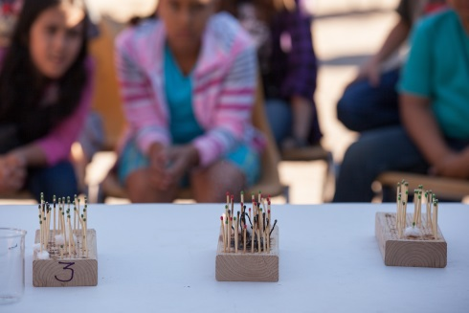
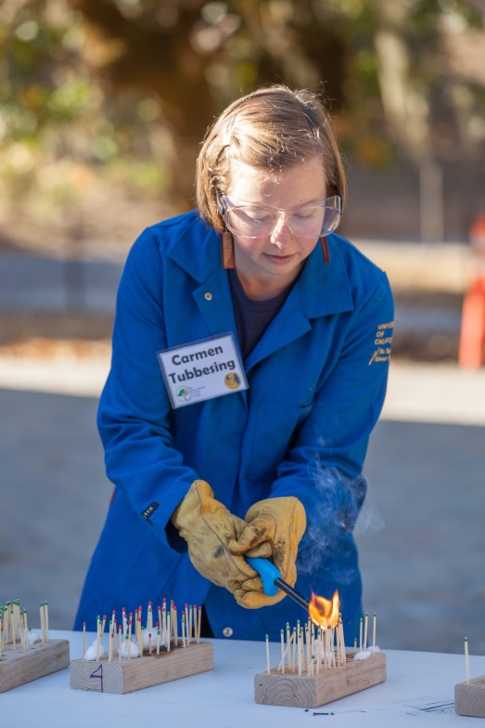
Density Burn Boards
Chris Pugh-Ukiah Daily Journal 2015

Chris Pugh-Ukiah Daily Journal 2015

Goal: To demonstrate and understand the influence of fuel density (aka tree density) on fire behavior

Fire intensity: Similar to a 30-year-old’s birthday cake

Space Requirements
- Indoor or outdoor
  - If outside, low wind conditions
  - If inside, open windows and potentially have fan
- Burn-proof table (or place fire blanket between boards and table)
- Participants 6ft back from table

Supplies
- Burn boards (enough for groups of 3-6)
- Matches (plenty, strike-on-box type)
- Cotton balls (surface/ladder fuels) – only if inside
- Water spray bottle
- Long-handled lighter
- Fan (optional)
- Glass loaf pan for extinguishing matches
- Water spray bottle for extinguishing matches
Personal Protective Equipment
- Protective goggles
- Nomex lab coat or jacket
- Leather gloves
- Long cotton/nomex pants
- Hard hat
- Fire extinguisher
- Fire blanket (optional, for protecting table)

Standard Operating Procedure
- Explain basics of fire behavior
  - Fire triangle
- How does density influence fire?
- Split kids into groups of 3-6 (at least 4 groups)
- Hand out matches (but not match striker) to groups of kids and ask them to make more/less dense forest
  - Emphasize that they are supposed to make the forest NOT light the matches – this usually isn’t a problem
  - Make sure kids are supervised so they don’t light the matches
- Collect the boards and bring them to the front
- Put on PPE and explain safety – DON’T TRY THIS AT HOME!
- Arrange them in order of density
- Ask kids which will the most trees survive
  - Where will some trees survive?
  - Where will all trees die?
- light boards, starting with least dense (if using cotton balls, light cotton)
- once all boards have been lit, talk about slope and wind – relight less dense forest and try to make fire move more with slope and wind (tip up and use fan/face it into ambient wind)
- Which board has tree densities like forests today?
- What did forests look like 100 years ago? Same?
- Show photos of same location past and present
- Do you think fires behave the same way now as they did in the past?
Video: https://youtu.be/sA2QoBPmbFk

