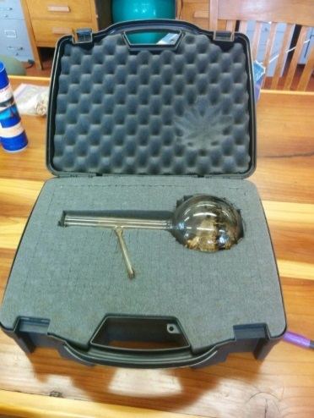

Pyrolysis

Goal: To demonstrate and understand the physics of fire – solid fuel is gasified with the application of heat and the gas itself burns

Fire intensity: Similar to a small fire without a flue

Space Requirements
- Outdoor recommended, unless fume hood available
  - Excellent outside demo outside unless wind is strong
  - If inside, must be under a fume hood
- Solid table
- Participants 5ft back from table

Supplies
- Camping stove & fuel
- Ring stand with clamp
- Distillation flask/flask with small outlet
- Wood shavings & funnel
- Lighter
- Tar catchment beaker
Personal Protective Equipment
- Protective goggles
- Nomex lab coat or jacket
- Leather gloves
- Long cotton/nomex pants
- Hard hat
- Fire extinguisher

Standard Operating Procedure
- Make sure distillation flask is empty of charred fuel

- Check distillation flask for any cracks/chips
- Make sure there is sufficient fuel for the demo (fuel canister not empty)
- Fill flask ½ way with wood shavings and cap with stopper
- Put on all PPE described above
- Set up flask on ring stand with stove underneath
  - Be sure there is no risk of flask tipping
    - Set up on flat, even surface
    - Make sure flask is not pulling ring stand over in a direction that is less stable
- Place drip catcher (small flask) directly under distillation tube (where pyrolyte will be exiting)
- Set up stove underneath flask
- Light stove
- Proceed with demo, making sure nobody gets too close
  - GLASS IS VERY HOT!
- When done, turn off stove, but leave it set up until it cools off naturally
- Empty out used fuel, and store back into padded protective box

