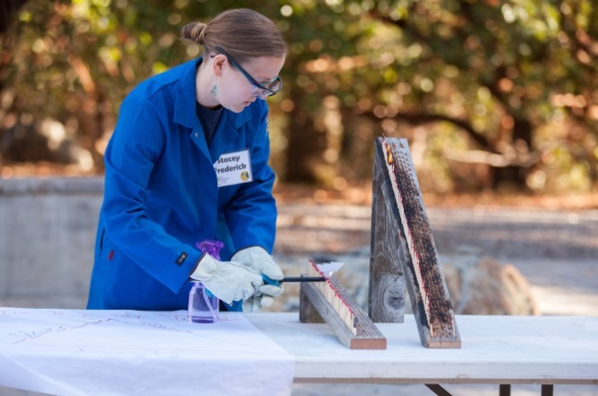
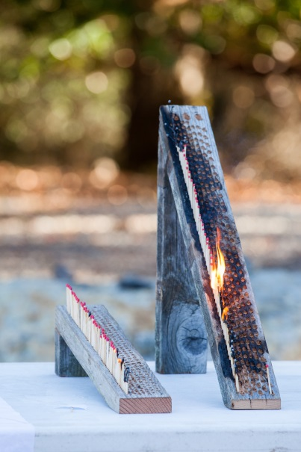
Chris Pugh-Ukiah Daily Journal 2015

Chris Pugh-Ukiah Daily Journal 2015

Sloped Burn Board

Goal: Explore the fire behavior triangle: To demonstrate and understand the influence of topography (slope) and weather (wind and precipitation) on fire behavior

Fire intensity: Similar to a 30-year-old’s birthday cake

Space Requirements
- Indoor or outdoor
  - If outside, low wind conditions
  - If inside, open windows and potentially have fan
- Burn-proof table (or place fire blanket between boards and table)
- Participants 6ft back from table

Supplies
- Sloped burn board – steep (45º) & shallow (15º)
- Matches (plenty)
- Paper tree attached to stick (use nametag stickers, fold over matchstick, cut out tree shape)
- Firesafe defensible space swag
  - Pamphlets for homeowners
  - Stickers
- Long-handled lighter
- Personal, battery-powered fan
Personal Protective Equipment
- Protective goggles
- Nomex lab coat or jacket
- Leather gloves
- Long cotton/nomex pants
- Hard hat
- Glass loaf pan for extinguishing matches
- Fire extinguisher
- Water spray bottle

Standard Operating Procedure
- Explain the fire behavior triangle – fuel, topography, and weather – what are examples of each?
- Put matches into board - Have a few sections if running back-to-back demos
  - If windy, make sure boards are facing into the wind (wind helping fire along)
- Put on full PPE and explain not to try this at home!
- Which tree will survive? - predict, then have fire “race” up the two slopes
- Burn the slope, use fan to blow fire, if necessary
- Use glass loaf pan/water spray to smother fire - ask “Why did this work to put out the fire?”
- Extinguish with spray bottle before matches burn too low for easy removal; ask “Why did this work to put out the fire?”
- Explain firesafe council and defensible space
- Hand out stickers and pamphlets
- Encourage kids to share with their parents
- Don’t scare them too much!
  - Emphasize protecting the house and not the risk of getting caught in the fire
Video: https://youtu.be/L_PzioASxZI

