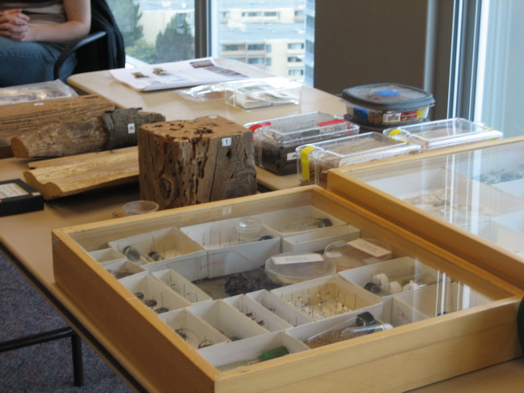
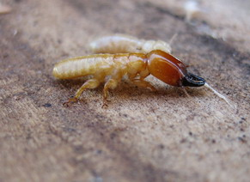
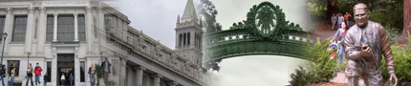
University of California, Berkeley
Urban Pest Management Center

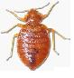
Enclosed is my unrestricted gift in support of the Dr. Vernard Lewis laboratory and urban pest management research. The check should be made payable to the UC Regents and is tax deductible.
$100 $250 $500 $1000 $_______________
From: |  | Mail To: | Dr. Vernard R. Lewis
 |  |  | c/o Robin L. Tabuchi
 |  |  | University of California, Berkeley
 |  |  | 1301 South 46th Street, Building 478
e-mail: |  |  | Richmond, CA 94804-4698

