Chapter 1: Review of Cydia (Lepidoptera: Tortricidae: Olethreutinae: Grapholitini)

Introduction

The moth family Tortricidae includes over 1,000 genera and nearly 10,000 named species distributed throughout all the continents except Antarctica . The only family in the superfamily Tortricoidea, Tortricidae is second only to the Gelechioidea in species diversity within the “microlepidoptera” grade . Tortricids are also numerically abundant in many habitats and are often important economic and ecological pests . For example, larvae of the spruce budworm complex (Choristoneura spp.) are well-known defoliators of conifer forests, creating wildfire hazards and reducing timber harvest and regeneration .
Likewise, the genus Cydia Hübner, whose larvae often bore into plant reproductive structures, includes several pests of agriculture and forestry. For example, the codling moth (Cydia pomonella Linnaeus) is a world-wide pest of apples, a $1.5 billion average annual production value crop in the U.S. from 1997-2003 . Larvae bore into the fruit of apples, pears, walnuts, and several other species, costing millions of dollars in monitoring and pesticide application in addition to lost yield. In 2009 in California alone, 186,000 acres of apples were treated with 469,000 pounds of pesticide . Because of their pest status, the biology and distribution of several Cydia species have been studied extensively . However, for many non-pest species, little biological information is available.
The purpose of this review is to summarize our current knowledge of the taxonomy, distribution, and biology of the genus Cydia. Recent collections of Neotropical tortricids indicate that many more Cydia species remain to be described (J.W. Brown & J.A. Powell, unpublished data), while several species currently included as Cydia may later prove to belong to other genera. Moreover, the biology of many species remains unknown and their importance in foodwebs and ecosystem function underappreciated. This review does not aspire to remedy these issues, but rather to provide an historical perspective on our understanding of this genus, a guide to navigating the taxonomic literature, and a foundation from which further coordinated studies of biology and ecology may be launched.
DIVERSITY & DISTRIBUTION
The genus Cydia includes 231 named species and subspecies distributed worldwide . The greatest diversity of known species is in the Holarctic, with ~113 species in the Palaearctic and ~56 species in the Nearctic (Figure 1). However, native species are also known from South America , Madagascar , the South Pacific , and other southerly locations . Habitats span boreal to tropical forest, and range from sea level to high elevation tree line. Most species are tightly coupled with their host plants, both in distribution and seasonality.
TAXONOMY & MORPHOLOGY
Species assigned to Cydia have a confusing history in both nomenclature and systematic classification . Since 1825, at least nineteen different genus names plus misspellings have been proposed for species currently assigned to Cydia (see below). Hübner proposed the genus Cydia (p. 375) to include pomonana Linnaeus (= Cydia pomonella (Linnaeus)), aspidiscana Hübner (= Eucosma aspidiscana (Hübner)), and monetulana Hübner (= Eucosma cana (Haworth)), but he did not designate a type species. In the same publication, Hübner proposed Laspeyresia (p. 381) to include stagnana Denis & Schiffermüller (= Rhopobota stagnana (Denis & Schiffermüller)), cinereana Haworth (= Epinotia nisella (Clerck)), and corollana Hübner (= Cydia corollana (Hübner)), with no type designations. Some authors have argued that Hübner’s (1825) Verzeichniss Bekannter Schmettlinge [sic] is not a valid systematic treatise, that his genera are “childish guesses,” and should “never be quoted as an authority for genera” .
Nonetheless, Hübner’s generic names were adopted by taxonomists and eventually designated by type species. The first restricted use of a Cydia species was by Kirby and Spence in reference to the larval mouthparts of Erminea pomonella (Linnaeus), thus making pomonella type species of Erminea by monotypy. However, Erminea was preoccupied by Erminea Haworth (Yponomeutidae), and therefore not available. It is unclear why Kirby and Spence used Erminea when referring to the figure of “les chenilles des pommes” from Réaumur , unless they were misapplying Erminea Haworth. Treitschke proposed the genus Carpocapsa to include pomonana L. and four other species with no type designation. Curtis subsequently designated pomonella as type species for Carpocapsa, and Walsingham designated pomonella as the type species for Cydia. Busck argued that Curtis’ type designation for Carpocapsa was the first (valid) restricted use of a genus name for pomonella and therefore has priority. But as Brown points out, Walsingham’s designation made Cydia and Carpocapsa objective synonyms, giving priority to the older name: Cydia.
Fernald designated aspidiscana Hübner as type for Cydia, and corollana Hübner as type for Laspeyresia Hübner, the first restricted use of Laspeyresia. Walsingham concluded pomonella and corollana were congeneric, thus making Cydia the senior synonym to Laspeyresia, Carpocapsa, and any subsequent genera proposed for species congeneric with C. pomonella. Adding further confusion, Fletcher listed Enarmonia Hübner (1825) as senior synonym to Cydia and Laspeyresia based partly on notes from Meyrick and Durrant , a synonymy followed by several workers in the early 20th century. However, Enarmonia is now considered a distinctly separate lineage from Cydia .
Although Obraztsov treated Cydia and Carpocapsa as junior synonyms of Laspeyresia, priority dictates that Cydia remain the senior synonym. Kuznetsov and Kerzhner petitioned the International Commission on Zoological Nomenclature to suppress Cydia in favor of Laspeyresia due to greater usage (ICNZ, 2000, article 23.9), which incited some debate , but no decision was rendered. Therefore, as a result of differing regional preferences, both Cydia and Laspeyresia (and to a lesser degree Carpocapsa) remained in common usage for species of Cydia into the 1970’s and 1980’s. Regardless of regional preferences, however, the above arguments are irrelevant because, as Walsingham indicated, Laspeyresia Hübner is preoccupied by Laspeyresia R.L. , a justified emendation of Laspeyria Germar , a genus of Noctuidae. Therefore, current workers follow Brown’s conclusion that Cydia is the proper generic name for pomonella and congeneric species.
The systematic history of Cydia has been equally confusing. Cydia belong to the monophyletic subfamily Olethreutinae which is characterized as Tortricidae with a single row of scales per antennal flagellomere (as opposed to two rows in most other Tortricidae); male with modified genitalia, including the fusion of the juxta and caulis into a single structure, absence of transtilla, and reduced gnathos; and hindwing usually with a cubital pecten or cluster of long hair-like scales along the base of the cubital vein (absent in most other Tortricidae) . Within the Olethreutinae, Cydia belong to the tribe Grapholitini Guenée 1845 . Heinrich’s concept of the subfamily Laspeyresiinae (≈ tribe Grapholitini), with hindwing veins M2 and M3 parallel and distant from each other, and male genitalia with uncus and socii absent or very reduced, was adopted by most workers for the tribe Laspeyresiini. This conception included Laspeyresia (= Cydia) plus 15 other Nearctic genera (Figure 2) and 14 Palaearctic genera (Figure 3). However, some genera currently placed within Grapholitini (e.g. Acanthoclita Diakonoff, Thaumatotibia Zacher, and some Cryptophlebia Walsingham) include species which have M2 base curved towards M3 (as in tribe Eucosmini), while some species placed within Olethreutini and Enarmoniini have venation consistent with typical Grapholitini . Horak and Brown considered these characters indicative of a polyphyletic grade rather than a monophyletic clade. Komai , however, proposed that males with abdominal sternite 8 shortened and posterior margin straight (versus sternite 8 as long as tergite 8 and posterior margin bilobed) is a synapomorphy uniting Grapholitini (Figure 4). For a more thorough discussion of the monophyly and diagnosis of Grapholitini see Komai & Horak .
While the general concept of Grapholitini has changed little since Heinrich , relationships among genera within Grapholitini have undergone many permutations. In Heinrich’s concept, Grapholita Treitschke was derived from Cydia, with Pammene Hübner as “a higher development” of Cydia (Figure 2). Following this concept, some British workers considered Grapholita a subgroup within Cydia. Komai , however, proposed three synapomorphies for a Cydia genus group, including Cydia, Leguminivora Obraztsov, Fulcrifera Danilevsky & Kuznetzov, Lathronympha Meyrick, Notocydia Komai & Horak, and Apocydia Komai & Horak; and two for a separate and distinct Grapholita genus group, including Grapholita and 31 other genera (Figure 4). For the Grapholita group Komai noted that all species possess a specialized scent organ (coremata) between abdominal segments 8 and 9, a character previously noted by other authors and discussed by Danilevsky and Kuznetsoz ; and male genitalia with tegumen strongly curved at its base. For the Cydia genus group, Komai noted that most species have male genitalia with sacculus ventral margin concave near base; male hindwing with anal fold; and male hindwing A3 close to anal edge . However, these characters are absent in several Cydia species, perhaps as secondary losses .
The genus Cydia can claim few, if any, synapomorphies . Hübner’s original description of Cydia, “Die Schwingen mit einem golden bezeichneten Eckfleck geziert” [wings with a golden distinct corner marking], referring to the light-colored ocellar patch near the “anal angle” of the forewing, has little diagnostic value. Danilevsky and Kuznetsov recognized two features consistent in most Cydia: males with hindwing vein A3 bordered dorsally by small glandular thecae or androconia (figure 5), and female corpus bursae with a diverticulum (figure 6), though the latter is found in some other Grapholitini genera . R.L. Brown (unpublished) also suggested the division of sternum VII of females into three sections by weakly sclerotized lines may represent another synapomorphy, although, like the two former characters, it is absent in several Cydia species. The lack of consistent synapomorphies across all species may be an indication that Cydia is polyphyletic, but may also be the result of secondary losses, particularly for secondary sexual characters that may be under selection. Although molecular data are not immune to the problems of homoplasy and secondary gains and losses, ongoing DNA sequencing efforts is it hoped will contribute new insights to the relationships among species and genera by adding new character systems to larger and combined morphological analyses (e.g. Oboyski Chapter 3).
As a taxonomic convenience and to aid in biological understanding of the genus, authors have divided Cydia into subgenera and/or species groups. Danilevsky and Kuznetsov divided the genus Laspeyresia Hübner into three subgenera, Endopisa, Laspeyresia (sensu stricto), and Kenneliola, based on secondary sexual characters and host preferences. According to their concept, Endopisa are associated with herbaceous plants, particularly legumes (Fabaceae); Laspeyresia with gymnosperms; and Kenneliola with woody angiosperms. Morphologically, species of the subgenus Endopisa have hindwing vein A3 located near the wing edge; males with small glandular androconia (thecae) along vein A3 and small, deciduous cornuti on the aedeagus; and females with the lamellae postvaginalis sclerotized and sometimes with a proximally-directed sharp protrusion, ostium with a sclerotized half-ring separated from the lamellae prevaginalis and converging on the lamellae postvaginalis, and with the ductus bursae weakly sclerotized. Species of the subgenus Laspeyresia have hindwing vein A3 not located near the wing edge; males without androconia along vein A3 and with (usually non-deciduous) cornuti on the aedeagus; and females with the lamellae postvaginalis heavily sclerotized, ostium sclerotized with a half-ring converging on the lamellae postvaginalis, and spines within the ductus bursae. And species of the subgenus Kenneliola have hindwing vein A3 not located near the wing edge; males do not have androconia along vein A3 and no cornuti on the aedeagus; and females have lamellae postvaginalis elongate and weakly sclerotized, ostium not encircled by a sclerotized ring, and ductus bursae without internal spines. However, these characteristics are neither unique to each group nor apparent in all members, making them of limited use in classification. Instead they may reflect a phylogenetic grade, or represent highly labile characters.
Bradley divided Cydia into four subgenera: Euspila, Grapholita, Coccyx, and Cydia sensu stricto, but made no indication of the characters used to separate each subgenus. Bradley’s Cydia sensu stricto includes species from all three of Danilevsky and Kuznetsov’s subgenera, while Bradley’s Coccyx and Euspila include one and four species, respectively, which are not included in Danilevsky and Kuznetsov (1968). Furthermore, most workers treat Grapholita as a separate genus rather than as a subgenus of Cydia . Therefore, few taxonomists have followed these subgeneric assignments. Similarly, some workers have designated species groups within Cydia , for species with similar biology and morphology, but these have not been widely adopted.

BIOLOGY
Host Plants
Cydia species have been recorded from at least 65 host-plant genera in 20 families (table 1). Although adults of both sexes of diurnal species visit flowers for nectar, those of nocturnal species are not known to do so. However, adult host records and effectiveness as pollinators have not been well documented. While larval host plants range from herbaceous and woody angiosperms to conifers , Cydia are not known to feed on grasses or ferns. Most species as larvae feed within generative tissues of plants such as seeds, fruits, flowers, apical buds, fleshy stems, and under bark (cambium). Consequently, many species are considered agricultural or ecological pests . The codling moth, Cydia pomonella, is a notorious pest of apples (Malus spp.), Pears (Pyrus spp.), and walnuts (Juglans spp.) in almost all regions where they are grown. The pea moth, C. nigricana (Fabricius), destroys the beans of many legume species including green (Pisum sativum) and sweet peas (Lathyrus odoratus). Other agricultural pests include the hickory shuckworm, Cydia caryana (Fitch), which bores into fruits of walnuts and hickory (Carya spp.), and the filbertworm, Cydia latiferreana (Walsingham), which infest filberts or hazel nuts (Corylus spp.), walnuts, and pomegranates (Punica granatum) as well as the acorns and cynipid galls of oaks (Quercus spp.) .
Several Cydia species are considered pests of forest ecosystems as well. The spruce seed moth, Cydia strobilella (Linnaeus), infests the seeds of several species of spruce (Picea spp.), and several species of pine seedworms, including Cydia piperana (Kearfott), infest the seeds of ponderosa and Jeffrey pines (Pinus spp.) . In Europe, the spruce bark tortrix, Cydia pactolana (Zeller) girdles small stems of Norway spruce (Picea abies), Cydia illutana (Herrich-Schäffer) infests the cones of several species of spruce and larch (Larix spp.), and the acorn moth, Cydia splendana (Hübner), infest the fruits of oaks, walnuts, and beech (Fagus spp.) .
While most Cydia species appear to be host specialists (monophagous or narrowly oligophagous), a few species, such as Cydia latiferreana and C. leguminana (Zeller) have a more catholic diet . This same propensity for host-plant specialization and feeding on reproductive structures makes some Cydia species attractive as potential biological control agents. For example, Cydia succedana (Denis and Schiffermüller) was successfully introduced into New Zealand for the control of gorse, Ulex europaeus , although some non-target feeding was observed .
Each Cydia species tends to specialize on a particular host substrate (i.e. seeds, flowers, under bark, etc.), although some species show plasticity in their substrate use. Comparing food resources among 78 Cydia species, Miller found that seeds provided higher crude protein than leaves, flowers, cambium, and other substrates, and adults of seed-feeding species are on average larger than species feeding on other substrates. Among seed-feeders, average adult moth size also was positively correlated with average seed size , even though some species are known to infest new seeds as old ones are depleted . Other species appear to take advantage of alternate substrates when primary substrates are unavailable. For example, Cydia walsinghamii (Butler) have been bred from seeds, twigs, and rust galls of Acacia koa in Hawaii . Cydia latiferreana, particularly in early summer, often are found in the large oak galls of Adricus quercuscalifornicus Bassett (Hymenoptera: Cynipidae) as well as oak acorns Similarly, C. “makai” [Oboyski mss.] typically feed within the seeds of Sophora chrysophylla in Hawaii, but on the island of Kauai where S. chrysophylla trees are few, stunted, and produce few seeds, larvae feed within apical buds (Oboyski Chapter 2).
Seasonality & Diapause
The life cycle of Cydia, particularly seed-feeding species, is often tightly correlated with the fruiting period of their host plants. ****
**** More on seasonality – overwintering, diapause, etc. ****
Predators & Control
Predators and parasitoids for some economically and ecologically important Cydia species are well known. For example, eggs of the codling moth, Cydia pomonella, are parasitized by species of trichogrammatid wasps, particularly Trichogramma platneri Nagarkatti , which may be massed released as part of integrated control programs . Codling moth larvae are parasitized by Hyssopus pallidus (Askew) (Hymenoptera: Eulophidae), **** . Overwintering larvae are subject to predation by birds, parasitism by Elodia morio (Fallen) (Diptera: Tachinidae), Pristomerus vulnerator Panz. (Ichneumonidae) and Ascogaster quadridentatus Wesm. (Braconidae) . Coccoon parasitoid Mastrus ridibundus (Ichneumonidae) [see Milles 2005]
of Wasps in the genus Pristomerus (Ichneumonidae) are endoparasitic koinobionts of several Cydia species.
**** Need to add compiled list of predators and parasitoids.
Pheromones and Kairomones
Female-produced sex attractant pheromones have been characterized for nearly 50 Cydia species . As with many Olethreutinae, the base component of most known Cydia female pheromones is a 12-carbon acetate chain, often with a double bond in the 8th, 9th, or 10th position (e.g. E8,E10-12Ac). For this reason there is often cross-reactivity in the field when only a generic formulation is used . Probably most pheromone bouquets contain a number of synergistic and/or antagonistic compounds that, in specific proportions, reduce interspecific reactivity . However, these adjuncts have been characterized for only a few Cydia species . For the most recent catalog of identified Cydia pheromones and literature references see www.pherobase.com and www.pherolist.slu.se/pherolist.php.
Tortricid pheromones are most commonly used for monitoring and mating disruption in agricultural systems . Monitoring crops with pheromones and kairomones can aid in calculating the timing and intensity of pesticide applications . Lure and capture traps use pheromones to reduce pest abundance, while mating disruption employs pheromone dispensers to saturate local areas with female sex pheromones that prevents males from finding mates .
In addition to their practical use in integrated pest management, pheromones offer a great opportunity for ecological and evolutionary research. As a mate recognition system, pheromones offer an independent character set for the identification of species to complement genitalia characters, which are often simplified and reduced in the Grapholitini. Combined with a well-resolved phylogeny, pheromones can further elucidate patterns and processes of speciation . For example, one might expect that closely related species in geographic proximity would experience character displacement in the form of pheromone bouquet differences that prevent hybridization or introgression, compared to species that are not likely to interact due to geographic isolation.
Male tortricid pheromones, however, are less well-known. Secondary sexual structures in Lepidoptera are often used in courtship . In the Tortricidae these include modified scales within forewing costal folds, hindwing anal folds and cubital pouches, abdominal coremata, and leg hair pencils . Male Cydia species in particular often have the anal margin of the hindwing curled dorsally (anal roll) enclosing modified scales (Figure 8) presumed to be associated with pheromone dispensing . In other Cydia species (particularly C. latiferreana (Walsingham), C. maackiana (Danilevsky), and most Hawaiian species, and to a lesser extent C. pomonella and C. caryana (Fitch)), a dorsally-opening ventral pouch below the cubital vein encloses modified pectin scales (Figure 9). However, the chemical signatures of the pheromones dispensed by these scales have not yet been characterized.
Host plant volatiles, particularly those from ripening fruits, are known to attract Cydia moths . For codling moth, host plant esters, sesquiterpenes, and other volatiles from apple, pear, and walnut aggregate moths for mating and oviposition , as well as attract neonate larvae to fruits . Some of these volatiles also have been successfully used in monitoring and calibrating pesticide application schedules . Likewise for Cydia strobilella, α-pinene and related compounds from spruce cones elicit antennal responses from both male and female moths . While it is clear that host volatiles are involved in host plant seeking, host acceptance, and mate seeking, the particular host kairomone components that elicit responses for most Cydia species are yet to be documented.

Discussion
There appears to be no single morphological character or combination of uniquely derived characters that can be found in all species of Cydia. There are several possibilities for this: 1) Cydia is polyphyletic, 2) Cydia represents a grade of evolutionary development, 3) Synapomorphies include highly labile sexual characters that have been gained and lost secondarily within several species groups, or 4) Incomplete lineage sorting has resulted in the inclusion of characters found in related genera. Therefore, new character systems, such as genomic data, pheromones, and **** are needed to support or challenge current morphological systematics and to further resolve inter- and intrageneric relationships.
Due to the pest status of many Cydia species, continued research on several fronts, including ecology, behavior, physiology, genomics, and phylogenetic relationships, is critical. Although biological research on prominent pests, such as the codling moth, have provided great insights into development, diapause, and chemical communication, little is known about the biology of most species. ****
**** Future needs – more information (biology, ecology, distribution, phylogenetic relationships) on non-pest species needed to understand evolutionary patterns, host-plant relationships, diapause conditions, etc. and to predict potential future pests ****

Annotated Taxonomy

Journal abbreviations
Hist. nat. gen. part. crustacés, insects Histoire naturelle générale et particulière des crustacés et des insectes,tome3
Trans. Entomol. Soc. London Transactions of the Entomological Society of London
Ann. Soc. Entomol. Fr. Annales de la Société Entomologique de France
Gen. gr. Tortr. Lep. Br. Is. Genitalia of the group Tortricidae of the Lepidoptera of the British Islands
U.S.N.M. Bull. United States National Museum Bulletin (Smithsonian Institution)
Z. Wien. Entomol. Ges. Zeitschrift der Wiener Entomologischen Gesellschaft
Verz. bek. Schmett. Verzeichniss bekannter Schmettlinge
Intro. Entomol. An introduction to entomology: or Elements of the natural history of insects
Schmett. Eur. Die schmetterlinge von Europa
Nom. Br. Insects The Nomenclature of British Insects

Family: Tortricidae
Tortrices Latrielle 1803. Hist. nat. gen. part. crustacés, insects:415.

Subfamily: Olethreutinae Walsingham
Olethreutinae Walsingham 1895. Trans. Entomol. Soc. London 1895(4):500.

Tribe: Grapholitini Guenée
Grapholithidi Guenée 1845. Ann. Soc. Entomol. Fr. (2)3:169.
Ephippiphoridii Pierce & Metcalf 1922. Gen. gr. Tortr. Lep. Br. Is.:xxi, 74.
Lipoptychidii Pierce & Metcalf 1922. Gen. gr. Tortr. Lep. Br. Is.:xxi, 93.
Laspeyresiinae Heinrich 1923. U.S.N.M. Bull. 123:10. Razowski pointed out that because its type genus, Laspeyresia Hübner is a junior homonym of Laspeyresia R. L., it is invalid and proposed the use of Grapholitini based on the oldest family group name, Grapholithidi Guenée 1845.
Laspeyresiini Obraztsov 1946. Z. Wien. Entomol. Ges. 30: 23.

Genus: Cydia Hübner
Cydia Hübner . Type species: Phalaena (Tortrix) pomonella Linnaeus , by subsequent designation by Walsingham .
Laspeyresia Hübner . Type species: Tortrix corollana Hübner , by subsequent designation by Fernald . Laspeyresia Hübner preoccupied by Laspeyresia R. L. [author “R. L.” unknown], an emendation of Laspeyria Germar (Lepidoptera: Noctuidae). Laspeyresia sensu Hübner a junior subjective synonym of Cydia Hübner . Conservation of Laspeyresia Hübner proposed to ICZN by suppression of Cydia Hübner due to common usage – no decision rendered.
Erminea Kirby and Spence . Type species: Phalaena pomonella Linnaeus , by monotypy. Erminea Kirby and Spence preoccupied by Erminea Haworth . Erminea pomonella (Linnaeus) Kirby & Spence a junior objective synonym of Cydia pomonella (Linnaeus) .
Semasia Stephens . Type species: Phalaena pomonella Linnaeus , by subsequent designation by Fernald . Semasia pomonella (Linnaeus) Stephens a junior objective synonym of Cydia pomonella (Linnaeus) .
Coccyx Treitschke . Type species: Tortrix strobilana Hübner [1799]:pl. 12, fig. 70 (an emendation of Phalaena strobilella Linnaeus 1758:539), by subsequent designation by Desmarest . [Phalaena] tedella Clerck, 1759:plate 10, figure 13, later designated as type species for Coccyx by Fernald, 1908:****. Coccyx Treitschke a junior subjective synonym of Cydia Hübner .
Carpocapsa Treitschke . Type species: Phalaena pomonella Linnaeus , by subsequent designation by Curtis . Carpocapsa pomonella (Linnaeus) Treitschke a junior objective synonym of Cydia pomonella (Linnaeus) .

Strobila Sodoffsky 1837:92. An unnecessary replacement name for Coccyx Treitschke. Strobila Sodoffsky preoccupied by Strobila Sars (Coelenterata).
Carpocampa Harris . An unnecessary emendation of Carpocapsa Treitschke.
Cerata Stephens . Type species: Penthina servillana Duponchel , by (virtual) monotypy. Cerata Stephens a junior subjective synonym of Cydia Hübner (CITE previous?).
Melissopus Riley . Type species: Carpocapsa latiferreana Walsingham , by monotypy. Melissopus Riley a junior subjective synonym of Cydia Hübner (CITE).
Melisopus Riley . Misspelling of Melissopus Riley.
Mellisopus Fernald . Misspelling of Melissopus Riley.
Melliopus Packard . Misspelling of Melissopus Riley.
Adenoneura Walsingham . Type species: Adenoneura falsifalcellum Walsingham , by original description. Adenoneura Walsingham a junior subjective synonym of Cydia Hübner .
Mellissopus Fernald . Misspelling of Melissopus Riley.
Crobylophora Kennel . Type species: Tortrix inquinatana Hübner [1799]:pl. 8, fig. 43, by original description. Crobylophora Kennel preoccupied by Crobylophora Meyrick 1880:177 (Lepidoptera: Lyonetidae). Crobylophora sensu Kennel a junior subjective synonym of Cydia Hübner (Bradley et al. 1972 CITE previous?).
Hedulia Heinrich, 1926:6, 65. Type species: Hedulia injectiva Heinrich, 1926:65, by original description. Hedulia Heinrich a junior subjective synonym of Cydia Hübner (Bradley et al. 1972 CITE previous?).
Lasperesia Wu 1938:57. Incorrect spelling of Laspeyresia Hübner.
Kenneliola Paclt 1951:127. Type species: Tortrix inquinatana Hübner [1799]:pl. 8, fig. 43. as replacement name for Crobylophora Kennel. Kenneliola Paclt is a junior subjective synonym of Cydia Hübner (Bradley et al. 1972 CITE previous?). Kenneliola Paclt also a subgenus of Laspeyresia (= Cydia) .
Lespeyresia Gozmany 1957:133. Incorrect spelling of Laspeyresia Hübner.
Pseudotomoides Obraztsov 1959:200. Type species: Phalaena strobilella Linnaeus 1758:539, by original designation. Pseudotomoides Obraztsov a junior subjective synonym of Cydia Hübner (Bradley et al. 1972 CITE previous?).
Erminia Obraztsov 1959:175. Incorrect spelling of Erminea Kirby and Spence.
Crobilophora Obraztsov 1959:176. Incorrect spelling of Crobylophora Kennel.
Collicularia Obraztsov 1960:134. Type species: Catoptria microgrammana Guenée 1845:188, by original designation. Collicularia Obraztsov a junior subjective synonym of Cydia Hübner (CITE).
Phanetoprepa Obraztsov 1968:236. Type species: Phanetoprepa agenjoi Obraztsov 1968:237 [= Cydia strigulatana (Kennel)], by original designation. Phanetoprepa Obraztsov a junior subjective synonym of Cydia Hübner (Baixeras & Dominguez 1994).
Danilevskia Kuznetsov 1970:446. Type species: Danilevskia silvana Kuznetsov 1970:446, by original designation. Danilevskia Kuznetsov a junior subjective synonym of Cydia Hübner (CITE).
Dicraniana Diakonoff 1984:162. Type species: Semasia seriana Kennel 1901:270 [= Cydia strigulatana (Kennel)], by original designation. Originally proposed as a subgenus of Cydia Hübner. Dicraniana Diakonoff a junior subjective synonym of Cydia Hübner (Baixeras & Dominguez 1994 CITE previous?).
[Genus Endopisa Guenée 1845:182 considered a junior subjective synonym of Cydia Hübner based on the type designation Pyralis nigricana Fabricius by Fernald 1908:****. However, as Brown (1979) points out, Grapholitha nebritana Treitschke is the earliest type designation for Eudopisa Guenée, a misspelling of Endopisa, by Desmarest, 1857. Therefore, Endopisa Guenée a junior subjective synonym of Grapholita Treitschke, not Cydia Hübner.] ****
Table 1. Host plants of Cydia.

Family | Genus | Plant Part
Aceraceae | Acer | cortex
 |  | seeds
Araucariaceae | Araucaria | cones
 |  | cortex
Arecaceae | Coccothrinax | seeds
Betulaceae | Betula | cortex
 | Corylus | fruits
 | Populus | cortex
Boraginaceae | Cordia | stems
Cupressaceae | Cryptomeria | seeds
 | Cupressus | cortex
 | Juniperus | sapwood
Fabaceae | Abrus | seeds
 | Acacia | cortex
 |  | flowers
 |  | rust galls
 |  | seeds
 |  | twigs
 | Adenocarpus | seeds
 | Bauhinia | cortex
 | Butea | stems
 | Canavalia | seeds
 |  | stems
 | Cassia | flowers
 |  | seeds
 | Cytisus | seeds
 | Genista | seeds
 | Lathyrus | seeds
 | Lotus | seeds
 | Lupinus | seeds
 | Lysiloma
 | Maackia | seeds
 | Medicago | seeds
 | Ononis | seeds
 | Oxytropis | seeds
 | Parkinsonia | seeds
 | Pisum | seeds
 | Pithecellobium | seeds
 | Pongamia | seeds
 | Prosopis | seeds
 | Retama | seeds
 | Sarothamnus | seeds
 | Sesbania | seeds
 | Sophora | seeds
 | Strongylodon | seeds
 | Ulex | seeds
 | Vicia | seeds
Fagaceae | Castanea | fruits
 | Fagus | cortex
 |  | fruits
 | Juglans | fruits
 | Quercus | fruits
Juglandaceae | Carya | seed husk
 | Juglans | seed husk
Lythraceae | Punica | fruits
Moraceae | Ficus | fruits
Nitrariaceae | Peganum | flowers
Ochnaceae | Ochna | foliage
Oleaceae | Fraxinus
Pinaceae | Abies | cone
 |  | cortex
 | Larix | cones
 |  | cortex
 |  | twigs
 | Picea | cones
 |  | cortex
 |  | Stems
 | Pinus | cortex
 |  | Dioryctria galls
 |  | Petrova galls
 |  | Retinia tunnels
 |  | seeds
 | Pseudotsuga | cortex
Rosaceae | Cydonia | fruits
 | Malus | fruits
 | Prunus | fruits
 | Pyrus | fruits
 | Rosa | Diplolepis galls
 | Sorbus | fruits
Salicaceae | Salix | dipterous galls
 |  | twigs
Sapondaceae | Dodonaea | fruits
Theaceae | Camellia | foliage
Ulmaceae | Ulmus | cortex

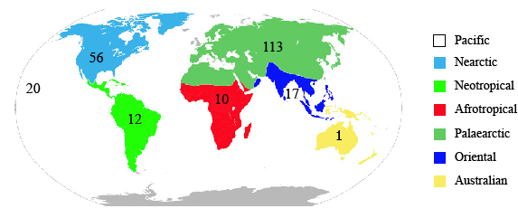
Figure 1. Zoogeographic regions and numbers of Cydia species. Numbers of species per region based on type localities and other published distribution records.

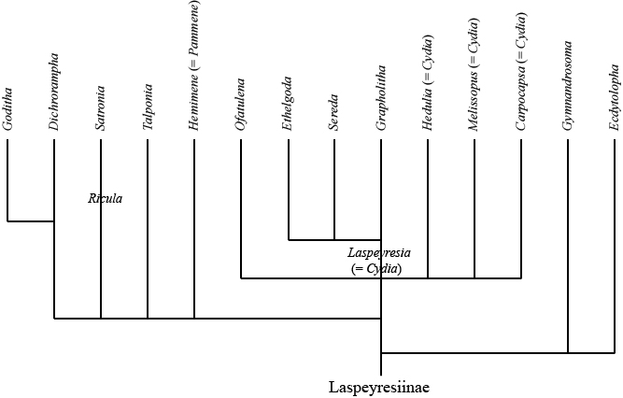
Figure 2. Phylogenic tree of Nearctic Laspeyresiinae (≈ Grapholitini) redrawn from Heinrich . Note that Sereda and Ethelgoda are derived from Grapholita, which is derived from Laspeyresia (= Cydia), while Hemimene (= Pammene) constitutes a “higher development” of Laspeyresia .

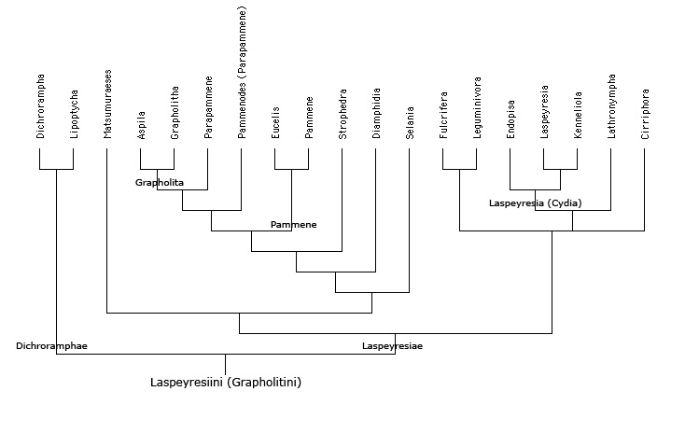
Figure 3. Phylogenic tree of Palearctic Laspeyresiinae (≈ Grapholitini) redrawn from Danilevsky & Kuznetsov . Note that Cydia is divided into three subgenera and fits within the subtribe of Laspeyresiae.

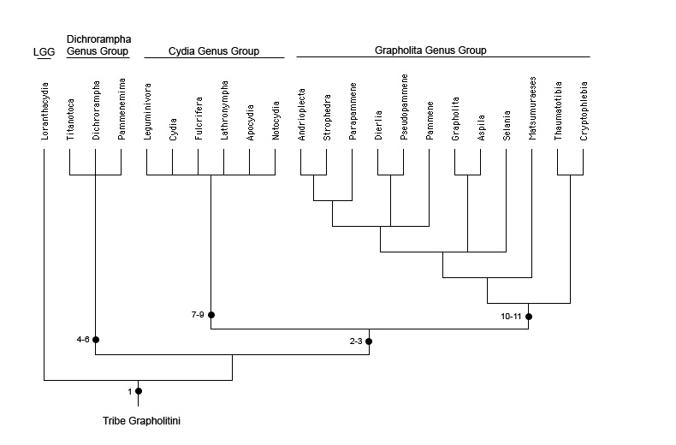
Figure 4. Cladogram of (palaearctic) Grapholitini redrawn from Komai . Mapped apomorphic character as follows: 1. S8 in male shortened with posterior margin straight (vs. posterior margin bilobed), 2. Bulbus ejaculatorius crescent-shaped (vs. fist-shaped), 3. Corpus bursae with diverticulum (vs. without), 4. Rs and M1 of hindwing separate and parallel (vs. approximate at base), 5. Forewing with row of dots along termen (vs. without), 6. Sterigma, 7th sternite, and sclerotized section of ductus bursae fused (vs. not fused), 7. Ventral margin at base of sacculus concave (vs. smooth/straight), 8. Male hindwing with anal fold (vs. without), 9. Male hindwing vein 3A close to anal edge (vs. distant), 10. Tegumen base (pedunculus) strongly curved (vs. straight), 11. Coremata present between 8th and 9th segments of male abdomen (vs. absent).

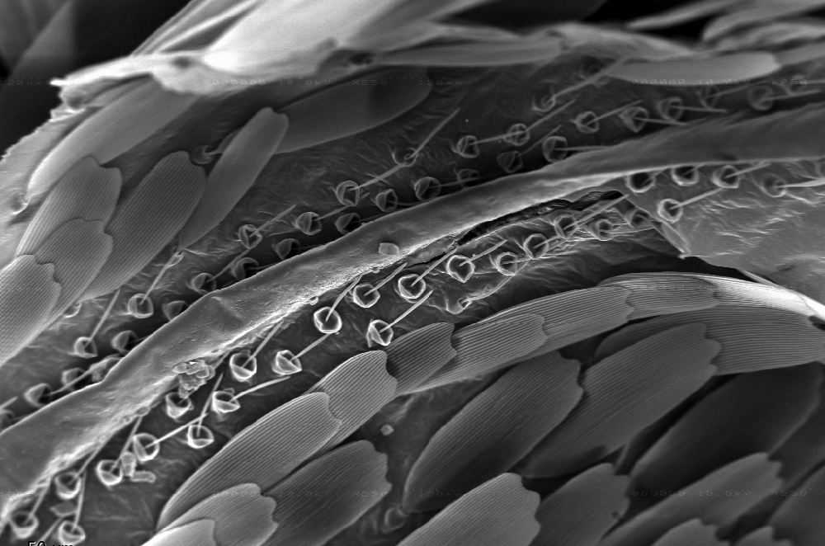
Figure 5. Thecae (andriconial scales) lining either side of vein A3 in male hindwing of Cydia latiferreana (Walsingham).
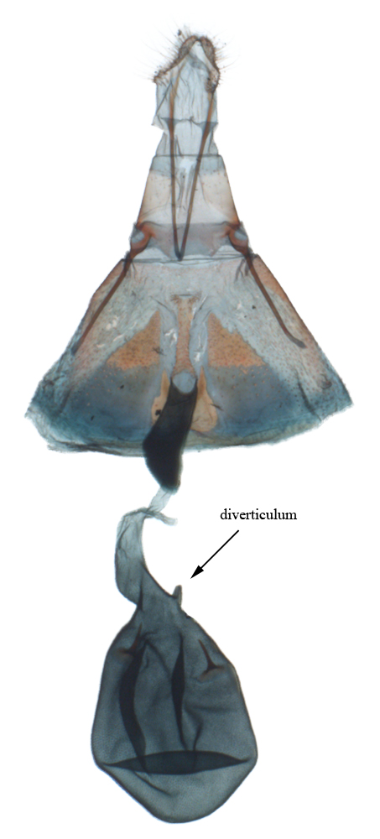
Figure 6. Female genitalia of Cydia plicata (Walsingham 1907). Membranous and lightly sclerotized tissues stained blue-black by Cholorsol-E black, more heavily sclerotized tissues stained red with Eosin-Y. Diverticulum of bursa copulatrix indicated by arrow. Oboyski slide pto-s143.

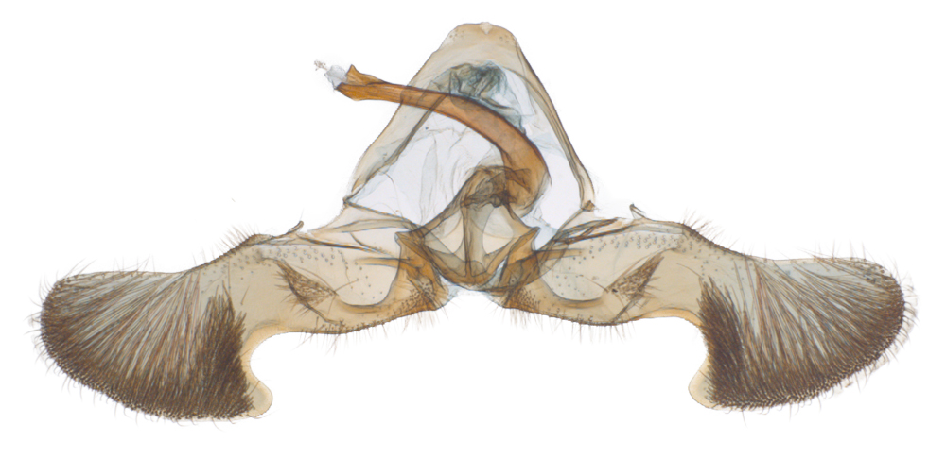
Figure 7. Male genitalia of Cydia hawaiiensis Oboyski. Oboyski slide pto-s302.
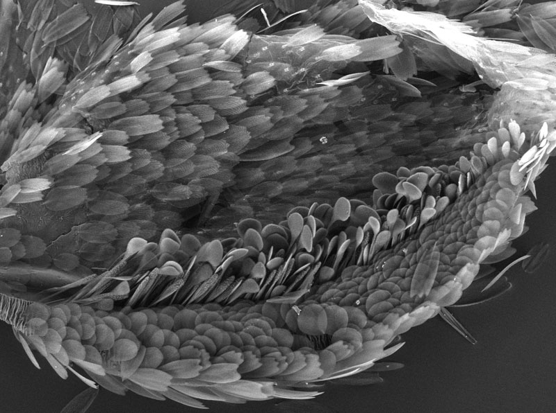
Figure 8. Hindwing “anal roll” of Cydia latiferreana. The dorsal curl of the anal margin encloses phylliform and fusiform scales probably associated with pheromone dispensing.

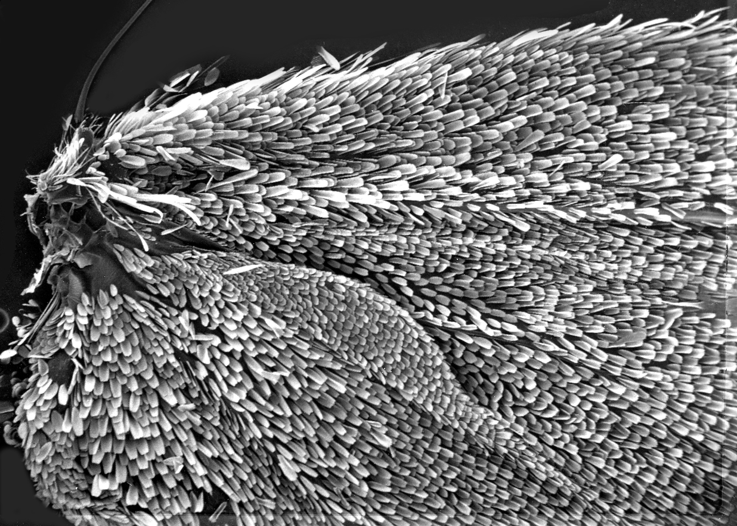
Figure 9. Hind wing pouch of Cydia latiferreana. Ventral view of male hindwing showing elongate pouch cloaked in smaller scales than the rest of the wing surface. The pouch opens dorsally and encloses modified pectin scales.
References Cited

