CHAPTER 3

Host-plant shifts and interisland dispersal in the evolution

of Hawaiian Cydia Hübner (Lepidoptera: Tortricidae)

ABSTRACT

What drives diversification and speciation is a central topic of biodiversity research. Geographic isolation is thought to be one of the most important factors leading to new species formation, although renewed interest in ecological speciation has led to convincing evidence that niche partitioning and symbiotic relationships can play an equally important role in speciation in some biological systems. To evaluate the relative importance of geography and ecology in diversification I mapping the distribution and host-plant affinities of 14 species of Hawaiian Cydia moths on a molecular phylogeny constructed from nuclear and mitochondrial genes. The genus Cydia is represented by a monophyletic clade of at least 21 endemic species distributed throughout the Hawaiian Islands and feed on endemic plants in the family Fabaceae. I show that diversification of this genus in Hawaii is associated with host-plant shifts followed by dispersal to similar niches on other islands. I also show that Cydia pseudomalesana Clarke in French Polynesia is a separate colonization of the Pacific from the Hawaiian species, stemming from the Austral-Asian region. The origins of Hawaiian Cydia remain obscured although they appear most closely related to species in the Holarctic region.

INTRODUCTION

The relative influence of geographic isolation and ecology in the diversification of lineages has long been debated, but has been recently rekindled through renewed interest in ecological speciation . Host plants of phytophagous insects, in particular, can act as aggregation sites for mating, facilitate differential developmental rates and success among populations, and result in genetic differentiation through adaptive selection or genetic drift . More often, however, differentiation among populations of phytophagous insects probably is caused by a number of interacting factors including ecological opportunity, competitive displacement, specialization, sexual selection, and reproductive success, as well as the geographic structure of populations that can minimize gene flow . As molecular tools for identifying population structure continue to expand and improve, the nexus of ecology and geography in promoting speciation are becoming better understood. However, much of our understanding is based on a limited number of model systems.

Remote island ecosystems offer a fertile laboratory for contrasting the role of ecology and geography in speciation because of their discrete geographic units and the endemic radiations often found on them. The Hawaiian Islands are home to some 6000+ native insects and spiders that are thought to have diversified from only 233-400 independent colonizations . While some genera, such as Drosophila flies and Hyposmocoma moths , have diversified extraordinarily from one or few initial colonizers, others such as Manduca moths and Vanessa butterflies are known by only a single endemic species . Moreover, entire families of insects that are widespread and common on continents, such as ants, hover flies, and ladybird beetles, have no native representatives in Hawaii . While contingency probably has played an important role in the establishment of new lineages, the extreme isolation of the Hawaiian Archipelago likely is responsible for the lack of many taxonomic groups, attenuation of others, and fostering of the spectacular radiations for some of those fortunate enough to reach Hawaii .

Of the 20 families of moths with native species in the Hawaiian Islands, the cosmopolitan and species-rich family Tortricidae is represented by eleven native and eight wholly non-native genera . The eight non-native genera, (Acleris, Amorbia, Bactra, Epiphyas, Episimus, Lorita, Platynota, and Strepsicrates), include both accidental introductions and purposefully released biological control agents . Of the eleven genera having native species, eight are endemic to Hawaii (Eccoptocera, Macraesthetica, Mantua, Nuritamburia [formerly Bradleyella ], Panaphelix, Paraphasis, Pararrhaptica, and Spheterista). Of the three remaining tortricid genera in Hawaii, Cryptophlebia includes one putatively native and one non-native species, Crocidosema includes three endemic species, and the genus Cydia, although it includes many widespread pests of legumes and conifers, is known only from 21 endemic species in Hawaii .

Hawaiian Cydia (Grapholitini) is distributed across all the high islands from shoreline to tree line and feed in the generative tissues of legumes (Fabaceae), thus forming a ubiquitous and important link in Hawaiian food webs (Table 2). Larvae of Hawaiian Cydia appear to be host-specific, feeding within the seeds, flowers, terminal twigs, or under bark of Acacia koa A. Gray, Acacia koaia Hillebr., Canavalia spp., Sophora chrysophylla (Salisb.) Seem., Strongylodon ruber Vogel, and Vicia menziesii Spreng. , consuming up to 70% of the seed crop in the case of Sophora . Larvae also provide a rich protein source for rare endemic Hawaiian birds such as the akiapola’au (TK Pratt and PT Oboyski unpublished data) and palila , and share a suite of parasitoid wasps with agricultural pests and other native moth species . Despite their ecological importance, however, the evolutionary history of Hawaiian Cydia is largely unknown.

In addition to improving our taxonomic and ecological understanding of this group, resolution of the evolutionary history of Hawaiian Cydia would provide an opportunity to test hypotheses regarding modes of speciation within lineages of vagile, monophagous insects. Hawaii has long been recognized as an ideal natural laboratory for studying the processes of evolution due to the extreme isolation of the archipelago and the known ages of the linearly arranged high islands . Given the chronological arrangement of the islands, Funk and Wagner formalized a “progression rule” of diversification whereby lineages established on older islands gave rise to new species on younger islands. In contrast, Ehrlich and Raven suggested that a shift to new host plants could lead to speciation in tightly coupled plant-herbivore interactions. The legume hosts on which Hawaiian Cydia feed represent diverse lineages within the Fabaceae, which typically produce a diverse array of secondary compounds including canavanine, β-cyanoalinine, and quinolizidine alkaloids thought to deter many herbivores . Therefore a shift to a new host plant accompanied by adaptations to detoxify or sequester host toxins could represent a “key innovation” that leads to diversification .

Although Hawaii is rich with endemic, host-specific, insect herbivores, surprisingly few studies have sought to compare the relative influence of biogeography and host-plant use on speciation in a phylogenetic framework. Here I present a molecular phylogeny of Hawaiian Cydia to test hypotheses regarding the evolutionary history of this genus in the Hawaiian Islands. More specifically, using DNA sequence data from Hawaiian Cydia and their non-Hawaiian relatives I address the following questions: 1) Are Hawaiian Cydia a monophyletic lineage? 2) What are the likely origins of Hawaiian Cydia? 3) What are the biogeographic patterns of species groups relative to present-day distributions and host-plant usage? 4) What are the likely modes of diversification within Hawaiian Cydia?

METHODS

Taxon sampling
Specimens used in molecular analyses were collected for that purpose in the Hawaiian Islands (Figure 1) between 2002 and 2006. Additional outgroup specimens were collected in California, Mississippi, Portugal, Reunion Island, Japan, Micronesia, and French Polynesia by the author or colleagues (Table 1). Adult moths were collected using 15W ultraviolet lights powered by 12v DC batteries in targeted habitats in Hawaii (i.e. habitats supporting the known host plants of Hawaiian Cydia) and opportunistically elsewhere. Some adult specimens were collected using an insect net by sweeping vegetation or aerial capture of day-flying individuals. Moths were dispatched at the time of capture using potassium cyanide or frozen alive within a few hours after capture. Shortly thereafter, the middle and hind legs on one side of each specimen were pulled free from the body and placed in 95% ethyl alcohol for subsequent analysis. Moths were then pinned for identification and morphological analysis (e.g. genitalia dissections to confirm identification).

Larvae were also collected for molecular analyses and to assess host plant affinities. Known and suspected host plants were inspected for evidence of larvae boring into seeds, flowers, and twigs, and under bark. Host plant material was placed in 240 ml clear plastic containers fitted with screen lids and checked periodically for emergence of adult moths or parasitoid wasps. Some larvae were sacrificed before pupation and preserved in 95% ethyl alcohol. Both sacrificed larvae and emerged adults from host plants were used for DNA sequence analysis. Although in some cases several individuals from each location were sequenced from either captured adults or reared larvae, specimens with identical sequences from the same island were not included in the following analyses.

DNA sequencing
Total genomic DNA was extracted from one or two legs (adult moths) or a section of abdominal muscle (larvae) using a DNEasy® tissue kit (Qiagen Corporation) following the manufacturer’s protocol for animal tissue. Fragments of the mitochondrial (mtDNA) gene regions cytochrome c oxidase subunit I (COI) and subunit II (COII), the nuclear ribosomal RNA (rRNA) gene region 28S (domain ‘A’), and the nuclear gene (nDNA) regions elongation factor 1 alpha (EF1α) and wingless (WG) (Table 3) were amplified using the polymerase chain reaction (PCR) (Table 4). The PCR thermal profile consisted of 2 minutes at 95 °C; 35 cycles of 30 seconds at 95 °C, 45 seconds at X °C (where annealing temperature X = 50, 63, 64 °C for the mtDNA & 28S genes, EF1α, and WG, respectively), and 90 seconds at 72 °C; and an extension cycle of 10 minutes at 72 °C. PCR products were purified using ExoSAP-IT® (USB Corporation, Cleveland, Ohio) following manufacturer’s specifications but at one-tenth the recommended concentration. Cycle sequencing of purified PCR products was done in both forward and reverse directions for each specimen using BigDye® v3.1 sequencing kit (ABI) following the manufacturer’s protocols and subsequently cleaned by EtOH / EDTA precipitation. Sequencing was performed on an ABI 3730 automated sequencer (Applied BioSystems). Sequence editing and alignment using Geneious® 5 was trivial since only one three-basepair (bp) insertion for COII and one three-bp insertion for WG were found.

Analyses
Uncorrected genetic distances (uncorrected p) were calculated using PAUP* and visually depicted with heat maps using a Visual Basic script in Microsoft Excel® to assess the range of genetic distances between species and to distinguish genetic outliers (i.e. potential disagreement between taxonomy and genetic distance). Phylogenetic trees were generated using 2579 bp of sequence data from specimens representing 66 Hawaiian Cydia and 11 non-Hawaiian Cydia, and 12 non-Cydia tortricid moths, with Clepsis peritana (Clemens) (Tortricinae: Archipini) as the outgroup taxon (Table 1). Phylogenetic estimation criteria included maximum parsimony (MP) and Bayesian (BA) Markov Chain Monte Carlo (MCMC) analyses. Unweighted, unpartitioned MP analysis was performed using TNT for each gene separately and all genes fragments combined using the new technology search option employing sectorial search, ratcheting, drift, and tree fusing. Two independent runs of 100 replicates with 10 random addition sequences contributed to the final strict consensus tree for each analysis, with 100 random addition bootstrap replicates to measure branch support. Bayesian analysis was performed by MrBayes on CIPRES for all data combined and for each gene fragment separately. Separate analysis of mtDNA and nDNA data followed a GTR model based on recommendations from ModelTest , and allowed bp frequencies for each codon position to vary independently using a partitioned dataset with nst=6 and rates=invgamma for each partition. The 28S analysis was run as a single partition with nst=6 and rates=propinv. For each analysis two independent runs of four chains each were run for 10,000,000 generations, with sampling every 1,000 generations. For each analysis a consensus tree was generated after discarding the first 25% of samples as burnin. Analyses of combined data included all partitions as listed above in a single analysis and combining partitions for mtDNA and nDNA. Combined analyses with partitions required 35,000,000 generations for convergence and adequate mixing of chains as estimated by split frequencies, potential scale reduction factors (PSRF), and tree mixing overlay plots. Branch support was assessed by posterior probability (PP). Bayesian consensus trees were then used to test alternative evolutionary models of progression rule and ecological speciation.

Model Testing
Patterns of diversification within Hawaiian Cydia were tested by comparing Bayes factors derived from an unconstrained consensus tree (null model) with alternative hypotheses based on host-plant use and contemporary distribution . To compare alternative hypotheses, phylogenies of the Hawaiian species were generated by Bayesian analysis using Cydia latiferreana as the outgroup and the following constraint trees: 1) in order to test the progression rule, whereby older lineages are found on older islands, a constraint tree forced monophyly for species found on progressively younger islands (i.e. derived from older-island species); and 2) in order to test if shifting to a new host acted as a “key innovation” that promoted subsequent speciation, constraint trees were constructed that forced species that feed on the same host plant to be either a clade or grade. Bayes factors from the constrained analyses were then compared with the unconstrained analysis. Bayes factors within one or two units indicate that there is no discernable difference between models, while a difference in Bayes factors greater than ten units indicates that the model with the greater Bayes factor (i.e. less negative) is “very strong” evidence in favor of that model .

RESULTS

DNA Sequencing
Five gene fragments were successfully sequenced for specimens of Hawaiian Cydia, non-Hawaiian Cydia, and non-Cydia Tortricidae. However, the nDNA genes EF1α and WG failed to amplify for some non-Hawaiian specimens (Table 1). The mtDNA genes, COI and COII, were A/T-rich (70% and 76%, respectively) compared to the rRNA gene, 28S, (48%), while the nDNA genes, WG and EF1α, tended toward greater C/G content (64% and 57%, respectively). Overall, COI and COII had a comparable proportion of variable loci: 34% of 658 bp for COI, and 40% of 480 bp for COII. However, COII showed a far greater proportion of non-synonymous substitutions (24%) than COI (6%). This corresponds with proportionally greater first and second codon position substitutions for COII than for COI (Table 5). Within Hawaiian Cydia both COI and COII showed proportionally less variation than the overall trends (18% each), with COII continuing to show a greater proportion of non-synonymous substitutions (Table 5). The 28S gene fragment showed little variation (5 of 520 bp) within Hawaiian Cydia. Three variable loci within 28S were limited to one specimen (walsinghami_56004), while the two other variable positions had widespread pyrimidine transitions. The 28S fragment did, however, show greater variation (38 of 520 bp) across the entire taxa set. The nDNA gene fragments, particularly WG, also showed considerable variation among outgroup species, and some informative variation within Hawaiian Cydia (Table 5, Figure 2).

The within and among species genetic distance for Hawaiian Cydia was greatest for COI followed by COII (Table 6). Within species distance (uncorrected P) ranged from 0 – 1.98% for COI, while among species distance ranged from 1.4 – 6.4%. Cydia mauiensis was the most different (4.6 – 6.4%) from the remaining Hawaiian Cydia species, while the least distance between species (1.4%) was between a specimen of C. falcifalcella and C. conspicua. Consistent across all genes was the genetic similarity between C. rufipennis and C. montana. Within species genetic distance of COI within the C. rufipennis-montana complex, treated as two separate species in this analysis, ranged from 0.8 – 0.9% and 0.2 – 1.5% for C. rufipennis and C. montana, respectively, while the between species distance ranged from 2.28 – 2.74%. Some taxa (C. mauiensis, C. velocilimitata, C. falsifalcella, C. parapteryx, C. hawaiiensis, C. koaiae, C. latifemoris) were represented by one to few specimens and are known from only one island (and in some cases were collecting during a single event), while others (C. conspicua, C. makai, C. pseudanomalosa, C. plicata, and C. walsinghamii) were represented by more specimens and/or were collected from two or more islands.

Phylogenetic Analyses
Cladograms from each of the five genes analyzed separately provided differing levels of resolution and somewhat conflicting topologies. Therefore, each gene tree is presented separately along with a combined-analysis tree. Maximum parsimony and Bayesian topologies were largely in agreement for each gene. Therefore, only Bayesian phylograms are presented because they provide estimates of branch lengths and were used for model testing. Each of the mtDNA and nDNA gene trees strongly support (1.00 PP) the monophyly of a Hawaiian Cydia clade, while the 28S tree does not distinguish Hawaiian Cydia from other Grapholitini (Figures 3-7). The mtDNA genes, COI and COII, place most of the Hawaiian species in a polytomy with some sister-species relationships evident (Figures 3-4). Both genes recover a sister-relationship between C. rufipennis and C. montana (> 0.99 PP). Other recovered clades appear particular to the genes analyzed, although the following weak patterns bear mentioning as they gain support in the analysis of the full data-set. COI weakly groups the Canavalia-feeding species C. parapteryx, C. falsifalcella, and C. velocilimitata as a clade (0.54 PP) with a weak sister-relationship to the Acacia-feeding C. conspicua (0.69 PP), but does not include the Canavalia-feeding C. mauiensis. COI also weakly groups the C. rufipennis-montana complex with C. makai (0.68 PP). And whereas COI places C. koaiae sister to C. walsinghamii (0.56 PP), COII places C. acaciavora sister to C. walsinghamii (0.56 PP). The nDNA gene trees separate the four Canavalia-feeding species (C. mauiensis, C. parapteryx, C. falsifalcella, C. velocilimitata) from the remaining species, forming a basal polytomy along with C. conspicua and C. koaiae as sister to the other species in the case of EF1α, and as a separate clade (0.99 PP) within a broader polytomy for WG. Neither gene provides much resolution for the remaining Hawaiian species (Figures 6-7).

The combined analysis for all five genes provides greater resolution across the Hawaiian Cydia clade (Figure 8). The Canavalia-feeding species form a moderately supported clade (0.76 PP) sister to the remaining Hawaiian species (0.93 PP). The strict consensus maximum parsimony tree (not shown) supports a basal grade of these species, with C. mauiensis basally divergent to a clade of the other three species, which in turn are sister to the remaining species. The remaining species form a progression of nested polytomies of varying support (Figures 8-9), with the following notable sister group relationships: C. haleakalaensis sister to C. latifemoris (0.79 PP); C. koaiae sister to C. conspicua (0.89 PP); C. rufipennis sister to C. montana (1.00 PP); and C. acaciavora sister to C. walsinghamii (0.99 PP).

Model testing and evolutionary patterns
Model testing using Bayes factors does not support a progression rule pattern of phylogeography, but does support successive host-plant shifts (Table 7). Constraining species from younger islands to be nested within older-island species resulted in a topology (not shown) that did not fit the data as well as the unconstrained analysis (107 log likelihood units difference) which scattered older island species throughout the Hawaiian Cydia clade (Figure 9). Further evidence against a progression rule pattern is the placement of C. mauiensis from Maui as sister-group to the rest of the Hawaiian species in many analyses.

Constraining clades by host-plant affinities, however, resulted in topologies that fit the data as well as unconstrained analyses (Table 7). Constraining species that feed on either Canavalia, Sophora, or Acacia to be monophyletic resulted in a topology (not shown) that fit the data almost as well as the unconstrained analysis (1.99 log likelihood units difference). Constraining each host group to successive nesting (i.e. Acacia feeders nested within Sophora feeders and together nested within Canavalia feeders) resulted in a topology indistinguishable from the unconstrained analysis (0.57 log likelihood units difference).

Origins of Hawaiian Cydia
The relationship of Hawaiian Cydia to other species sampled is equivocal. The individual-gene and combined-data analyses consistently place the Hawaiian species well within Cydia with six non-Hawaiian species, including C. latiferreana, clustered as nearest relatives (Figures 3-8). However, none of these species consistently emerged as sister to the Hawaiian species, but rather they grouped more consistently with each other with varying levels of support. Cydia pseudomalesana from French Polynesia consistently grouped with C. undosa from the Indian Ocean for each gene separately and in combined-analyses (> 95% PP for each). Overall, the Cydia species analyzed nested within the tribe Grapholitini with the exception of C. deshaisiana, which grouped with species in the tribe Eucosmini.

DISCUSSION

Utility of molecular characters
Five gene fragments provided varying levels of phylogenetic resolution. The two mitochondrial genes, COI and COII, had the greatest amount of variation and consistently united morphologically determined species. However, these genes failed to resolve relationships among most of the Hawaiian species. COII had a greater proportion of non-synonymous first and second codon position changes resulting in more amino acid changes than in COI. COII also resulted in different sister-species pairings than COI for the few species that showed this level of resolution. The “barcode” region of COI used in the present study, therefore, was useful for assigning specimens to species using reciprocal monophyly but not for relationships among species. Furthermore, the 2-3% COI divergence threshold recommended for many animal groups could result in misidentification of species such as C. conspicua and C. falsifalcella (1.4 % divergence), consistent with the caution noted by other authors that arbitrary barcode thresholds are not appropriate for understudied taxa.

The nuclear rRNA gene 28S contained little phylogenetically informative variation for the species studied, while the two nuclear genes, EF1α and wingless, provided resolution for among-species relationships. The 28S gene fragment from the ‘A’ domain used in this study showed variation at the tribe and subfamily level that may be useful for resolving relationships at these higher levels. However, its lack of variation below the tribal level marginalized its utility in the current study. Similarly, EF1α and wingless were of limited value in assigning individuals to species, but variation in these genes among the basal Hawaiian and deeper nodes provided phylogenetic resolution not provided by the mitochondrial genes. Therefore, the combination of characters provided resolution throughout the phylogeny that the individual genes alone could not.

An examination of morphological characters does not refute the molecular phylogeny presented here. Cydia males have relatively simplified genitalia, (lacking developed socii, gnathos, or uncus), compared to other Lepidoptera. Hawaiian Cydia is also relatively uniform in the proportional size of the wings and legs (Oboyski Chapter 2). One species, C. anomalosa, is an exception among the morphological uniformity of the Hawaiian species, calling into question its phylogenetic placement. Cydia anomalosa is typical of non-Hawaiian Cydia species in having the anal margin of male hindwings rolled dorsally enclosing specialized scales, characteristics suggested as synapomorphic for the genus Cydia . No other Cydia in Hawaii possesses the anal roll, but instead most species possess a ventral pouch on the male hindwing below the cubital vein (along the path of CuP) containing modified cubital pecten scales, much like C. latiferreana, C. maackiana, and a few other species to a lesser degree . However, both the mitochondrial and nuclear genes analyzed, together or separately, placed the morphologically divergent C. anomalosa well within Hawaiian Cydia. It appears that these secondary sexual characters are fairly labile, questioning their value as sources of synapomorphies for this genus .

Cydia in the Pacific
Cydia pseudomalesana Clarke from the Marquesas and Society archipelagos evidently represents a colonization into the Pacific islands separate from the Hawaiian clade. Of the species analyzed, C. pseudomalesana pairs consistently with C. undosa, reared from Sophora denudata Bory from Reunion Island, for all genes analyzed. The larvae of C. pseudomalesana in the Marquesas and Society islands feed on the seeds of Dodonaea viscosa Jacq. (Sapindaceae) (Oboyski, unpublished data), a cosmopolitan plant that is locally common on islands from Australia to Hawaii . Recently, Komai & Horak reported a Cydia species (“sp. A”) reared from D. viscosa in Australia that appears morphologically similar to C. pseudomalesana. Although specimens of the Australian species were not obtained for this study, it is likely these are close relatives, if not the same widespread species. Extensive efforts to rear tortricid larvae from D. viscosa seeds in Hawaii have resulted in only Cryptophlebia illepida (Butler). Therefore, the morphological, molecular, geographic, and behavioral differences between C. pseudomalesana and Hawaiian Cydia confirm that these two lineages are separate and distinct penetrations into the Pacific.

Several other Pacific Islands tortricid species are currently classified as Cydia. Little is known about C. callizona (Meyrick) from New Guinea. According to Clarke , C. celiae (Clarke) and C. doria (Clarke) from Micronesia most closely resemble Indian species of Cydia. However, female C. celiae lack a diverticulum on the corpus bursae, while male C. doria have a somewhat developed uncus (see figures in Clarke 1976), calling into question the generic placement of these Micronesian species. According to Diakonoff , C. inflata (Meyrick) from the Philippines is of questionable generic placement. Of the six species known from Japan (C. infausta (Walsingham), C. japonensis Kawabe, C. kamijoi (Oku), C. kurokoi (Amsel), C. pactolana yasudai (Oku), and C. trasias (Meyrick)), only C. trasias, reared from the seeds of Sophora japonica L., was available for inclusion in this study. Also included in the analyses were Acanthoclita balanoptycha (Meyrick) and A. defensa (Meyrick) from Micronesia, both considered by Clarke to be Cydia species . Considering these taxonomic uncertainties, as well as the long branch from the phylogenetic analyses, it is unlikely that any of the species above are close relatives of Hawaiian Cydia and do not provide evidence for island hopping to Hawaii. For the present, therefore, the origins of Hawaiian Cydia remain obscured.

Hawaiian Cydia origins and patterns of diversification
Hawaiian Cydia appears to represent a single endemic radiation restricted to the current “high islands” of Hawaii (Hawaii, Maui, Molokai, Oahu, Kauai). The relatively long branch separating the Hawaiian species from other Cydia suggests that this genus has a long history in Hawaii. However, the long branch is more likely an artifact of outgroup sampling. The genus Cydia currently includes 231 named species and subspecies with a worldwide distribution . A few named species are known to both the New World and Old World tropics and Australia, although some of these regions have not been explored to the same extent as the temperate regions. Outgroups used in the present study include Cydia and other tortricid species from California, Mississippi, Japan, French Polynesia, Micronesia, Portugal, and Reunion Island, including two Cydia that feed on Sophora spp. (C. trasias and C. undosa) and one (C. latiferreana) with a pronounced male hindwing pouch superficially similar to Hawaiian Cydia . Phylogenetic analyses placed six species, including C. latiferreana and C. undosa, near Hawaiian Cydia, but these six tended to group closer to each other than to the Hawaiian species, with the arrangement of species differing for each gene analyzed. The lack of agreement among analyses as to which species is most closely related to Hawaiian Cydia suggests that none is particularly close, resulting in a long branch to the Hawaiian clade.

Relationships among Hawaiian Cydia suggest a relatively recent arrival to Maui Island, with a geological date of 1.2 Mya or less . Relationships among the Hawaiian species were largely unresolved for individual genes analyzed separately, although a fairly well-supported and resolved phylogeny emerged from the full data set (Figure 8). Cydia mauiensis, collected in association with Canavalia along the Maui coast, appears basally divergent to taxa from Hawaii Island, Oahu, and Kauai in the sister clade to all other Hawaiian taxa in both maximum parsimony and Bayesian analyses of the full dataset. The early diverging positions of this Maui species and C. falsifalcella from Hawaii Island, and those of other taxa from Maui and Hawaii in successively diverging clades of non-Canavalia-feeders, precludes a progression rule of speciation from older to younger islands (Figure 9). Moreover, the progression rule was not supported by analysis of constraints placed on the data to simulate a progression rule pattern.

This study does suggest, however, that speciation accompanied successive colonization of new host-plant genera (Figure 9). Larvae of Hawaiian Cydia are confined to three major host-plant genera (Acacia, Canavalia, and Sophora) and two minor host genera (Strongylodon and Vicia) in the family Fabaceae . None of these genera is endemic to Hawaii and each belongs to a different plant tribe, although each has evolved endemic species in Hawaii . Therefore, Cydia did not track the diversification of their host-plants after arriving in Hawaii. Rather it appears likely that switching to new host genera acted as a key innovation that promoted speciation within Hawaiian Cydia. Phylogenetic analyses place the Canavalia-feeding species most basally divergent in the Hawaiian clade, either as a clade or as a grade with C. mauiensis as the earliest diverging lineage. A subsequent shift to feeding on Sophora chrysophylla was accompanied by speciation and filling of this feeding niche across the islands. Another shift to Acacia-feeding appears to have accompanied another wave of speciation and filling of this niche across the islands (Figure 9).

Despite the distribution of Canavalia throughout the Pacific, including widespread coastal species and upland island endemics , no Cydia species has been recorded from Canavalia outside of Hawaii . Nor do Hawaiian species appear to share a recent common ancestor with other Sophora- or Acacia-feeding species. Therefore, Cydia immigrants to Hawaii probably had to overcome the defenses of native plant species. Hawaiian species of Canavalia have not been assayed for canavanine, a toxic amino acid found in other species of Canavalia , or for other toxic compounds. Apart from native Cydia, only a small number of non-native Anthribidae, Bruchidae, and Tortricidae have been reared from Canavalia seeds (Oboyski unpublished data), although it is unclear whether this is due to host-plant chemistry or a lack of generalist seed predators. Sophora chrysophylla seeds, however, are high in pyralizidine alkaloids . Apart from one invasive species of anthribid beetle (Oboyski unpublished data), S. chrysophylla seeds are fed on by only endemic Hawaiian Cydia and palila birds, Loxioides bailleui Oustalet . We can assume, therefore, unique physiological adaptations to feeding on these underutilized resources allowed Cydia species to spread rapidly across the islands.

Although Hawaiian Cydia appears constrained to feeding on species of Fabaceae, the three major host-plant genera are fed on by the same or closely related Cydia species on each island (Table 4). For example, C. koaia, an Acacia twig-feeder on Hawaii Island is sister to the twig-feeding C. conspicua found on the older islands. Similarly, the Acacia flower-feeding C. rufipennis of Kauai and Oahu is sister to the Acacia flower-feeding C. montana on Maui and Hawaii Islands. However, not all sister pairs are found on different islands. For example, C. haleakalaensis is sister to C. latifemoris, both Sophora-feeding Maui species, and C. acaciavora from Maui is sister to the widespread and polymorphic C. walsinghamii. A similar island-by-host-plant matrix of herbivorous Hawaiian insects was first noted for cerambycid beetles , but is obvious for many genera of herbivorous insects with endemic radiations where host-plant affinities are well-known . As an increasing number of robust phylogenies are generated for Hawaiian insect radiations we can expect the interplay between geography and host-plant in promoting speciation to reveal some general patterns.

Southwood noted that the diversity of herbivores on Hawaiian trees was directly related to the relative abundance of each tree species, with Metrosideros and Acacia, the two most common and widespread tree species in Hawaii, supporting the greatest diversity of herbivores . Likewise, Acacia-feeding Cydia have the greatest number of species, both within and among islands (Table 2). Two species for which host affinities are unknown, C. obliqua and C. storeella, likely fed on Sophora chrysophylla, given the habitats from which they were collected, making Sophora-feeders the second most diverse. Canavalia, although not as abundant as the other two host plants, likely were more prominent in Hawaiian forests and waysides in the past, but are particularly vulnerable to browsing by ungulates and are now rare outside of protected areas . The herbivore diversity host-plant abundance hypothesis is further supported by the addition of three Sophora-feeding Cydia on Hawaii Island and Maui, where the abundance of Sophora, rare on the other islands, is greatly increased by the addition of the subalpine habitat. And indeed, two Sophora seed-feeding Cydia species, C. plicata and C. makai, appear to differ only in their altitudinal limits, with C. plicata reaching peak abundance in the subalpine Sophora forests of Mauna Kea, Hawaii and Haleakala, Maui and C. makai found across all the high islands at low elevations (Oboyski Chapter 2).

Extinction may have played a role in the current distribution of species, although its signal is not obvious in the present analyses. If Cydia species existed at high elevations (> 3000 m) on the older islands, these earlier lineages would have gone extinct as those islands eroded and subsided. Such species might have been closer to the original forms that colonized the archipelago than any of the currently known species and might belong to a more basal position in the phylogeny. Several species of Hawaiian Cydia, including C. chlorostola, C. crassicornis, C. gypsograpta, C. obliqua, and C. storeella, each known from one to three individuals collected at the turn of the 20th century, may have gone extinct in recent times . However, some of these “species” may be members of other more variable species such as C. plicata or C. walsinghamii (Oboyski Chapter 2). The phylogeny presented here is a hypothesis based on currently available data. Increased sampling, including better outgroup representation, inclusion of extinct species, and more sophisticated analyses can further refine this phylogeny in the future. However, the importance of host-shifting and ecological opportunity in the radiation of Hawaiian Cydia is unlikely to be discounted.

CONCLUSIONS

Hawaiian Cydia appears to represent a single radiation in the Hawaiian Islands. However, the outgroup taxa used in this analysis provide little insight into the ancestral habits or origins of Hawaiian Cydia. A much larger analysis including better representation of Asian and American species is necessary to resolve the likely origins of this group. Given the positions of C. mauiensis and C. falsifalcella in all phylogenetic analyses, and the early diverging positions of other Maui and Hawaii Island taxa in the larger clade exclusive of the Canavalia-feeding group, Cydia appears to have initially colonized Maui or Hawaii Island. Patterns of diversification do not follow a progression rule of speciation from older to younger islands, but do support the hypothesis of successive host-plant shifting from Canavalia to Sophora to Acacia associated with the formation of new species and filling of ecological niches across the high island chain. Geographic isolation does appear to have played an important role in that nominal sister pairs are often found on different islands. This host-plant-by-island matrix pattern is not unusual for herbivorous insects in Hawaii and indicates the importance of both ecology and geography in diversification of vagile, host-seeking, Hawaiian endemics.
Table 1. List of specimens used for molecular phylogeny analysis. General location (Country, US State, or Island) is given for all specimens; particular location (Region) is only given for Hawaiian Cydia. All specimens were collected by the author except Mississippi specimens collected along with R.L. Brown, C. succedana collected by Q. Paynter, C. trasias collected by F. Komai, and C. undosa collected by L. Jauze. Specimens were reared from host plants except where noted by superscript¹, which indicates that the host plant is assumed from published records and/or the habitat from which the specimen was collected.

Taxon Specimen Location Host

Tortricinae
Archipini
Clepsis peritana (Clemens, 1860) 606.09 Mississippi at light
Olethreutinae
Olethreutini
Episimus argutana (Clemens, 1860) 606.03 Missisiippi at light
Enarmoniini
Ancylis burgessiana (Zeller, 1875) 606.15 Mississippi at light
Eucosmini
Crocidosema sp. 505.17 Hawaii at light
Eccoptocera n.sp. 505.05 Hawaii at light
Epiblema abruptana (Walsingham, 1879) 605.11 Mississippi at light
Retinia gemistrigulana (Kearfott, 1905) 606.07 Mississippi at light
Rhopobota finitimana (Heinrich, 1923) 606.01 Mississippi at light
Grapholitini
Acanthoclita balanoptycha (Meyrick, 1910) 670.10 Micronesia at light
Acanthoclita defense (Meyrick, 1922) 688.11 Micronesia at light
Cryptophlebia ombrodelta (Lower, 1898) 688.14 Micronesia at light
Cydia caryana (Fitch, 1856) 606.02 Mississippi at light
Cydia conspicua (Walsingham, 1907) 351.02 Kauai (Kokee) Acacia
Cydia conspicua (Walsingham, 1907) 470.03 Kauai (Kokee) Acacia
Cydia conspicua (Walsingham, 1907) 482.01 Kauai (Kokee) Acacia
Cydia conspicua (Walsingham, 1907) 560.01 Oahu (Waianae Mts) Acacia
Cydia conspicua (Walsingham, 1907) 560.03 Oahu (Waianae Mts) Acacia
Cydia cupressana Kearfott, 1907 621.01 California Cupressus
Cydia deshaisiana (Lucas, 1858) 256.09 California Sebastiana
Cydia falsifalcella (Walsingham, 1907) 596.01 Hawaii (Mauna Loa) Canavalia¹
Cydia latifemoris Walsingham, 1907) 133.17 Maui (Haleakala) Sophora
Cydia latifemoris (Walsingham, 1907) 133.34 Maui (Haleakala) Sophora
Cydia latifemoris (Walsingham, 1907) 523.02 Maui (Haleakala) Sophora
Cydia latiferreana (Walsingham, 1879) 601.01 California Quercus¹
Cydia montana (Walsingham, 1907) 226.03 Hawaii (Mauna Kea) Acacia¹
Cydia montana (Walsingham, 1907) 529.01 Maui (Haleakala) Acacia¹
Cydia montana (Walsingham, 1907) 573.02 Hawaii (Hualalai) Acacia¹
Cydia montana (Walsingham, 1907) 584.03 Hawaii (Mauna Loa) Acacia¹
Cydia parapteryx (Meyrick, 1932) 563.01 Oahu (Waianae Mts) Strongylodon¹
Cydia parapteryx (Meyrick, 1932) 563.02 Oahu (Waianae Mts) Strongylodon¹
Cydia parapteryx (Meyrick, 1932) 563.03 Oahu (Waianae Mts) Strongylodon¹
Cydia plicata (Walsingham, 1907) 097.09 Maui (Haleakala) Sophora
Cydia plicata (Walsingham, 1907) 108.19 Maui (Haleakala) Sophora
Cydia plicata (Walsingham, 1907) 112.01 Maui (Haleakala) Sophora
Cydia plicata (Walsingham, 1907) 124.06 Maui (Haleakala) Sophora
Cydia plicata (Walsingham, 1907) 133.21 Maui (Haleakala) Sophora
Cydia plicata (Walsingham, 1907) 135.02 Hawaii (Mauna Kea) Sophora
Table 1. (Continued)

Cydia plicata (Walsingham, 1907) 136.09 Hawaii (Mauna Kea) Sophora
Cydia plicata (Walsingham, 1907) 157.08 Hawaii (Mauna Loa) Sophora
Cydia plicata (Walsingham, 1907) 157.10 Hawaii (Mauna Loa) Sophora
Cydia plicata (Walsingham, 1907) 278.22 Hawaii (Mauna Loa) Sophora
Cydia plicata (Walsingham, 1907) 303.07 Hawaii (Mauna Kea) Sophora
Cydia plicata (Walsingham, 1907) 536.01 Maui (Haleakala) Sophora
Cydia plicata (Walsingham, 1907) 593.01 Hawaii (Hualalai) Sophora
Cydia plicata (Walsingham, 1907) 594.04 Hawaii (Hualalai) Sophora
Cydia pomonella (Linnaeus, 1758) 448.04 California Malus
Cydia prosperana (Kearfott, 1907) 608.01 California Pseudotsuga¹
Cydia pseudomalesana Clarke, 1986 650.09 Marquesas Islands Dodonaea
Cydia rufipennis (Butler, 1881) 512.01 Kauai (Kokee) Acacia¹
Cydia rufipennis (Butler, 1881) 515.01 Kauai (Kokee) Acacia¹
Cydia rufipennis (Butler, 1881) 515.02 Kauai (Kokee) Acacia¹
Cydia succedana (Denis & Schiffermüller, 1775) 599.02 Portugal Ulex
Cydia trasias (Meyrick, 1928) 600.01 Japan Sophora
Cydia undosa (Diakonoff, 1957) 449.05 Reunion Island Sophora
Cydia walsinghamii (Butler, 1882) 054.01 Hawaii (Hualalai) Acacia
Cydia walsinghamii (Butler, 1882) 201.03 Molokai (Kamiloloa) Acacia
Cydia walsinghamii (Butler, 1882) 226.04 Hawaii (Mauna Kea) Acacia
Cydia walsinghamii (Butler, 1882) 268.01 Oahu (Koolau Mtns.) Acacia
Cydia walsinghamii (Butler, 1882) 470.17 Kauai (Kokee) Acacia
Cydia walsinghamii (Butler, 1882) 509.03 Kauai (Kokee) Acacia
Cydia walsinghamii (Butler, 1882) 529.04 Maui (Haleakala) Acacia
Cydia walsinghamii (Butler, 1882) 560.02 Oahu (Waianae Mts) Acacia
Cydia walsinghamii (Butler, 1882) 560.04 Oahu (Waianae Mts) Acacia
Cydia walsinghamii (Butler, 1882) 570.01 Hawaii (Kilauea) Acacia
Cydia koaiae Oboyski, 2011 323.02 Hawaii (Kohala) Acacia
Cydia hawaiiensis Oboyski, 2011 218.02 Hawaii (Mauna Loa) Acacia¹
Cydia hawaiiensis Oboyski, 2011 238.08 Hawaii (Kilauea) Acacia¹
Cydia hawaiiensis Oboyski, 2011 280.04 Hawaii (Mauna Loa) Acacia¹
Cydia haleakalaensis Oboyski, 2011 521.01 Maui (Haleakala) Sophora¹
Cydia anomolosa Oboyski, 2011 129.08 Maui (Haleakala) Acacia¹
Cydia anomolosa Oboyski, 2011 513.04 Kauai (Mt. Kahili) Acacia¹
Cydia anomolosa Oboyski, 2011 513.08 Kauai (Mt. Kahili) Acacia¹
Cydia mauiensis Oboyski, 2011 544.07 Maui (East Shore) Canavalia¹
Cydia mauiensis Oboyski, 2011 544.08 Maui (East Shore) Canavalia¹
Cydia acaciavora Oboyski, 2011 095.20 Maui (Haleakala) Acacia¹
Cydia acaciavora Oboyski, 2011 149.01 Hawaii (Kohala) Acacia¹
Cydia acaciavora Oboyski, 2011 343.05 Maui (Haleakala) Acacia¹
Cydia makai Oboyski, 2011 153.01 Hawaii (Kohala) Sophora
Cydia makai Oboyski, 2011 154.04 Hawaii (Kilauea) Sophora
Cydia makai Oboyski, 2011 154.05 Hawaii (Kilauea) Sophora
Cydia makai Oboyski, 2011 197.05 Molokai (Kamakou) Sophora
Cydia makai Oboyski, 2011 197.28 Molokai (Kamakou) Sophora
Cydia makai Oboyski, 2011 277.01 Hawaii (Mauna Kea) Sophora
Cydia makai Oboyski, 2011 464.03 Kauai (Kokee) Sophora¹
Cydia makai Oboyski, 2011 466.06 Kauai (Kokee) Sophora
Cydia velocilimitata Oboyski, 2011 519.01 Kauai (North Shore) Canavalia¹
Cydia velocilimitata Oboyski, 2011 519.03 Kauai (North Shore) Canavalia¹
Ecdytolopha mana (Kearfott, 1907) 605.06 Mississippi at light

Table 2. Cydia host-plant relationships by island. The epithet of each Hawaiian Cydia species is given for each of three host plant genera on each of the main Hawaiian Islands. Note that moth species may be found on more than one island, but are only listed for one host plant genus ª (specimens of C. parapteryx have also been reared from Strongylodon ruber, and C. falsifalcella from Vicia menziessii). ^{b} indicates seed-feeding in herbarium specimens, ^{c} indicates questionable/uncertain distribution status, and ^{d} indicates the species may require synonymization with another. The five species with unknown host plants are known from one to three individuals each collected 1896-1909.

Island / Host | Canavalia | Sophora | Acacia | Host Unknown | Total # spp.
Kauai | C. velocilimitata | C. makai | C. conspicua  C. anomalosa  C. rufipennis  C. walsinghami | --- | 6
Oahu | C. parapteryx ª | ^{b, c} | C. conspicua  C. rufipennis  C. walsinghami | C. chlorostola  C. gypsograpta | 6
Molokai | ^{b, c} | makai | C. walsinghami | --- | 2
Lanai | ^{c} | ^{b, c} | ^{c} | --- | ^{c}
Kahoolawe | --- | --- | --- | --- | ---
Maui | C. mauiensis | C. latifemoris  C. plicata  C. haleakalaensis | C. acaciavora  C. conspicua  C. montana  C. anomalosa  C. walsinghami | C. storeella ^{d} | 10
Hawaii | C. falsifalcella ª | C. latifemoris ^{c}  C. makai  C. plicata | C. hawaiiensis  C. koaiae  C. montana  C. walsinghami | C. crassicornis  C. obliqua ^{d} | 10
Total # spp. | 4 | 4 | 8 | 5 | 21

Table 3. Five gene fragments and associated primers.

Region | # bp | Primer | Primer sequence (5’ → 3’) | Reference
COI | 658 | LCO1490 | GGT CAA CAA ATC ATA AAG ATA TTG G | Folmer et al.
COI | 658 | HCO2198 | TAA ACT TCA GGG TGA CCA AAA AAT CA | Folmer et al.
COII | 477 | Eva | GAG ACC ATT ACT TGC TTT CAG TCA TCT | Caterino & Sperling
COII | 477 | Strom | TAA TTT GAA CTA TYT TAC CNG CA | Caterino & Sperling
28S | 520 | 28Sa | GAC CCG TCT TGA AGC ACG
28S | 520 | S8Sr5d2 | CCA CAG CGC CAG TTC TGC TTA
EF1α | 518 | M13-rcM4 | TGT AAA ACG ACG GCC AGT ACA GCV ACK GTY TGY CTC ATR TC | T. Gilligan (tortricid.net)
EF1α | 518 | M13REV_M51.9tort | CAG GAA ACA GCT ATG ACC CAR GAY GTN TAC AAA ATC GG | T. Gilligan (tortricid.net)
WG | 400 | LepWG1 | GARTGYAARTGYCAYGGYATGTCTGG | Brower & DeSalle
WG | 400 | LepWG2a | ACTICGCARCACCARTGGAATGTRCA | Brower & DeSalle

Table 4. PCR Reactions (volume and concentration of reagents) for five gene fragments.

Gene Region | COI, COII, 28S |  | LepWG, EF1α
Reagents | μL | [rxn] | μL | [rxn]
dH₂O | 8.8 | - | 5.9 | -
10x buffer* | 3 | - | 3 | -
MgCl₂ (25 mM) | 2 | 2.5 mM | 2.5 | 3.125 mM
BSA (0.1 x) | 1 | 0.1 x | 1 | 0.05
Betaine (1 x) | - | - | 3 | 0.15 x
dNTPs (8 μM) | 1 | 0.4 μM | 1 | 0.4 μM
F primer (10 μM) | 1 | 0.5 μM | 0.75 | 0.375 μM
R primer (10 μM) | 1 | 0.5 μM | 0.75 | 0.375 μM
Taq (5 U) | 0.2 | 0.05 U | 0.2 | 0.05 U
DNA template | 2 |  | 2
Total volume | 20 |  | 20

*500 mM KCL, 100 mM Tris–HCL at pH 8.3, 15 mM
Table 5. Patterns of genetic variation. Basepair (bp) frequencies for all 89 Tortricidae (All) and 68 Hawaiian Cydia (Hawaii) specimens, for five genes (COI, COII, 28S, WG, EF1α). Numbers indicate number of loci, numbers in parentheses indicate percentage. The percentage of parsimony-informative loci (Inform.) is out of the total number of loci. Note that Variable (Var) and Constant (Const.) loci sum to “Total”; synonymous (Syn) and Non-synonymous (Non.) substitutions do not always sum to “Var” because some loci had both synonymous and non-synonymous substitutions; and 1st, 2nd, and 3rd codon positions sum to either “Syn” or “Non” for each column. Ambiguous or polymorphic loci for WG and EF1α were treated as synonymous if one of the possible bases would result in a synonymous substitution.

 | COI |  | COII |  | 28S |  | WG |  | EF1α |  | Total
 | All | Hawaii | All | Hawaii | All | Hawaii | All | Hawaii | All | Hawaii | All | Hawaii
Total | 658 bp | 658 bp | 480 bp | 477 bp | 520 bp | 520 bp | 403 | 400 bp | 518 bp | 518 bp | 2579 bp | 2573 bp
Inform. | 181 (28) | 90 (14) | 142 (30) | 70 (15) | 22 (4) | 2 (0.4) | 111 (28) | 18 (5) | 74 (14) | 14 (3) | 530 (21) | 194 (8)
Const. | 437 (66) | 538 (82) | 290 (60) | 391 (82) | 480 (92) | 515 (99) | 247 (61) | 341 (85) | 383 (74) | 461 (89) | 1837 (71) | 2246 (87)
Var. | 221 (34) | 120 (18) | 187 (40) | 86 (18) | 40 (8) | 5 (1) | 156 (39) | 59 (15) | 135 (26) | 57 (11) | 739 (29) | 327 (13)
Syn. | 203 | 116 | 143 | 70 |  |  | 114 | 59 | 130 | 56 | 590 | 301
1st | 28 | 14 | 12 | 6 |  |  | 7 | 3 | 3 | 4 | 50 | 27
2nd | 0 | 0 | 0 | 0 |  |  | 0 | 0 | 5 | 4 | 5 | 4
3rd  23 | 175 | 102 | 131 | 64 |  |  | 107 | 56 | 122 | 48 | 535 | 270
Non. | 13 | 4 | 44 | 16 |  |  | 42 | 0 | 5 | 1 | 84 | 21
1st | 7 | 2 | 29 | 10 |  |  | 18 | 0 | 2 | 0 | 56 | 12
2nd | 4 | 2 | 12 | 5 |  |  | 14 | 0 | 1 | 1 | 31 | 8
3rd | 2 | 0 | 3 | 1 |  |  | 10 | 0 | 2 | 0 | 17 | 1
A | (30) | (30) | (36) | (36) | (25) | (25) | (21) | (21) | (23) | (23) | (27) | (27)
C | (16) | (16) | (13) | (13) | (22) | (22) | (31) | (31) | (32) | (32) | (22) | (22)
G | (14) | (14) | (11) | (11) | (30) | (30) | (33) | (33) | (25) | (25) | (22) | (22)
T | (40) | (40) | (40) | (40) | (23) | (23) | (15) | (15) | (20) | (20) | (29) | (29)
A/T | (70) | (70) | (76) | (76) | (48) | (48) | (36) | (36) | (43) | (43) | (56) | (56)
C/G | (30) | (30) | (24) | (24) | (52) | (52) | (64) | (64) | (57) | (57) | (44) | (44)

Table 6. Genetic variation (percent difference) within and among Hawaiian Cydia species. Within and among species genetic distance (uncorrected P x 100) for Hawaiian Cydia for five gene fragments separately and combined (all).

 | Within Species of Hawaiian Cydia |  |  |  | Among Species of Hawaiian Cydia
 | Range | Mode | Median | Mean ± SE | Range | Mode | Median | Mean ± SE
COI | 0.00 – 1.98 | 0.91 | 0.91 | 0.84 ± 0.03 | 1.37 – 6.38 | 2.89 | 3.19 | 3.34 ± 0.02
COII | 0.00 – 1.89 | 0.63 | 0.63 | 0.59 ± 0.03 | 0.42 – 6.29 | 3.35 | 3.35 | 3.51 ± 0.02
28S | 0.00 – 0.58 | 0.00 | 0.00 | 0.03 ± 0.01 | 0.00 – 0.77 | 0.19 | 0.19 | 0.14 ± 0.00
WG | 0.00 – 0.51 | 0.00 | 0.00 | 0.12 ± 0.01 | 0.00 – 2.50 | 0.50 | 0.51 | 0.79 ± 0.01
EF1α | 0.00 – 0.97 | 0.00 | 0.00 | 0.16 ± 0.02 | 0.00 – 1.37 | 0.58 | 0.58 | 0.47 ± 0.01
All | 0.00 – 1.47 | 0.61 | 0.55 | 0.54 ± 0.01 | 0.73 – 4.45 | 2.09 | 2.41 | 2.46 ± 0.01

Table 7. Models tested using Bayes factors. Comparison of alternative models using Bayes factors. The log likelihood functions (log_{e}ƒ(X|M)) are given for a null model (M₀ – an unconstrained consensus tree) and an alternative model (M₁ – phylogeny constrained by host or distribution). “Three host clades” forced monophyly for species feeding on each of three host plant genera. “Three host grades” constrained the topology to a progression of host plant feeding from Canavalia to Sophora to Acacia. “Younger islands nested” constrained Maui and Hawaii Island-limited species to a clade (i.e. Nested within the older islands). * 2log_{e}B₁₀ < 2 indicates the two models being compared are indistinguishable; 2log_{e}B₁₀ > 10 is a “very strong” indication that the model with the higher likelihood function (i.e. less negative) is a better fit .
________________________________________________________________________

Model comparison (M₁/M₀) log_{e}ƒ(X|M₁) log_{e}ƒ(X|M₀) log_{e}B₁₀ 2log_{e}B₁₀
________________________________________________________________________

Three host clades / unconstrained -6818.18 -6816.19 1.99 3.98
Three host grades / unconstrained -6816.76 -6816.19 0.57 1.14*

Younger islands nested / unconstrained -6922.97 -6816.19 107 214
_______________________________________________________________________

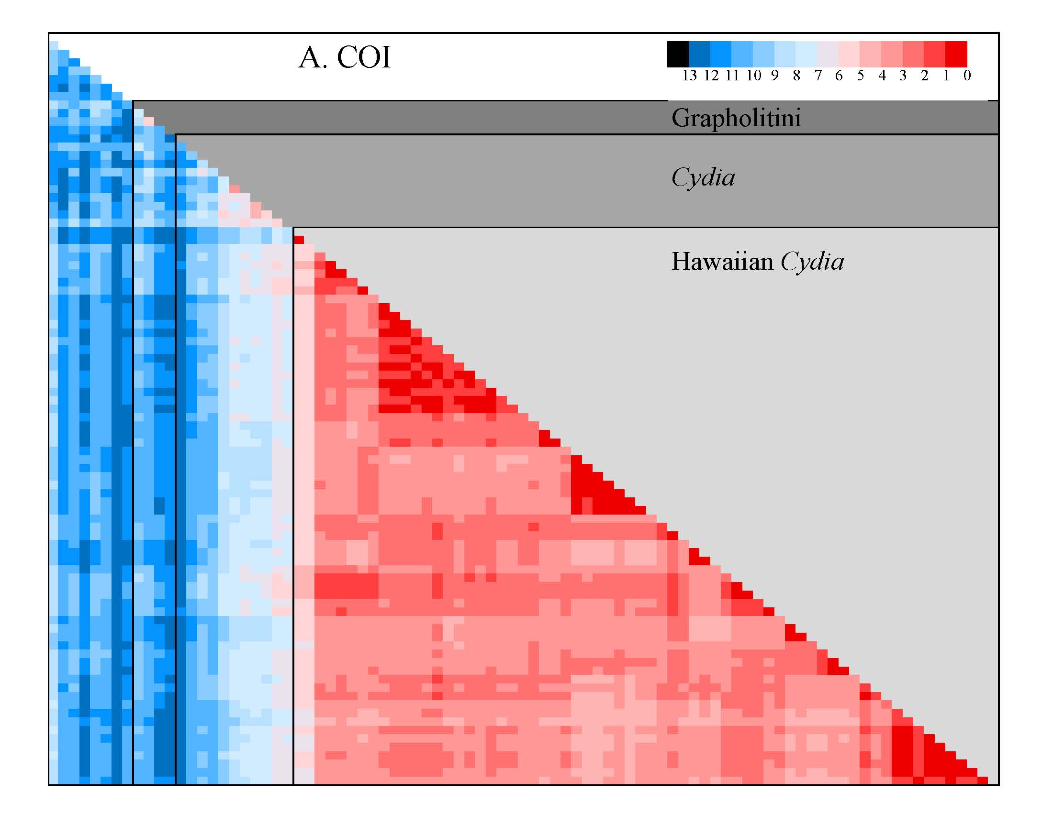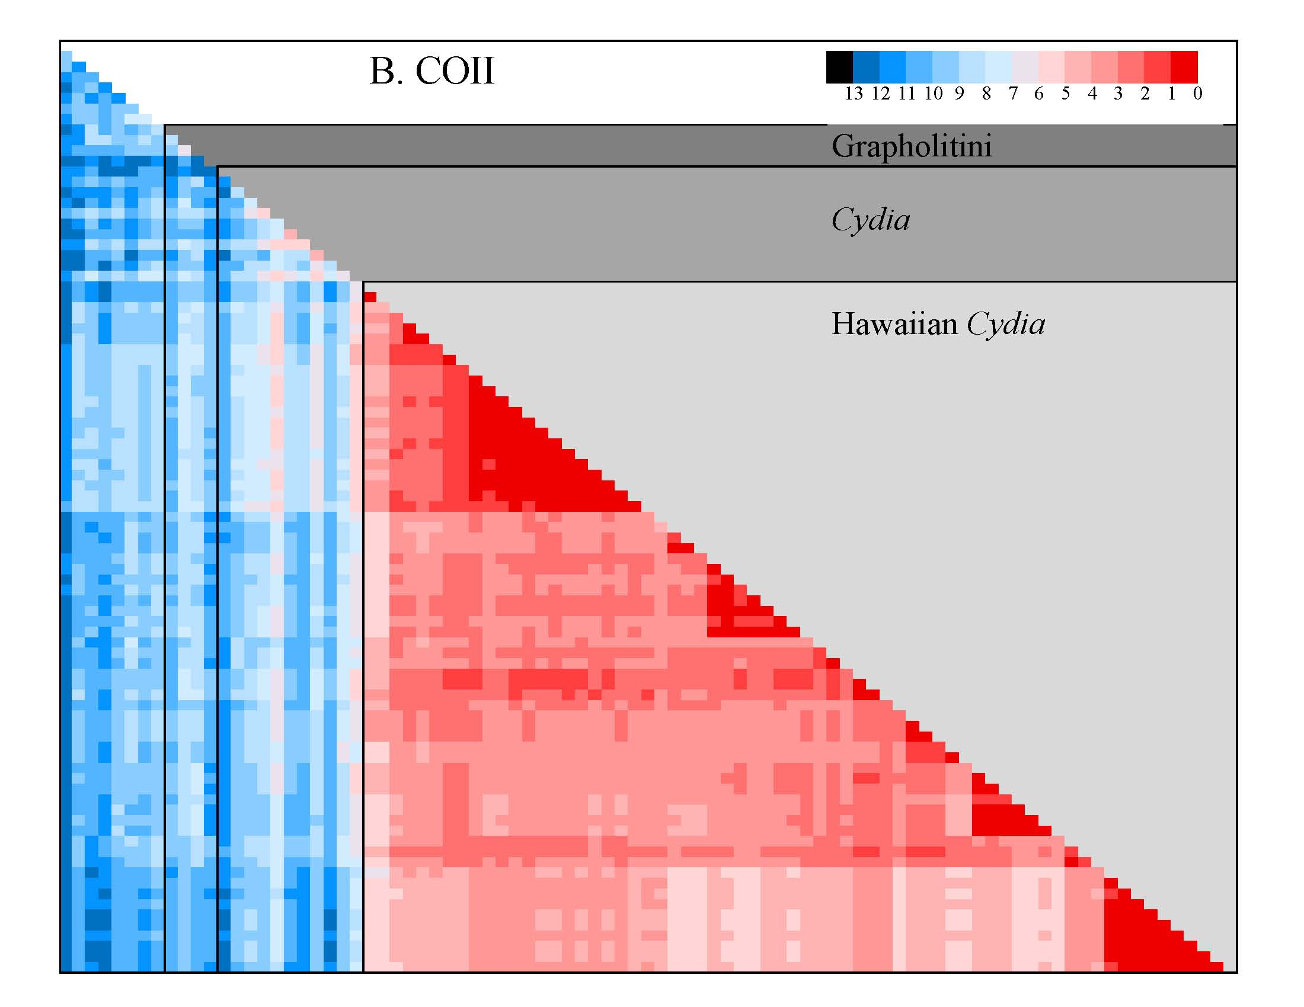
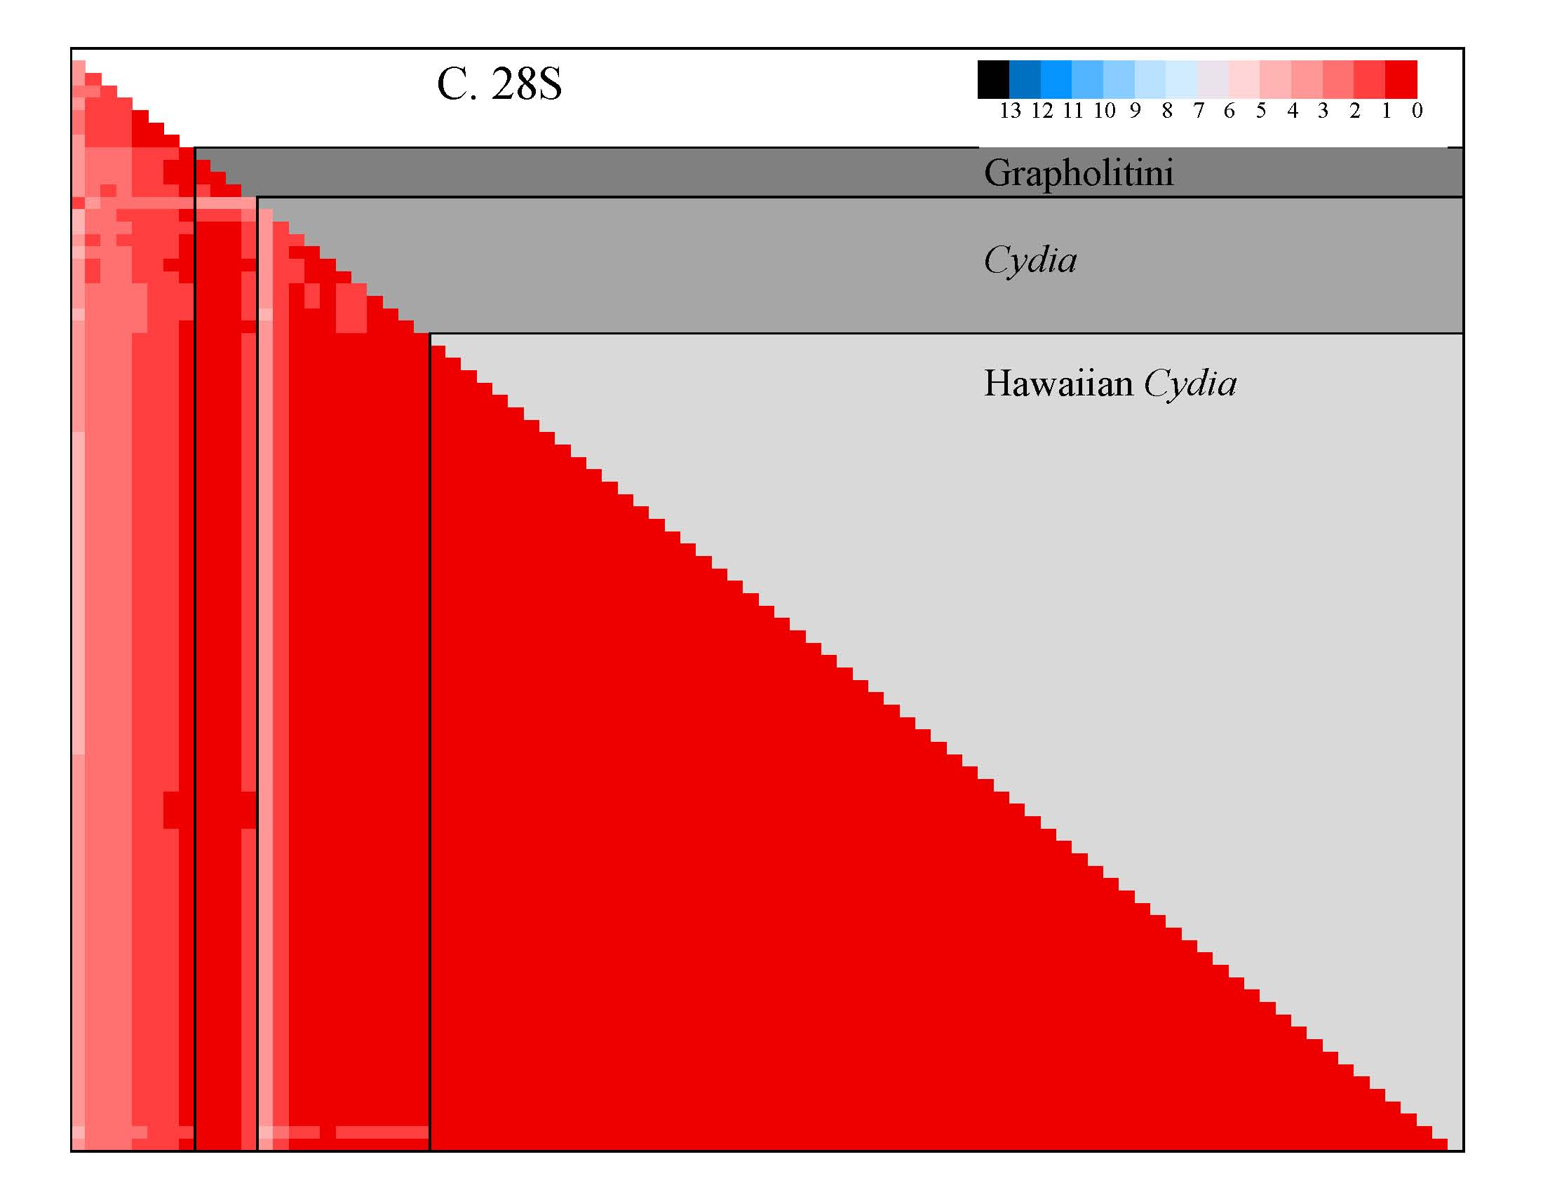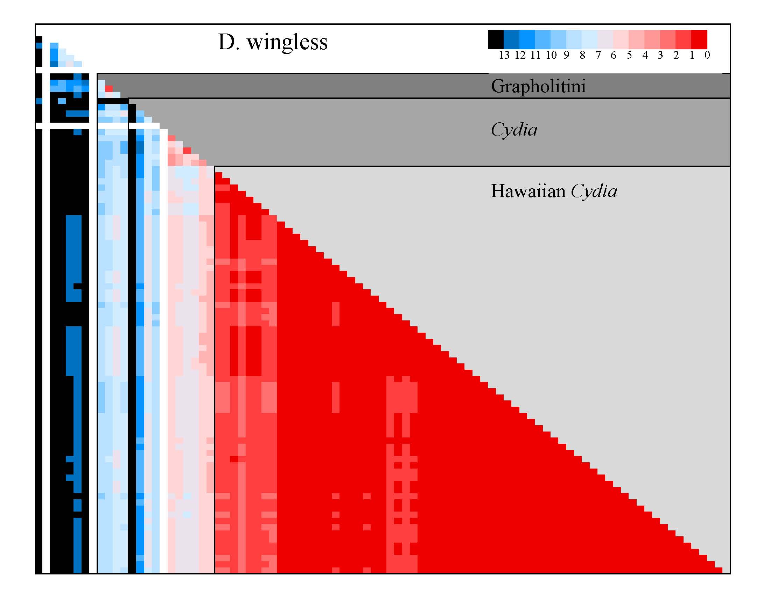
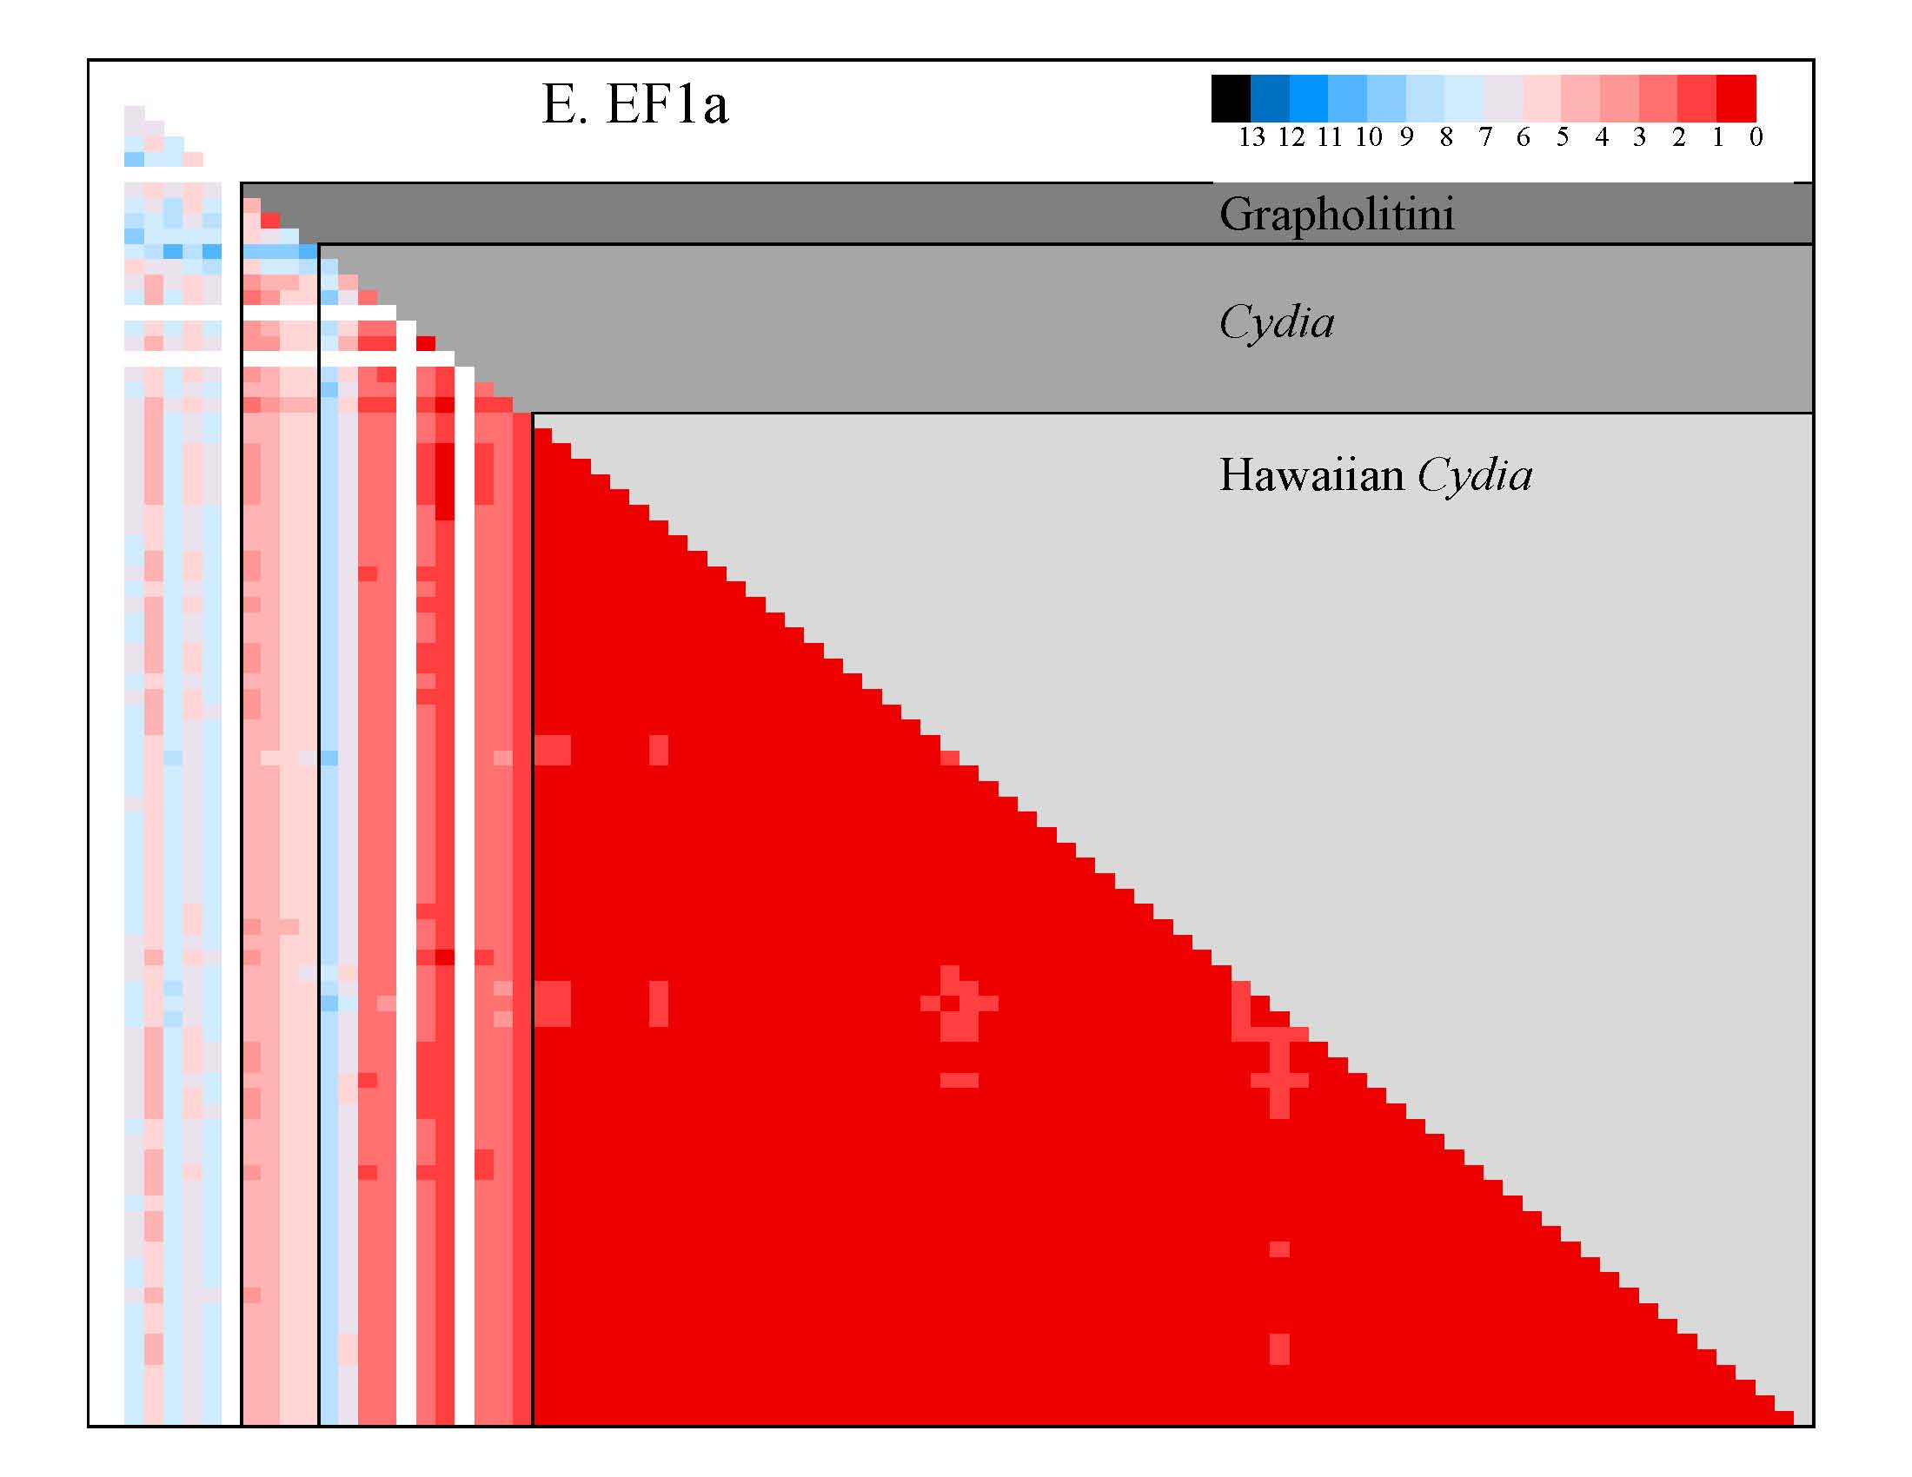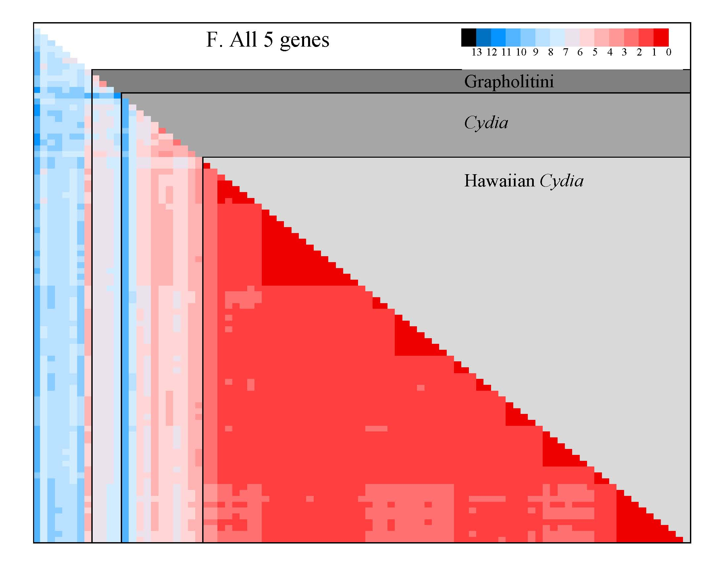

Figure 2. Heat maps – genetic distances between tortricid species. Visual depiction of genetic distance to illustrate the range of genetic variation at different taxonomic scales for five genes separately (A-E) and all genes combined (F). Color scale = uncorrected p distance x 100, with deep red indicating virtually identical genotypes to black indicating maximum genetic distance ( >13% difference, missing data in white). Note that the combined map (F) “smooths” the erratic variation of the individual genes and distinguishes genetic outliers for each taxonomic group (i.e. conspicuously different heat color than neighboring species). Order of taxa along the left and bottom axes follows the order of specimens in Figure 8, except Cydia deshaisiana is in the first Cydia position. The diagonal (i.e. each specimen compared to itself) is not displayed.
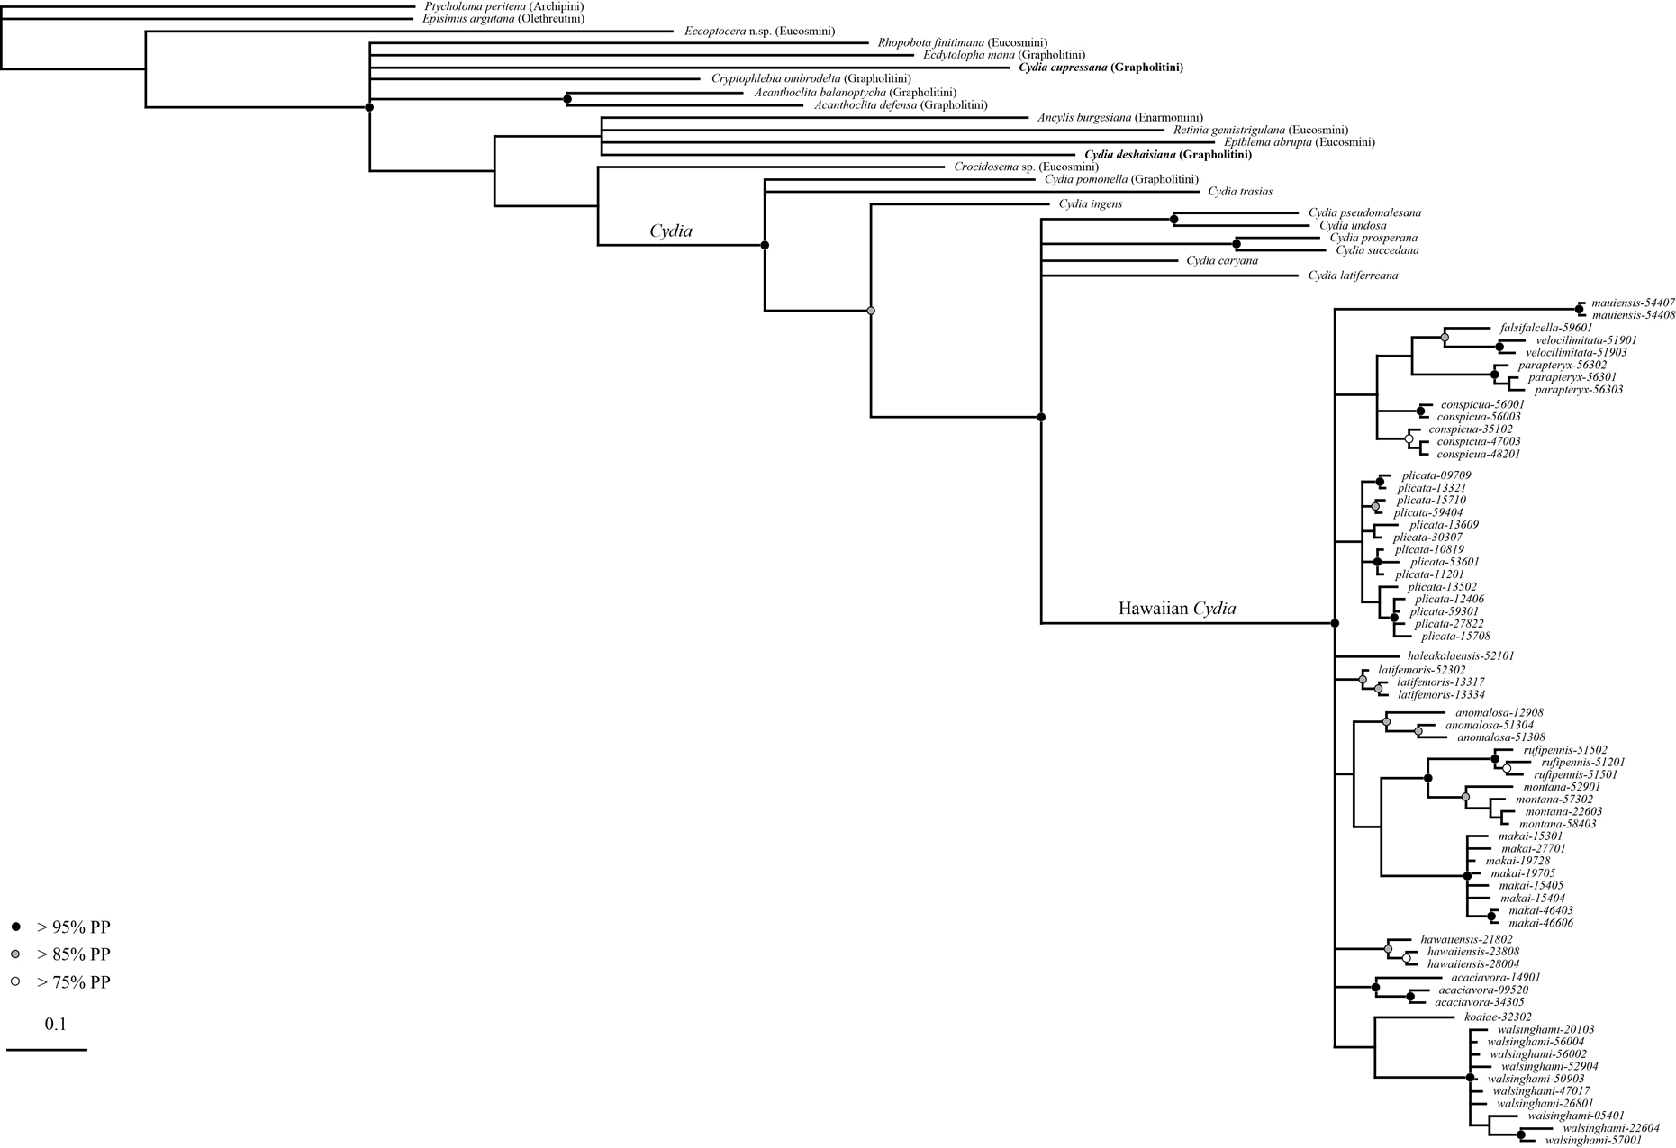
27

Figure 3. Gene tree for COI. Bayesian partitioned analysis (GTR model, nst=6, rates=invgamma) allowing each codon position to vary independently. Branch length scale bar indicates expected number of basepair changes. Black, gray, and white circles indicate node support. Nodes without circles have less than 75% posterior probability support.
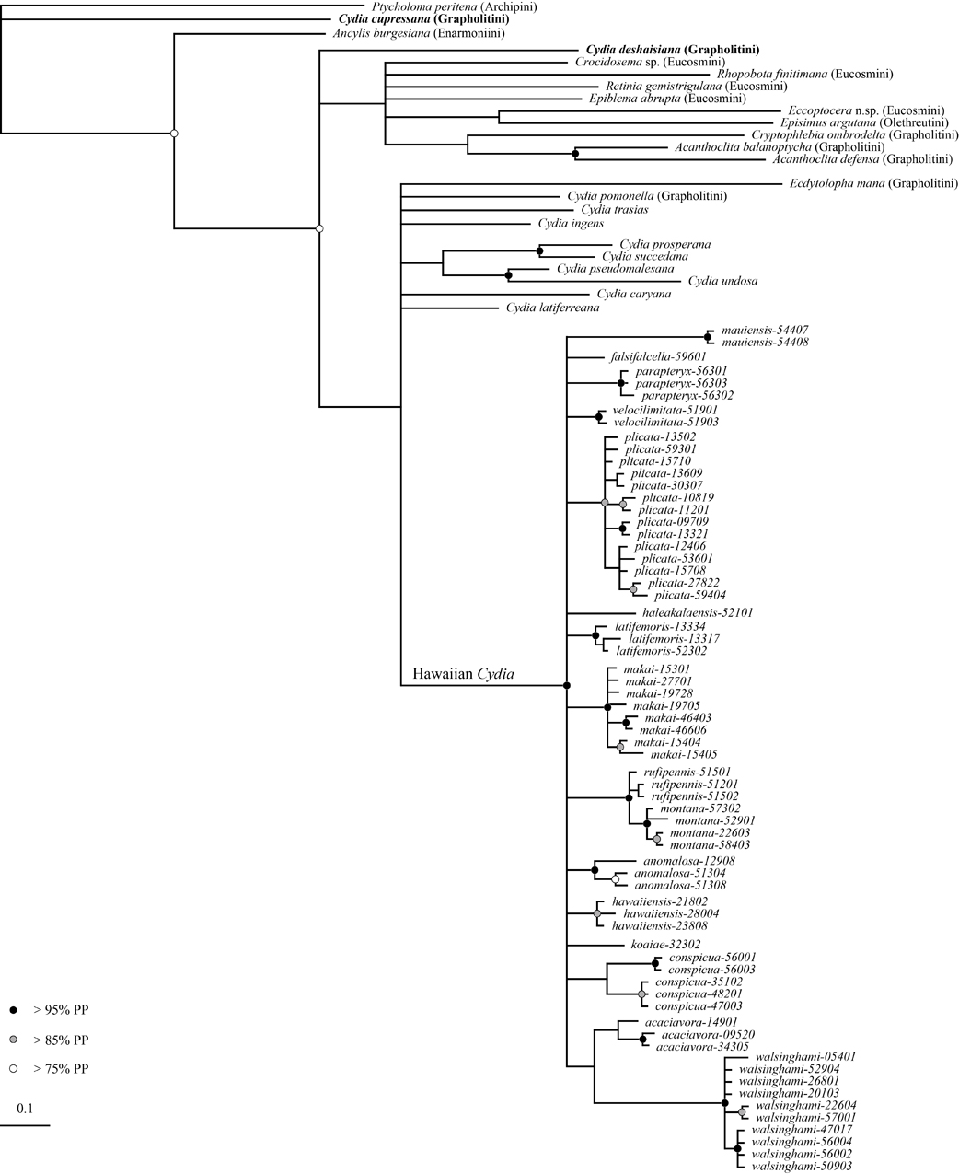

Figure 4. Gene tree for COII. Bayesian partitioned analysis (GTR model, nst=6, rates=invgamma) allowing each codon position to vary independently. Branch length scale bar indicates expected number of basepair changes. Black, gray, and white circles indicate node support. Nodes without circles have less than 75% posterior probability support.
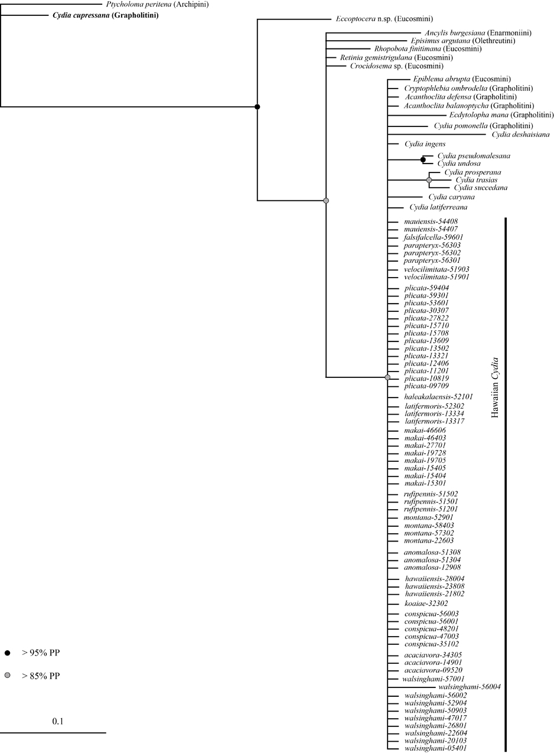

Figure 5. Gene tree for 28S. Bayesian partitioned analysis (nst=6, rates=propinv ) with no partitions. Branch length scale bar indicates expected number of basepair changes. Black, gray, and white circles indicate node support. Nodes without circles have less than 75% posterior probability support.
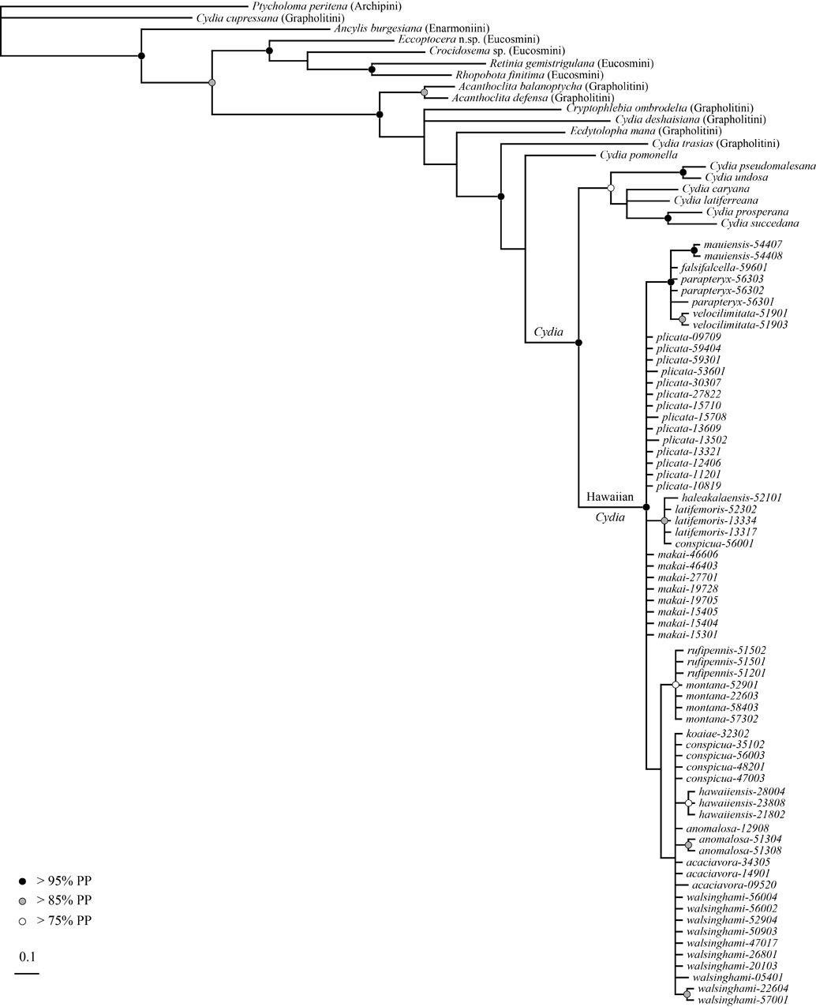

Figure 6. Gene tree for wingless (WG). Bayesian partitioned analysis (GTR model, nst=6, rates=invgamma) allowing each codon position to vary independently. Branch length scale bar indicates expected number of basepair changes. Black, gray, and white circles indicate node support. Nodes without circles have less than 75% posterior probability support.

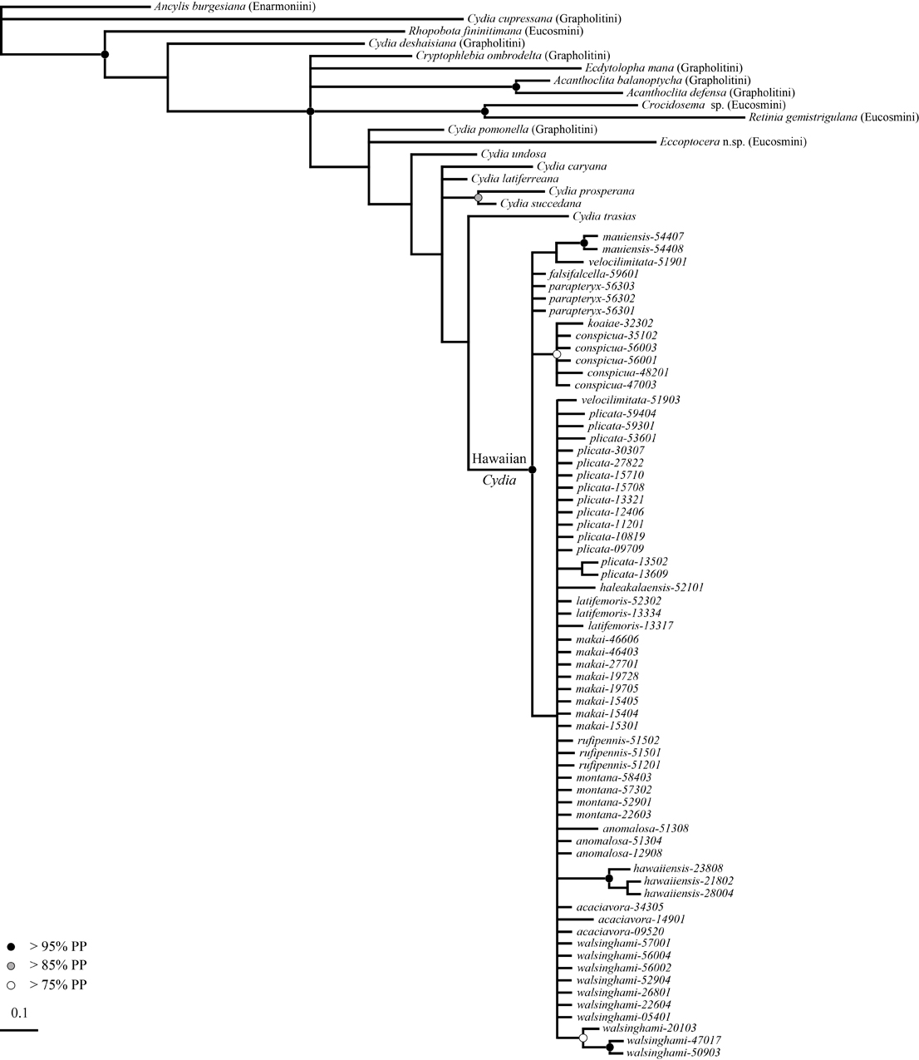

Figure 7. Gene tree for Elongation Factor 1 α (EF1α). Bayesian partitioned analysis (GTR model, nst=6, rates=invgamma) allowing each codon position to vary independently. Branch length scale bar indicates expected number of basepair changes. Black, gray, and white circles indicate node support. Nodes without circles have less than 75% posterior probability support.

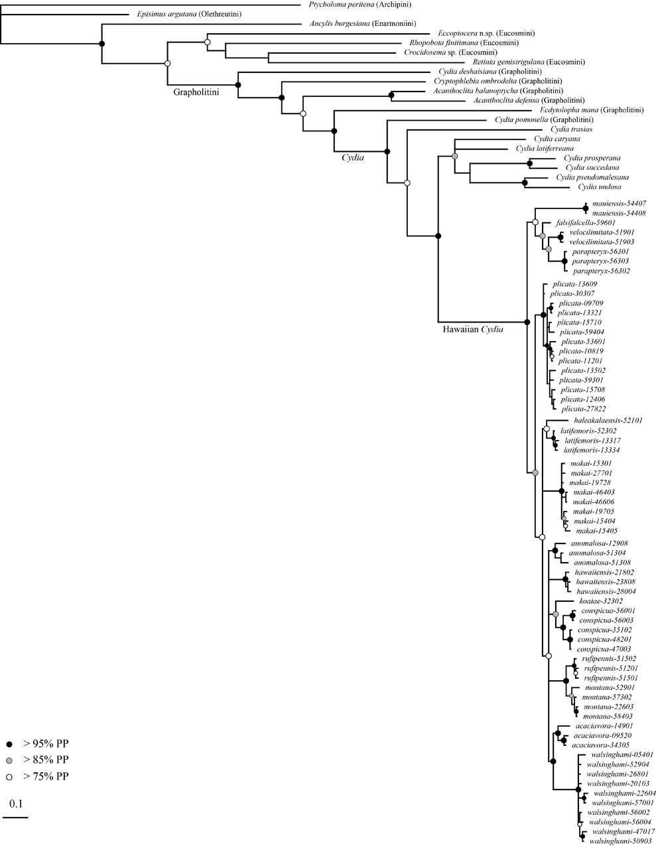

Figure 8. Phylogeny using five genes combined (COI, COII, 28S, WG, EF1α). Bayesian partitioned analysis (GTR model, nst=6, rates=invgamma) allowing each codon position to vary independently for mtDNA and nDNA; and (nst=6, rates=propinv ) with no partitions for 28S. Branch length scale bar indicates expected number of basepair changes. Black, gray, and white circles indicate node support. Nodes without circles have less than 75% posterior probability support.
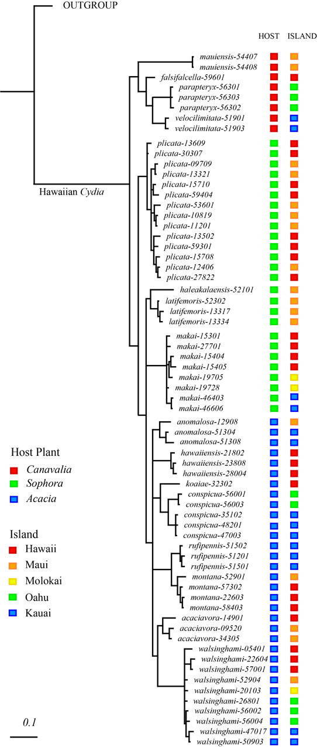

Figure 9. Phylogeny, host-plant affinities, and distribution for Hawaiian Cydia. Bayesian reconstruction using five gene fragments (see previous figure) with outgroups collapsed to a single branch, and each specimen color coded for host-plant and island origin. Scale bar indicates expected number of basepair changes.
REFERENCES CITED

